**ELECTRIC CURRENT**

**Exercises**

**Section 24.1 Electric Current**

**13.** **Interpret** This problem involves converting current in amperes to the number of electrons moving past a given point in a wire per unit time.

**Develop** Current in amperes is the amount of charge in Coulombs passing a given point in the wire, per second. Mathematically, this is given by Equation 24.1a:

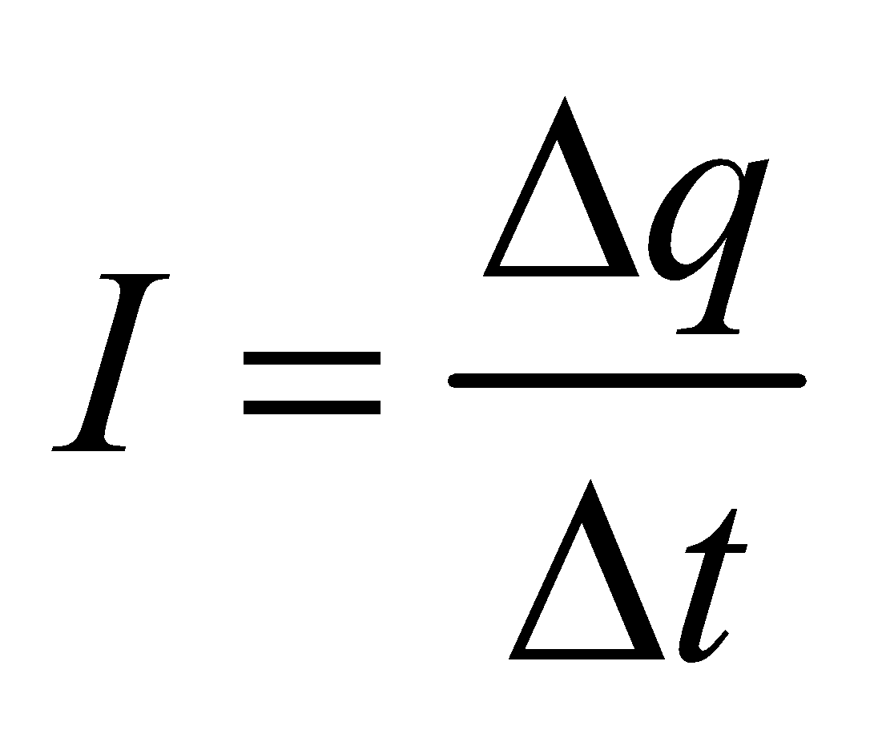

To find the number of electrons, divide the charge in Coulombs by the charge of a single electron in Coulombs (|*e*| = 1.60 × 10−19 C).

**Evaluate** Solving the expression above for the charge and dividing it by the charge of an electron gives the number *n* of electrons as

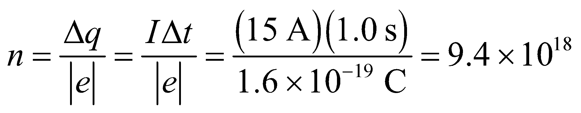

**Assess** Because electrons carry a negative charge, they actually move in the direction opposite that of the given current.

**14. Interpret** We are to find the charge (in Coulombs) that passes through a circuit given the battery capacity in ampere-hours.

**Develop** Use Equation 24.1a. A battery capacity of 80 A·h means that the battery can supply *I* = 80 A for 1 h. The definition of an ampere is 1 C/s. Inspecting the units shows that we can get the charge by multiplying this current *I* by the given time *Δt* over which the battery can supply this current (i.e., 1 h = 3600 s).

**Evaluate** A battery rated at 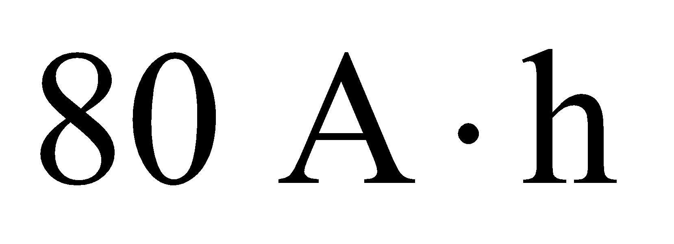 can supply a net charge of

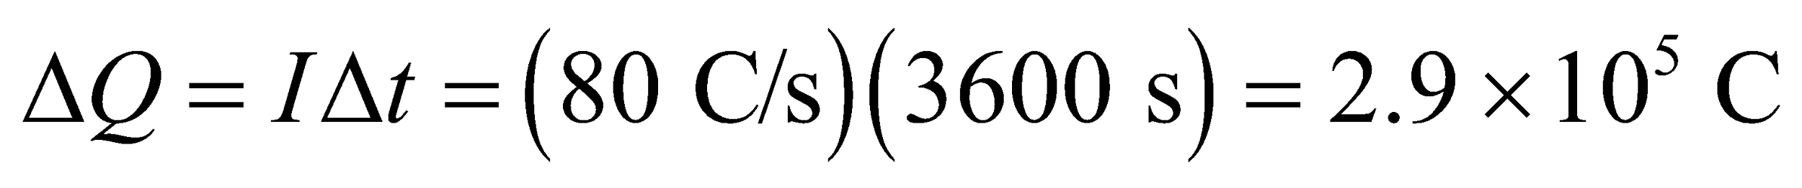

**Assess**By definition, 1A = 1 C/s, or 1C = 1 A·s, which agree with the units of the right-hand side of our calculation above.

**15.** **Interpret** This problem involves finding the charge that moves through a membrane over a given time intervale given the current.

**Develop** From the definition of an ampere, we know that the charge moving through the membrane each second is 30 nC (see Equation 24.1a; *q* =*IΔt*). Since singly-charged ions carry one elementary charge (about *q*ion = 160 zC), we can find the total charge that passes through the membrane in one second.

**Evaluate** Letting the units guide us, we find the number *n* of ions that pass the membrane in one second is

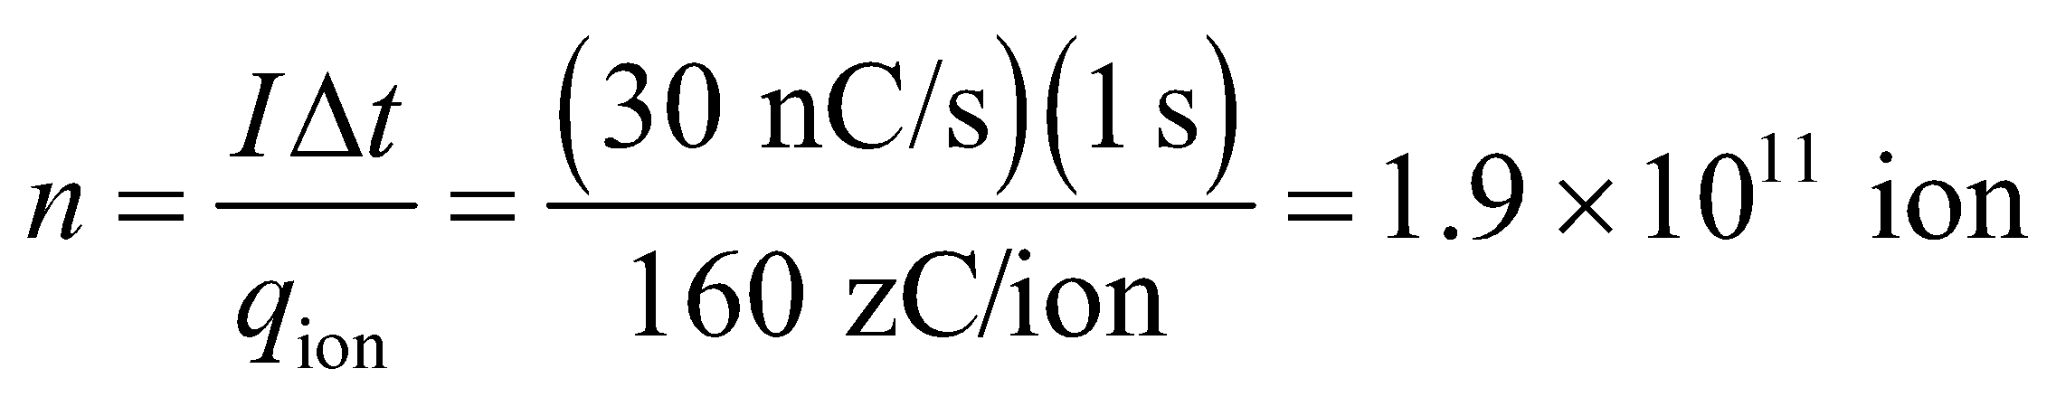

**Assess** This may also be expressed in terms of the number *n*mol of moles:

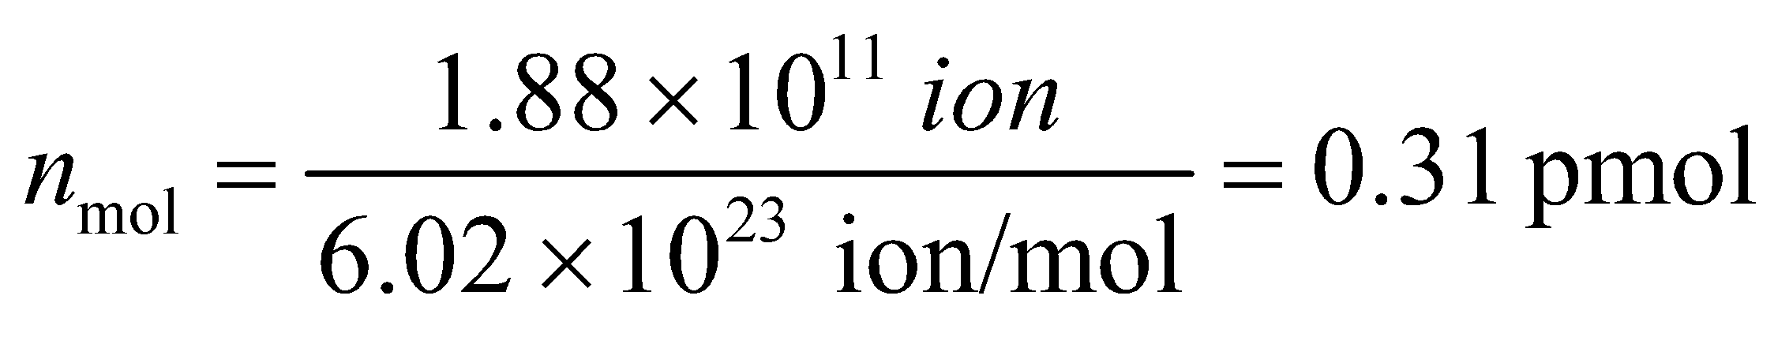

Chemical drug-testing instrumentation can detect amounts of substances this low.

**16. Interpret** In this problem we are asked to find the current density, given the electric current and the cross section through which it travels.

**Develop** The current density *J*, is defined as the current per unit area, or *J* = *I*/*A*. The area of the cross section of a circular wire is

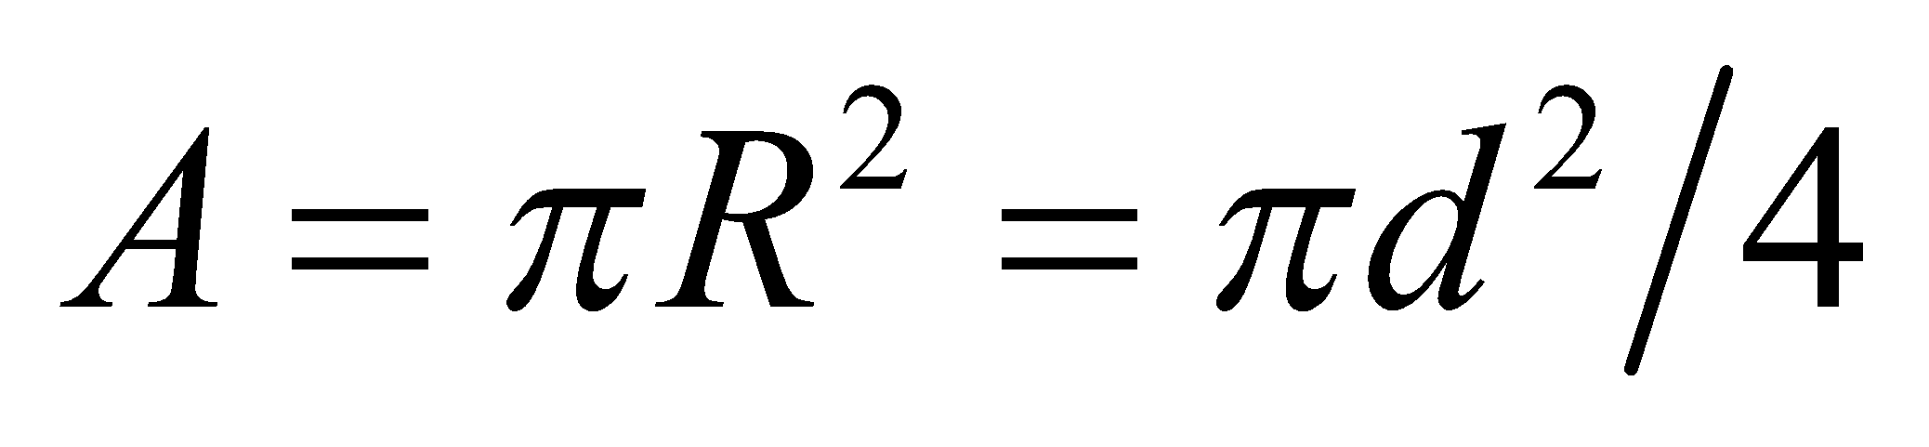

**Evaluate** The cross section of a wire is uniform, so the density is

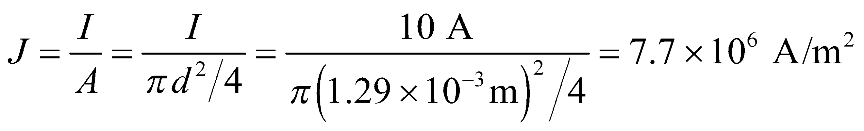

**Assess** This is the average current density. If the cross section was nonuniform, some areas would experience more current density while other areas would experience less.

**Section 24.2 Conduction Mechanisms**

**17.** **Interpret** The problem involves the microscopic version of Ohm's law.

**Develop** Aluminum obeys Ohm's law, so from Equation 24.4b: 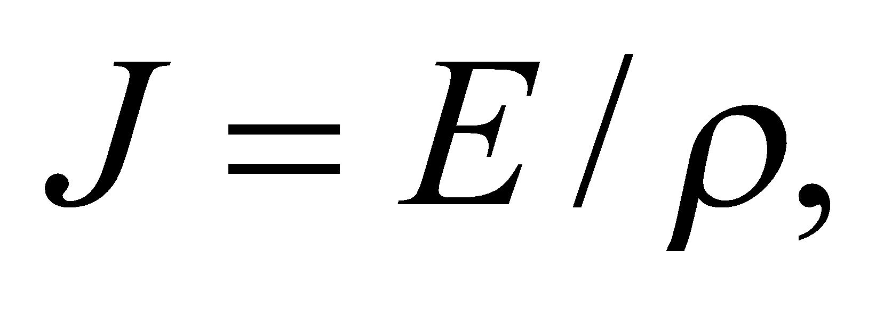 where the resistivity of aluminum is given in Table 24.1: 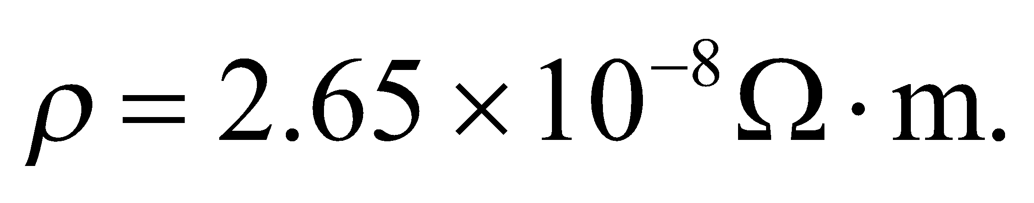

**Evaluate** The current density in the wire is:

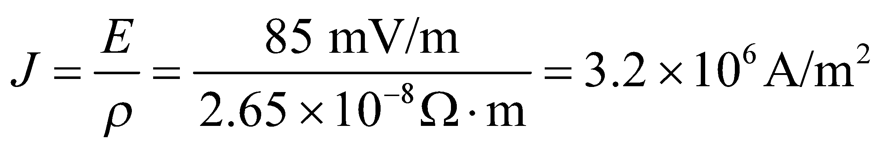

**Assess** The units work out, since 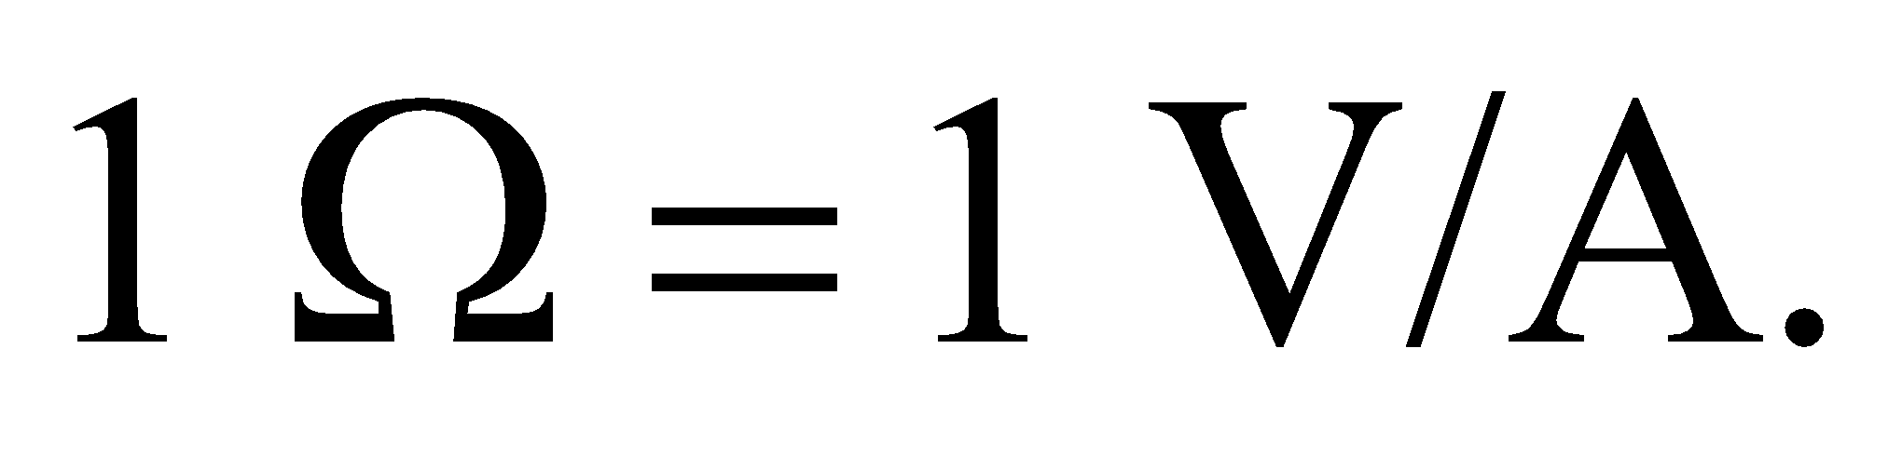

**18. Interpret** In this problem we are asked to calculate the electric field in a current-carrying conductor.

**Develop** To find the electric field, use Ohm’s law (which applies to silver), 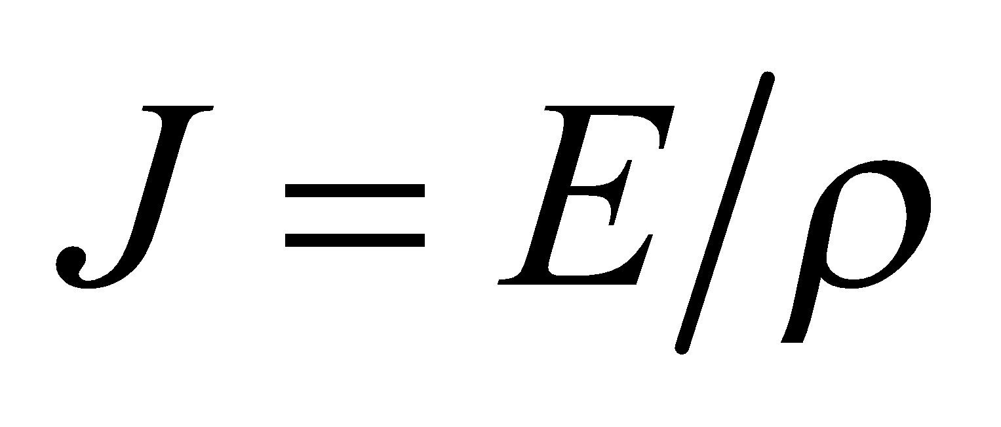, and the definition of current density, which is assumed to be uniform over the wire cross section.

**Evaluate** Using Table 24.1 to find the resistivity of silver, the electric field is

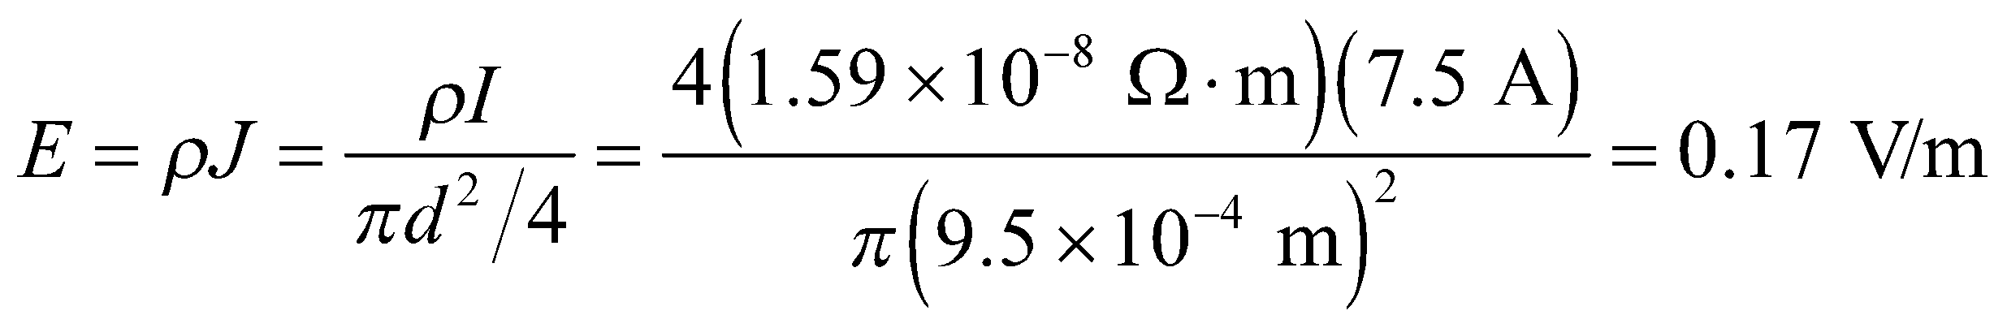

**Assess** The value is a lot smaller than the electric field we discussed in electrostatic situations. Since silver is such a good conductor, a small field can drive a substantial current.

**19.** **Interpret** We are asked to find the diameter of a current-carrying cylinder, given the current and the electric field. The resistivity of the cylinder is also known via Table 24.1.

**Develop** Assuming a uniform current density obeying Ohm’s law, apply Equation 24.4b, *J* = *E*/*ρ* to find the current density *J*. Knowing *J*, we can find the cylinder diameter using *J* = *I*/*A* (see Example 24.2), where *A* = *π*(*d*/2)2.

**Evaluate** Combining the expressions above to solve for the diameter *d* gives

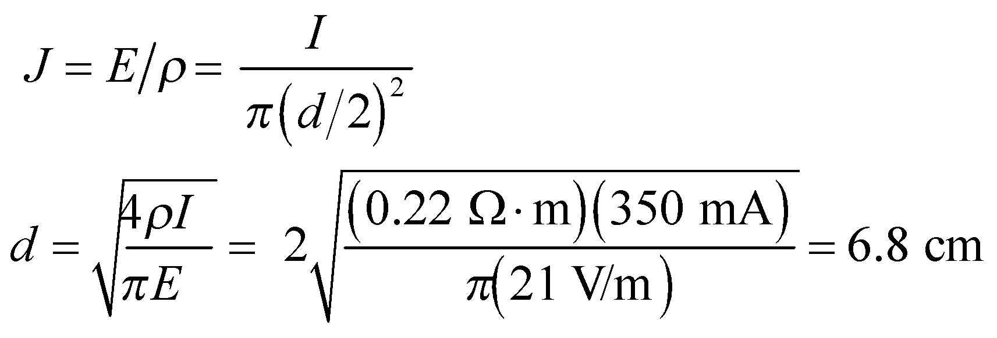

**Assess** This seems like a reasonable inner diameter for the tube.

**20. Interpret** This problem is about applying Ohm’s law to find the resistivity of a rod.

**Develop** If the rod has a uniform current density and obeys Ohm’s law (Equations 24.4a and 24.4b), then its resistivity is

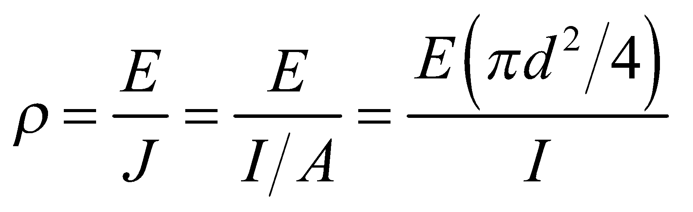

**Evaluate** Inserting the values given in the problem statement, the resistivity of the rod is

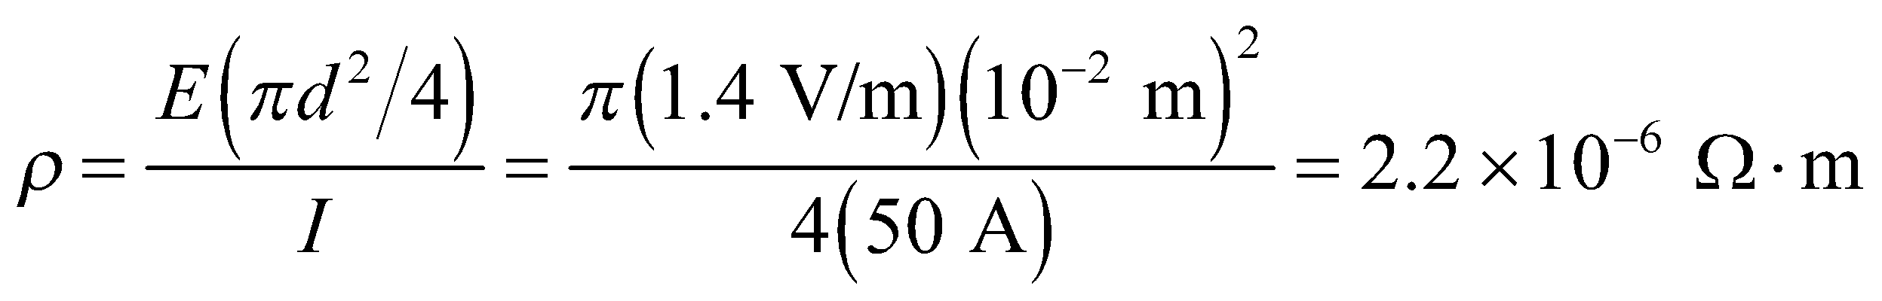

**Assess** With reference to Table 24.1, we see that the value is within the range of resistivity of metallic conductors.

**21.** **Interpret** Given the resistivity of two materials, we are to find their conductivity.

**Develop** Equation 24.4a and 24.4b show that the conductivity and the resistivity are reciprocals of one another.

**Evaluate** **(a)** For copper, 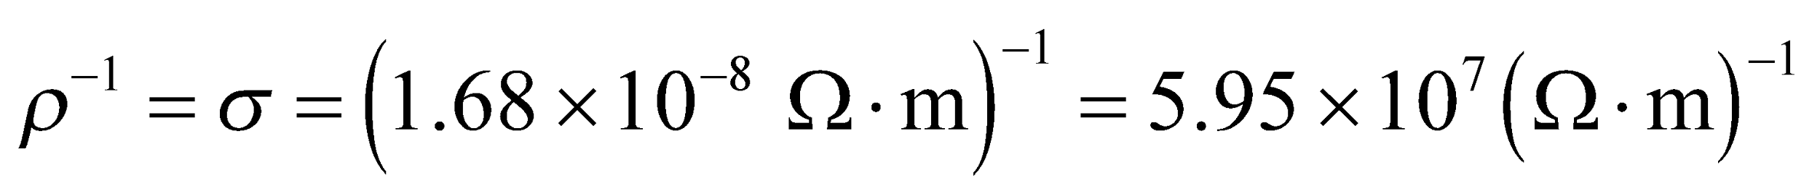.

(**b**) For seawater,** 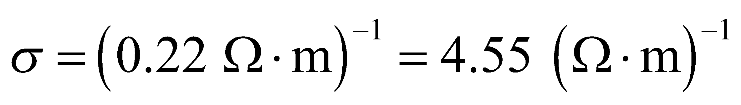.**

**Assess**  The salinity of open-ocean water varies between 33 and 37 parts per thousand, but can vary from 1 to 80 parts per thousand in shallow coastal waters. This variation has a proportional effect on the conductivity.

**Section 24.3 Resistance and Ohm’s Law**

**22. Interpret** This problem involves using the macroscopic version of Ohm’s law to calculate the resistance of a heating coil.

**Develop** The macroscopic form the Ohm’s law is probably applicable to the heating coil, which is typically a coil of wire. Equation 24.5 gives *R* = *V*/*I*.

**Evaluate** Inserting the values given in the problem statement, we find the resistance to be

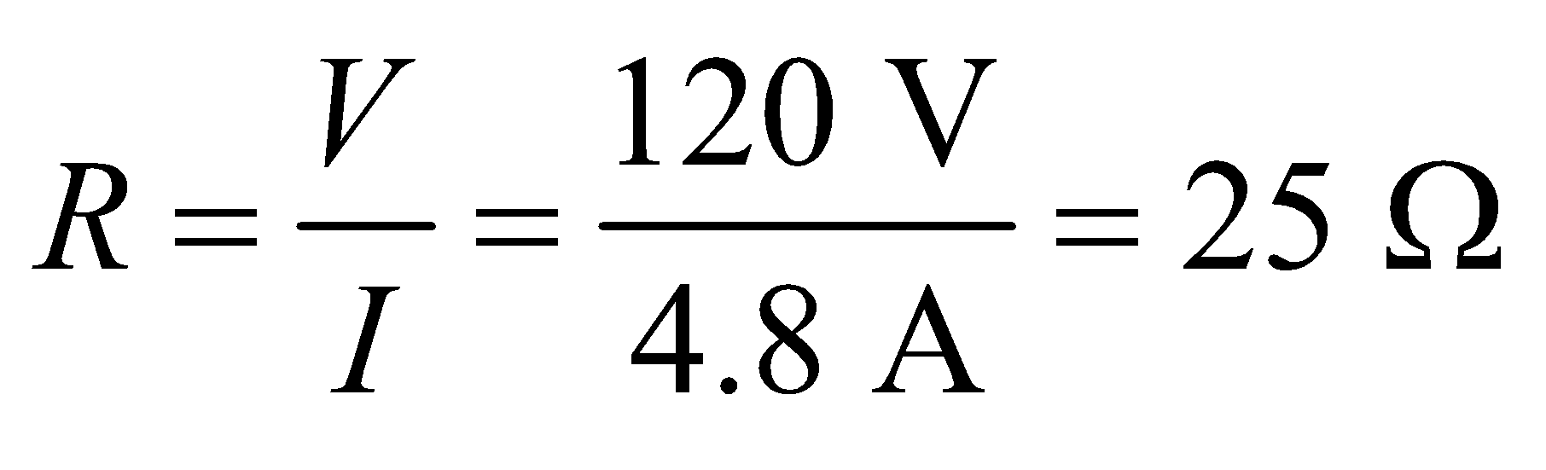

**Assess** This is a fairly large resistance. The resistance of the coil used for heating is usually quite high.

**23.** **Interpret** This problem involves using the macroscopic form of Ohm’s law to find the voltage needed to produce a desired current.

**Develop** For an Ohmic resistor, the macroscopic version of Ohm’s law (Equation 24.5) is V = IR.

**Evaluate** Inserting the given quantities gives 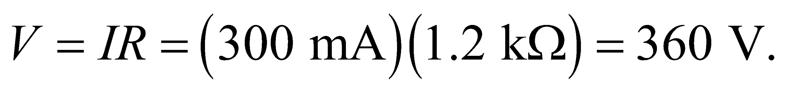

**Assess** This is three times the peak voltage provided by standard power outlets in the USA, so it would not be possible to generate this current without employing some method to increase the voltage from the power outlet.

**24. Interpret** In this problem we want to apply the macroscopic version of Ohm’s law to calculate the current across a resistor.

**Develop** The macroscopic version of Ohm’s law, *V* = *IR*, given in Equation 24.5 provides the connection between current, resistance, and voltage. This equation allows us to compute the current *I*.

**Evaluate** Inserting the values given in the problem statement, we find the current to be

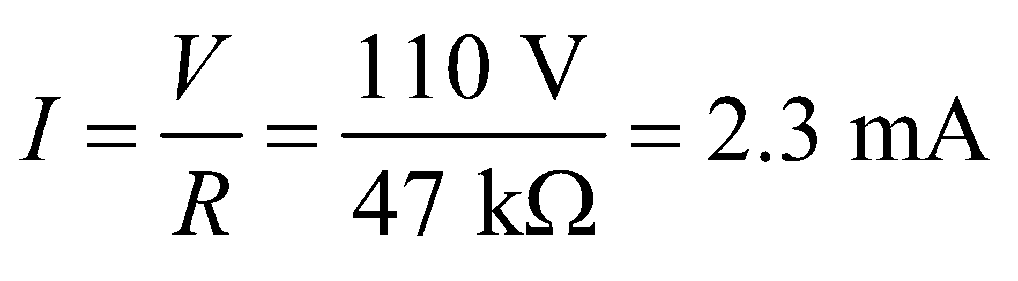

**Assess** From Ohm’s law, we see that current is inversely proportional to resistance when *V* is kept fixed. In our case, a large resistance yields a small current.

**25.** **Interpret** We are to find the resistance of an iron rail with the given dimensions. This involves using both macroscopic (resistantce) and microscopic (resitivity) concepts.

**Develop** The microscopic resistivity *ρ* is connected to the macroscopic resistance *R* by Equation 24.6, 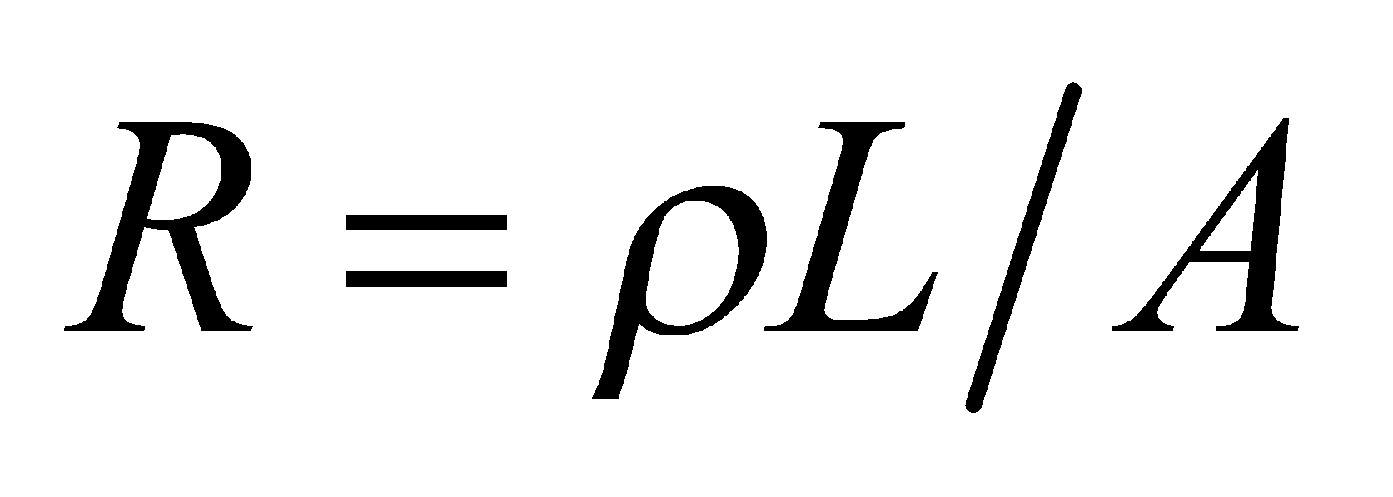.

**Evaluate** Inserting the given quantities gives .

**Assess** This resistance is quite low, which explains in part why this material is used for this purpose.

**26. Interpret** This problem is about applying the macroscopic version of Ohm’s law to calculate the current across a resistor.

**Develop** The macroscopic version of Ohm’s law (*V* = *IR*) given in Equation 24.5 provides the connection between current, resistance, and voltage. This equation allows us to compute the current *I*.

**Evaluate** Inserting the values given in the problem statement, we find the current is

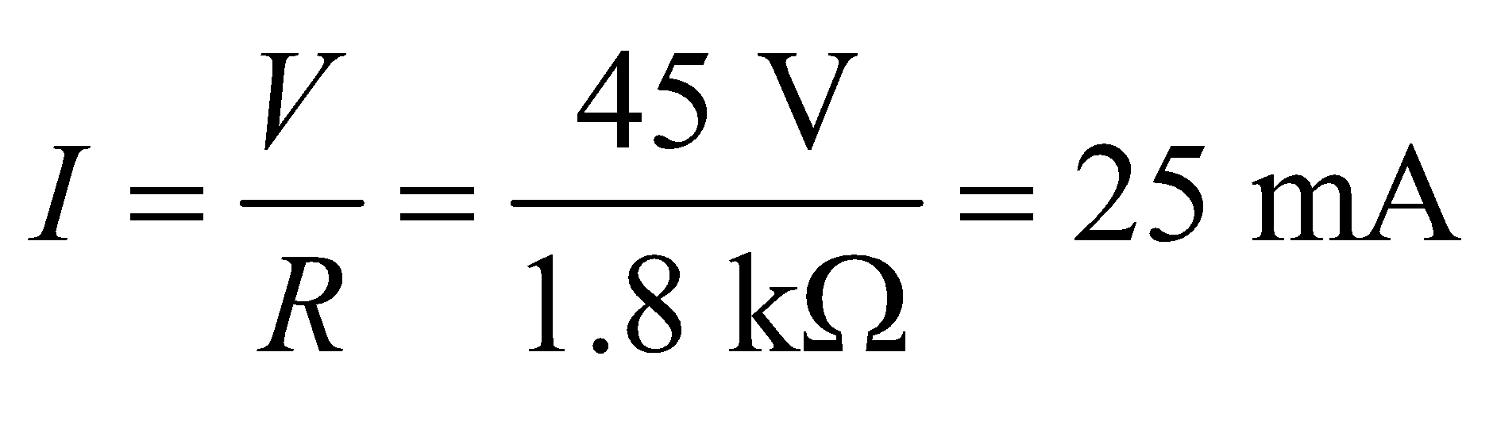

**Assess** From Ohm’s law, we see that current is inversely proportional to resistance when *V* is kept fixed. These values of current and resistance are typical of what are encountered in common electrical appliances.

**27.** **Interpret** We are to find the resistance of a wire whose length is doubled while its density remains constant.

**Develop** If the density (and mass) of the wire remains constant, then its volume is constant, so *V* = *LA* = constant. Using the fact that the length is doubled (2*L*1 = *L*2), we can find the new resistance by using Equations 24.6, *R* = *ρL*/*A*.

**Evaluate** Taking the ratio of the Equation 24.6 applied to the wire before and after stretching gives

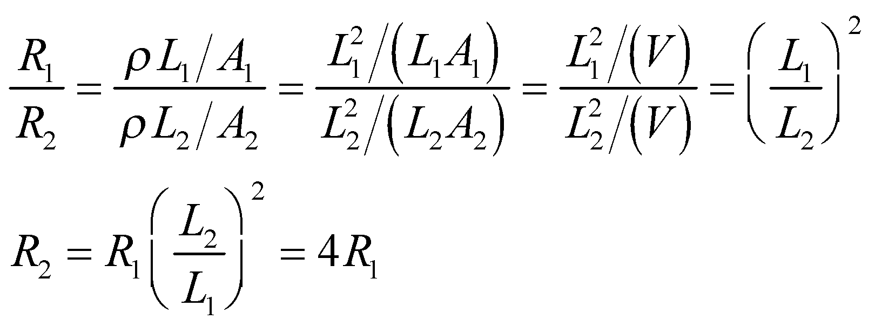

**Assess** The resistance is quadratic in *L*, so doubling *L* increases the resistance by a factor of 4.

**Section 24.4 Electric Power**

**28. Interpret** This problem involves the electric power of a motor. We are given the current drawn and the voltage across the terminals and are to find the power consumed by the motor.

**Develop** Equation 24.7, *P* = *IV*, provides the connection between electric current, voltage, and electric power. Apply this equation to compute the power *P*.

**Evaluate** Inserting the values given in the problem, we find the power consumption is

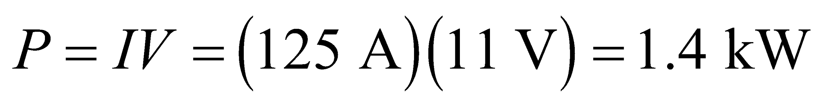

**Assess** A large electric power is needed to start a car. This is why a very high current is required in the starter motor to crank the engine.

**29.** **Interpret** We are given the power required to operate a device and the current it draws. From this information, we are to find its voltage and resistance.

**Develop** Apply Equation 24.7, *V* = *P*/*I*, to find the voltage and Equation 24.5, *R* = *V*/*I* to find the resistance.

**Evaluate** **(a)** From Equation 24.7, 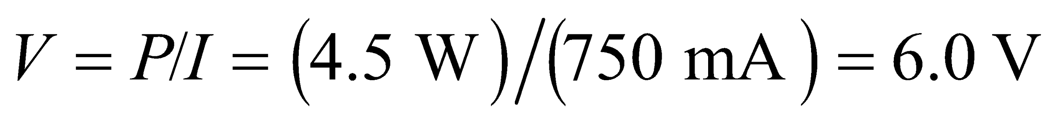.

**(b)** From Equation 24.5, 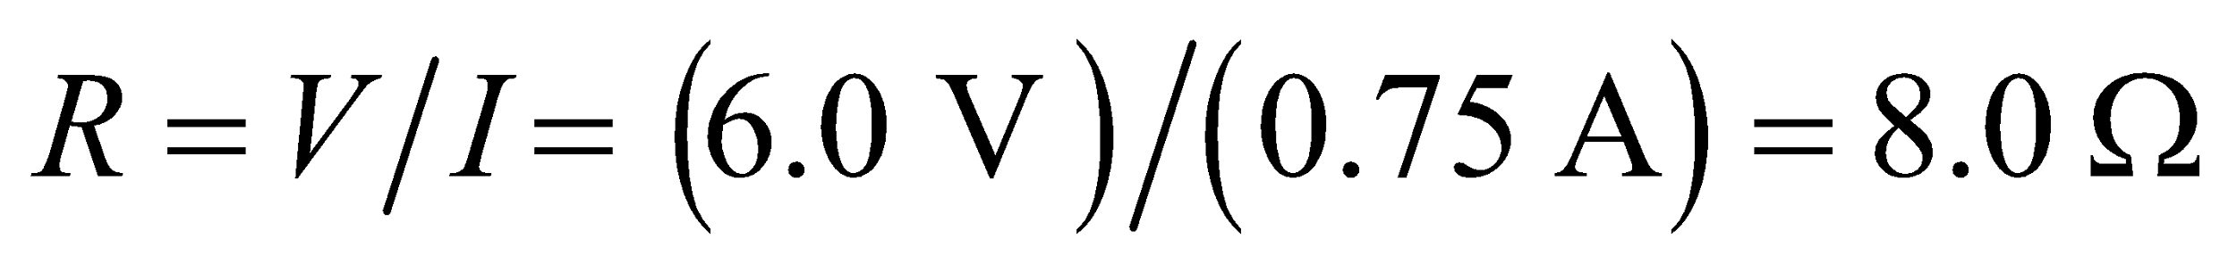.

**Assess** This is a small voltage and a small resistance, with the ratio giving rise to a significant current.

**30. Interpret** This problem requires us to find the current drawn from a battery, given its voltage and power rating.

**Develop** Equation 24.7, *P* = *IV*, provides the connection between electric current, voltage, and electric power.

**Evaluate** Rearranging Equation 24.7, we find

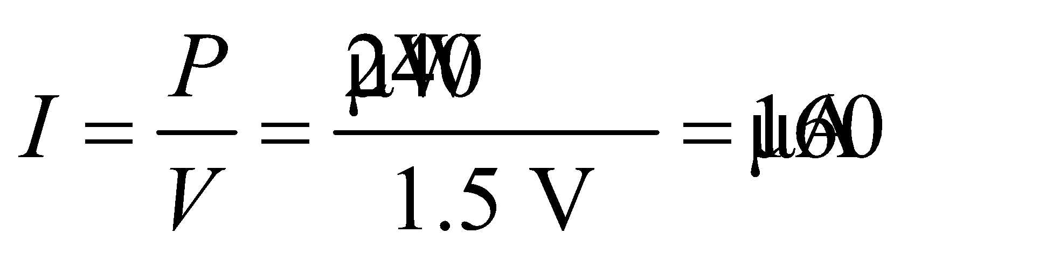

**Assess** We expect the current drawn from the battery to be very small since little power is needed to operate a watch.

**31.** **Interpret** We are to find the voltage at which a device operates, given its resistance and the power it consumes.

**Develop** Solve Equation 24.8b, *P*= *V*2/*R*, for the voltage *V*.

**Evaluate** Equation 24.8b gives 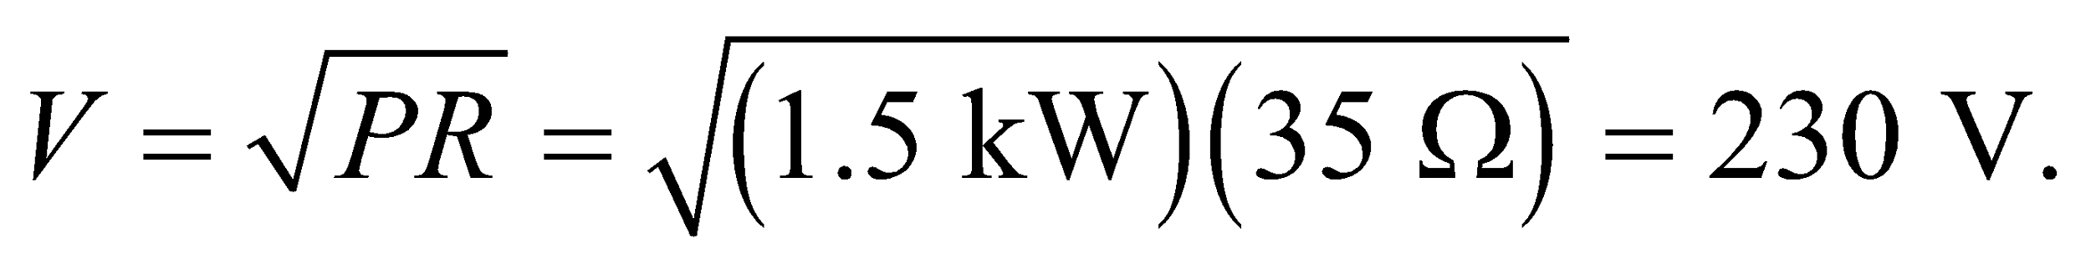

**Assess** This is greater than the peak power provided by standard power outlets in the USA, which is not surprising for an electric stove.

**32.** **Interpret** We want to compare the power consumption of two light bulbs.

**Develop** We're given the current and voltage, so we'll use Equation 24.7 to find the power: 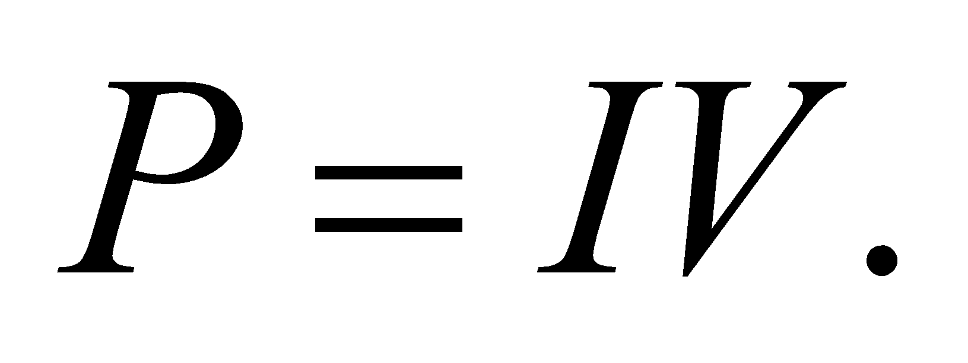

**Evaluate** The incandescent bulb consumes:

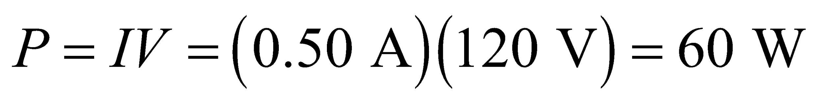

The compact fluorescent consumes:

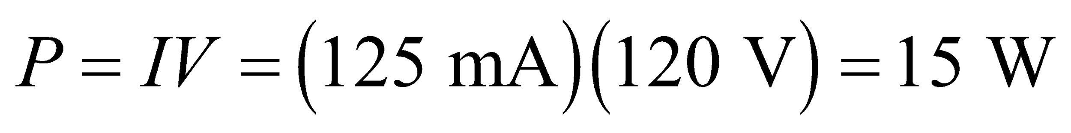

**Assess** The compact fluorescent consumes a quarter of the power consumed by the incandescent, which sounds reasonable. The two bulbs put out the same amount of visible light, but the incandescent emits a lot of heat (infrared light), which makes it much less efficient.

**Section 24.5 Electrical Safety**

**33. Interpret** We use the macroscopic version of Ohm’s law to find the resistance necessary for the given voltage to drive the given current.

**Develop** The macroscopic version of Ohm’s law is *V* = *IR* (Equation 24.5). We are given *V* = 30 V and *I* = 100 mA, so we can solve for *R*.

**Evaluate** Inserting the given quantities yields

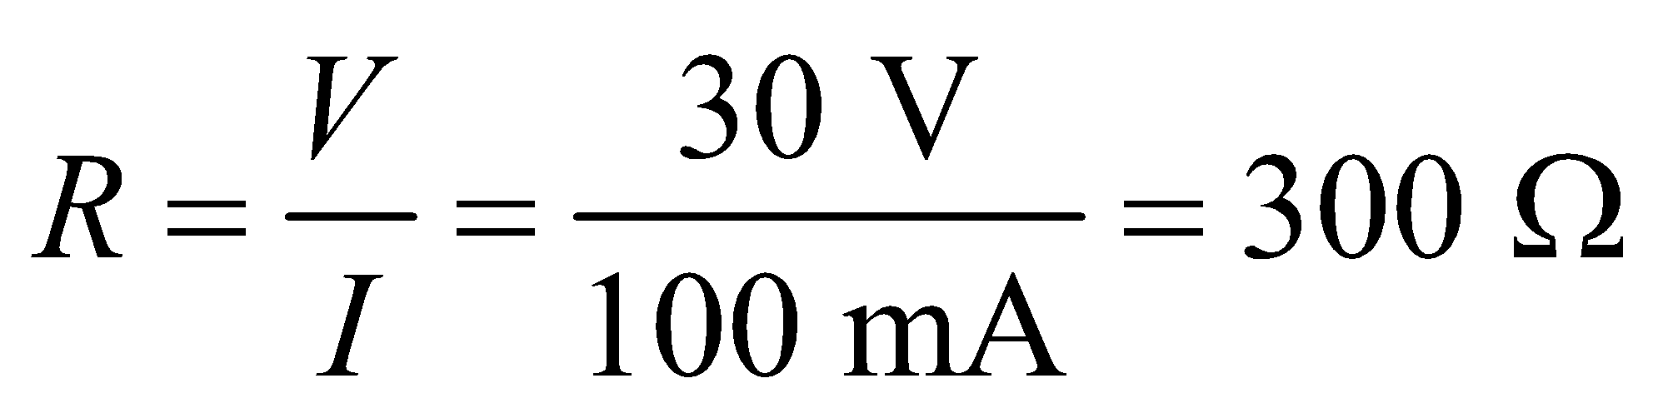

**Assess** The resistance of dry skin is much higher than this, so in dry conditions this voltage does not pose a threat.

**34. Interpret** We will use the macroscopic version of Ohm’s law to find the resistance necessary for a given voltage to drive a specified current.

**Develop** The macroscopic version of Ohm’s law is *V* = *IR*. We are given *V* = 120 V and *I* = 2.5 mA, so we can solve for *R*.

**Evaluate** Inserting the given quantities gives

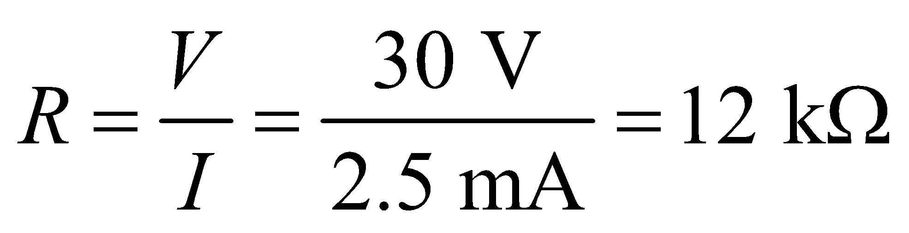

**Assess** If your skin was wet, your resistance would be much lower and this voltage would pose a serious threat.

**35. Interpret** Given a resistance and voltage, what current would flow? We will use the macroscopic version of Ohm’s law, and also estimate whether the resulting current could be felt.

**Develop** The macroscopic version of Ohm’s law is *V* = *IR*. The resistance is *R* = 100 kΩ, and the voltage is *V* = 12 V. The threshold for sensation is listed in Table 24.3 as 0.5–2 mA.

**Evaluate** **(a)** Inserting the given quantities gives a current of

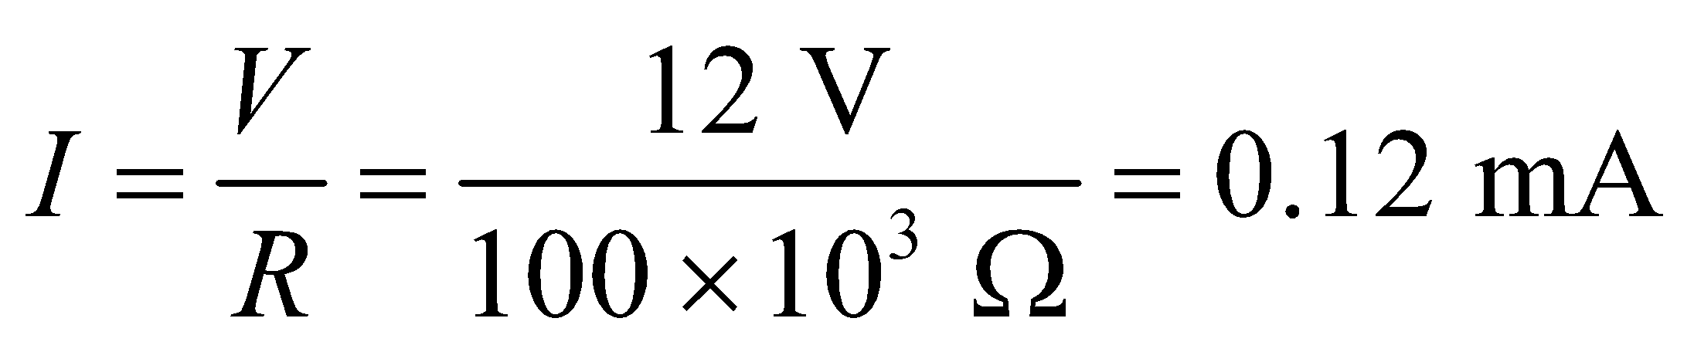

**(b)** This current is below the threshold for sensation, and would not be felt.

**Assess** The resistance of human skin varies considerably with moisture. If your hand was wet, the resistance would be lower and the current would be high enough to deliver a noticeable shock.

**Problems**

**36. Interpret** This problem involves finding the average current for a given time interval and the number of charges that can pass through given a current and a time interval.

**Develop** The average current is given by Equation 24.1a, which may be written as

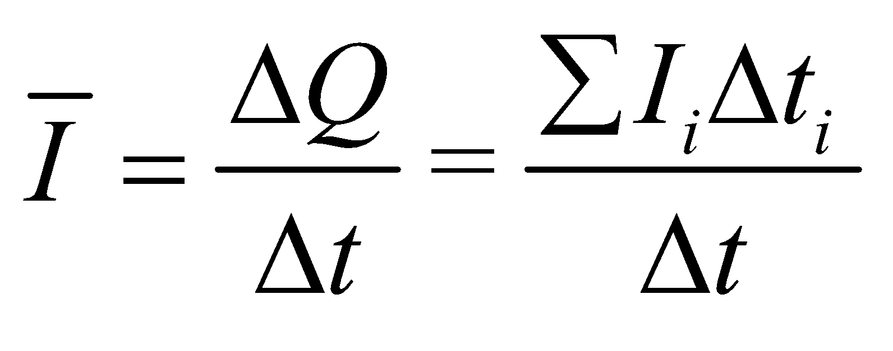

The number of singly-charged ions passing through the channel while current is flowing is 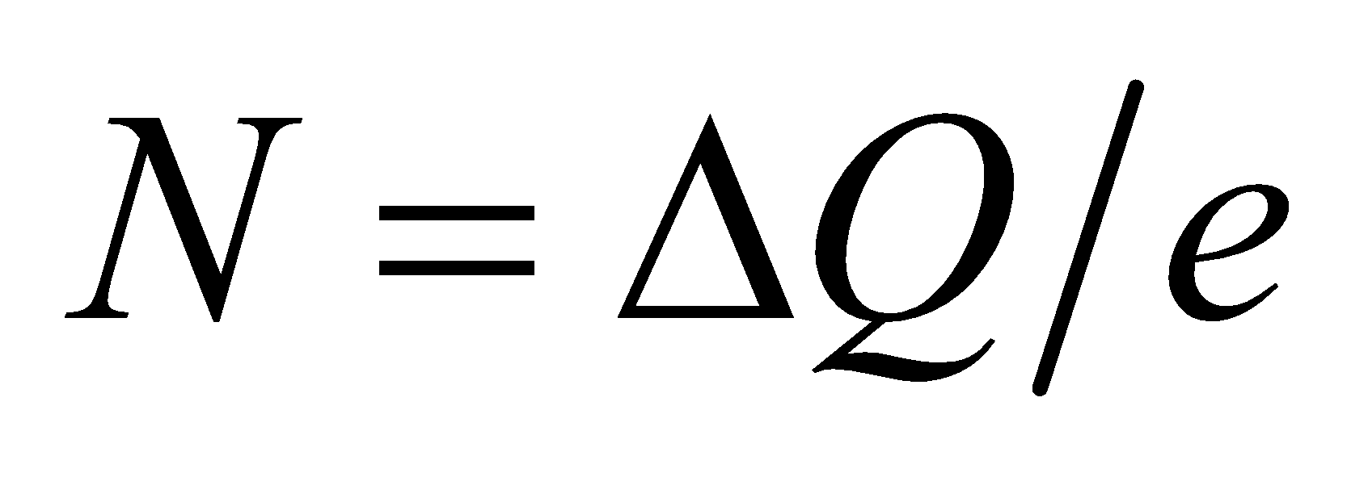.

**Evaluate** **(a)** The average current is

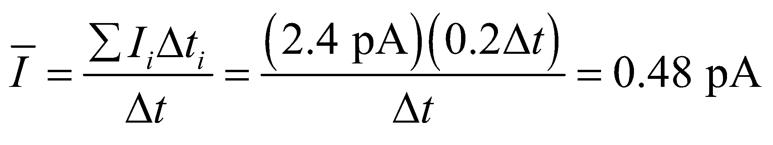

**(b)** The number of ions is

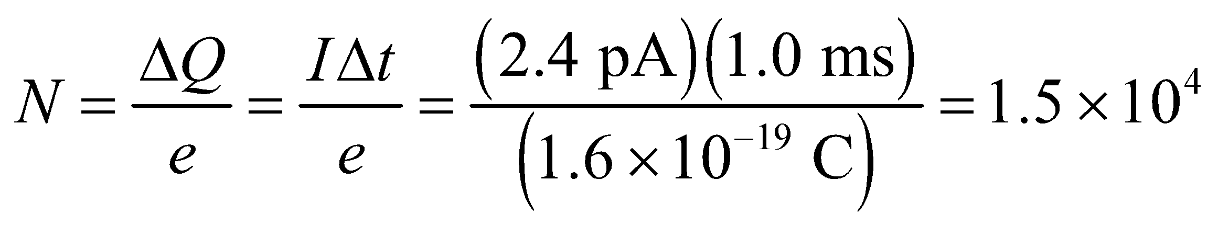

**Assess** This is a very small current. Nevertheless, there exists instrumentation that can measure current down to the pico-ampere range.

**37.** **Interpret** The problem asks us to compare the current density in a light bulb filament and the wire that supplies electricity to the bulb.

**Develop** The current density is just current divided by area. The same amount of current flows through the filament and the wire; only the area changes.

**Evaluate**  (a) For the filament, the current density is:

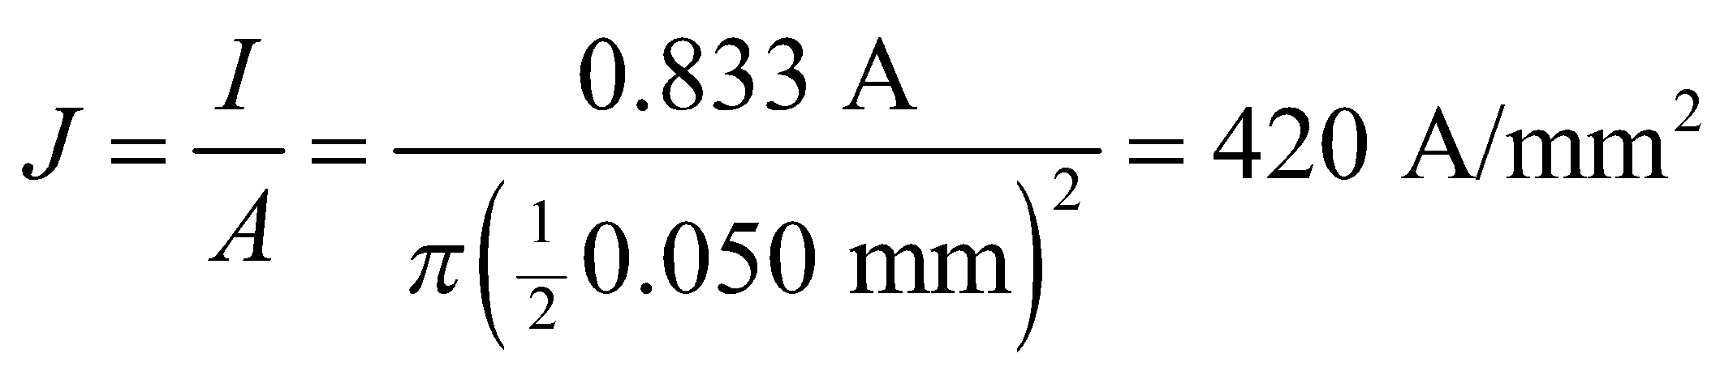

(b) For the 12-gauge wire, the current density is:

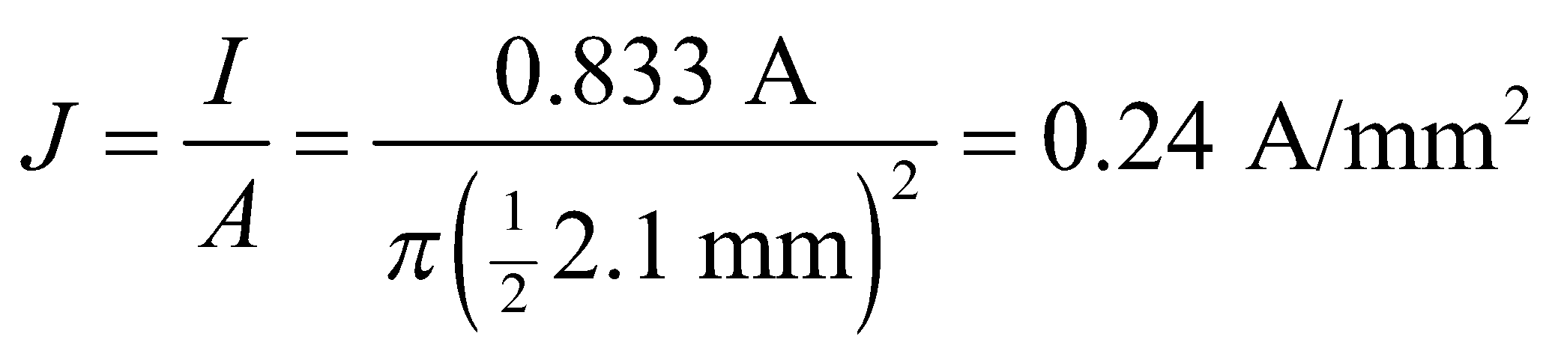

**Assess** The thinner filament has the higher current density, as we would expect.

**38. Interpret** This problem requires us to find the total current in a film, given the current density and the dimensions of the film.

**Develop** Since current density *J* is current per unit area (see Example 24.2), the current is *I* = *J*/*A* (assuming the current density is perpendicular to the cross-sectional area of the film).

**Evaluate** Substituting the values given in the problem statement, we find the current to be



**Assess**The current density 0.68 MA/m2 is approximately the maximum safe current density in typical household wiring.

**39.** **Interpret** This problem involves two wires of different radii, each carrying the same current I. Given the density of charge carriers in each, we are to find the drift speed and the current density between wires.

**Develop** Apply Equation 24.3 to each wire, and take the ratio to find the ratio of the drift speeds, using the fact that I = JA and we are given *A*Al = 4*A*Cu. The same strategy may be used to find the ratio of the current densities.

**Evaluate** Equation 24.3 gives

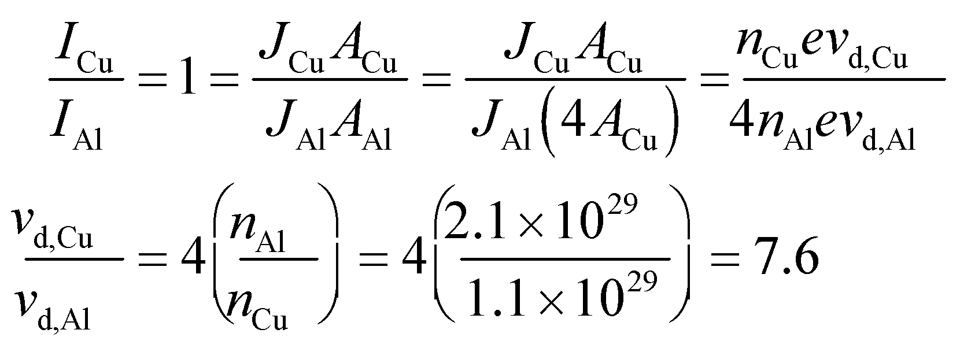

**(b)** The same equation also gives 

**Assess** Thus, the current density is 4 times greater in copper than in aluminum. Which wire would you expect to heat up faster for the same current? This is the fundamental concept of a fuse.

**40. Interpret** In this problem we are given the microscopic parameters for a circuit composed of three components and asked to calculate the drift speed of charge carriers in each component.

**Develop** The drift speed of a charge can be calculated using either Equation 24.2 or Equation 24.3:

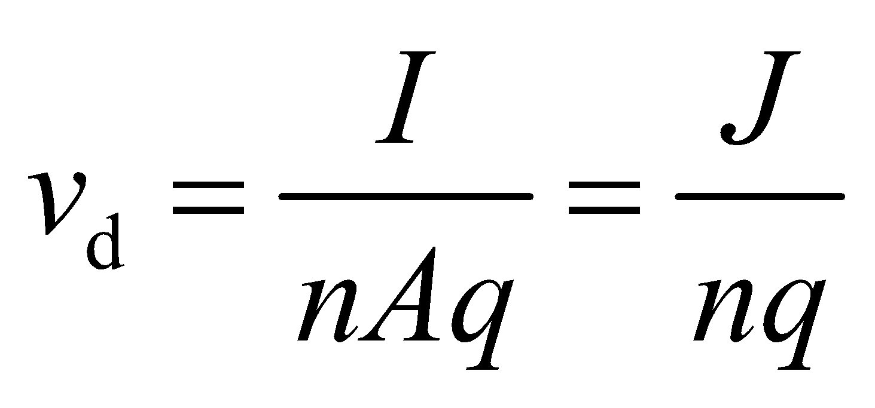

**Evaluate** In the copper wire, the drift speed is

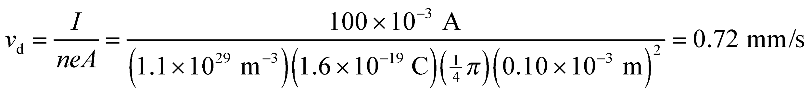

In the solution, the positive and negative ions have equal charge magnitudes, number, and current densities, so 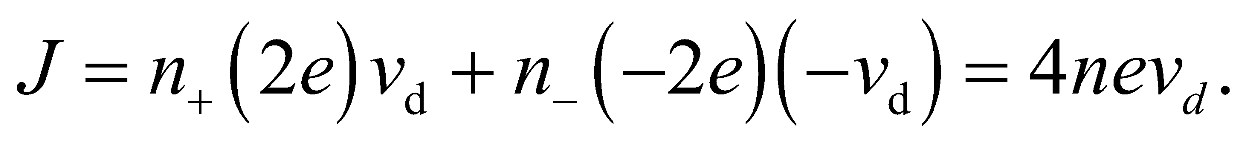 Thus, with uniform current density, *J* = *I*/*A*, the drift speed is

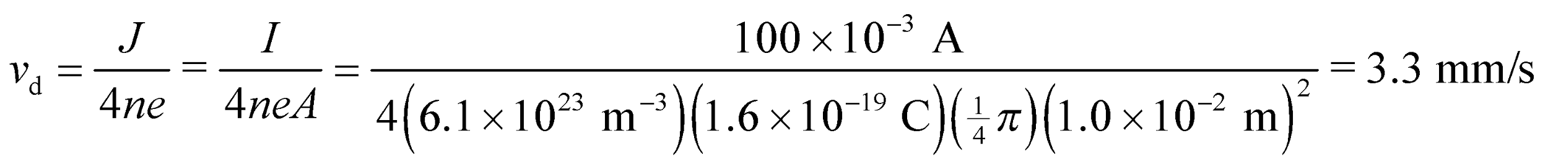

Similarly, in the vacuum tube, we have

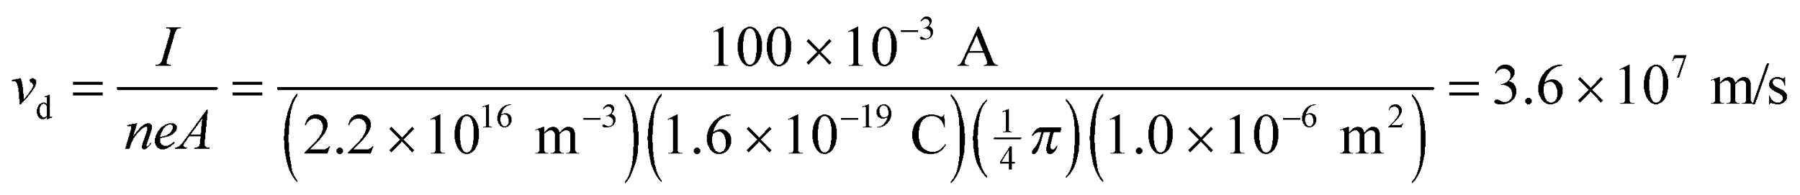

**Assess** Since the drift speed 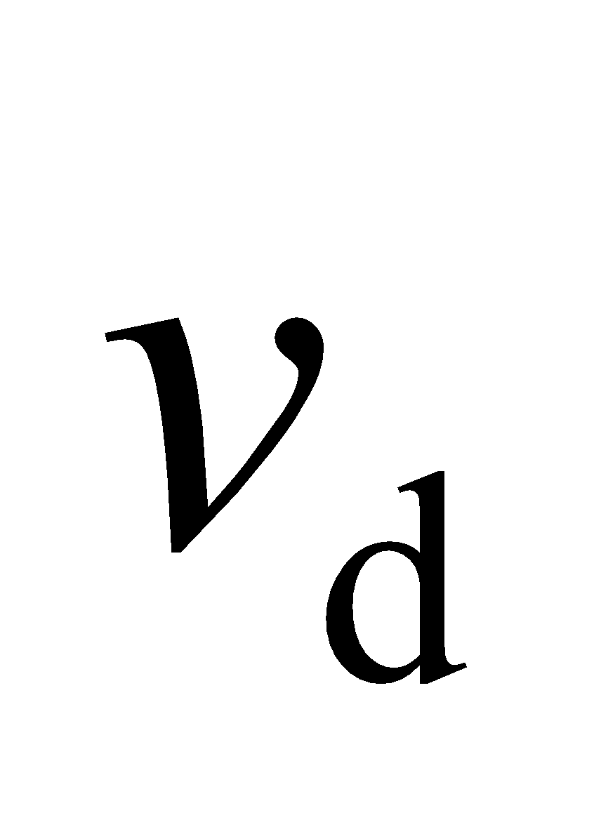 is inversely proportional to the number density *n*, it is greatest in the vacuum tube (by some 10 orders of magnitude!) and smallest in the copper wire.

**41. Interpret** For this problem, we are given the current as a function of time and are asked to find the current of a 5.0-s interval.

**Develop** Integrate Equation 24.1b from t = 0.0 to t = 5.0 s, with I(t) as given in the problem statement.

**Evaluate** Performing the integration gives



**Assess** Because the formula for *I* is in nA, we get nC when we multiply by seconds.

**42. Interpret** This problem involves using the macroscopic version of Ohm’s law to find the current density and the current given the potential difference between two ends of an iron wire.

**Develop** Equation 24.4b, *J* = *E*/*ρ* can be used to find the current density. The corresponding current is simply *I* = *JA* where *A* is the cross sectional area of the wire (*A* = *πd*2/4).

**Evaluate** **(a)** Inserting the values given in the problem statement, we find the current density to be

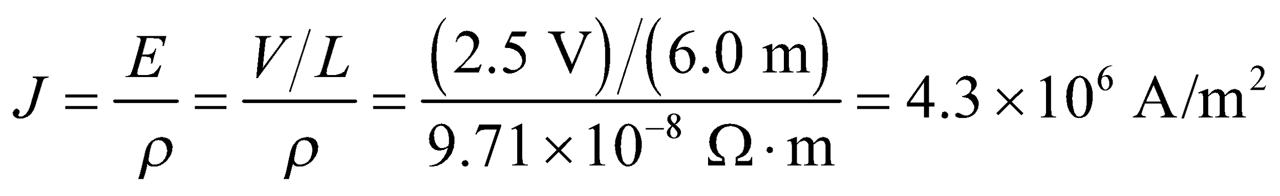

**(b)** The current is 

**Assess** Since the potential difference between the ends of the wire is only 2.5 V, we expect the resistance to be small as well. The resistance of the wire is 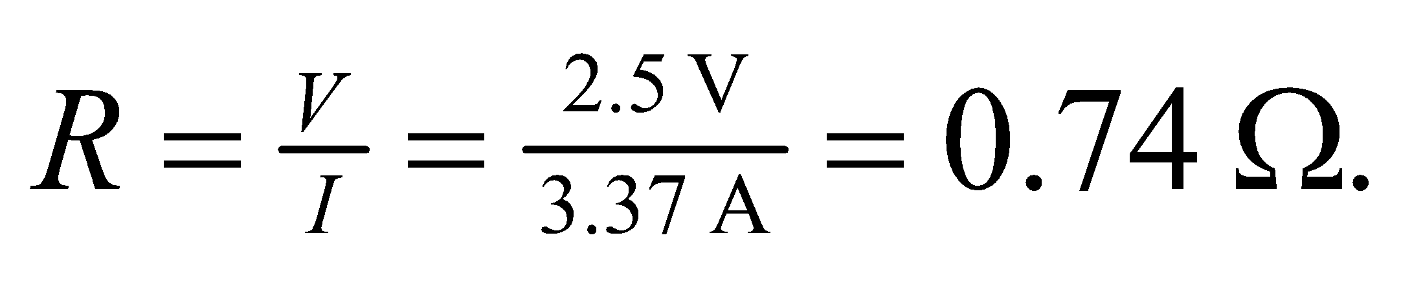 We can also find *R* by using Equation 24.6:

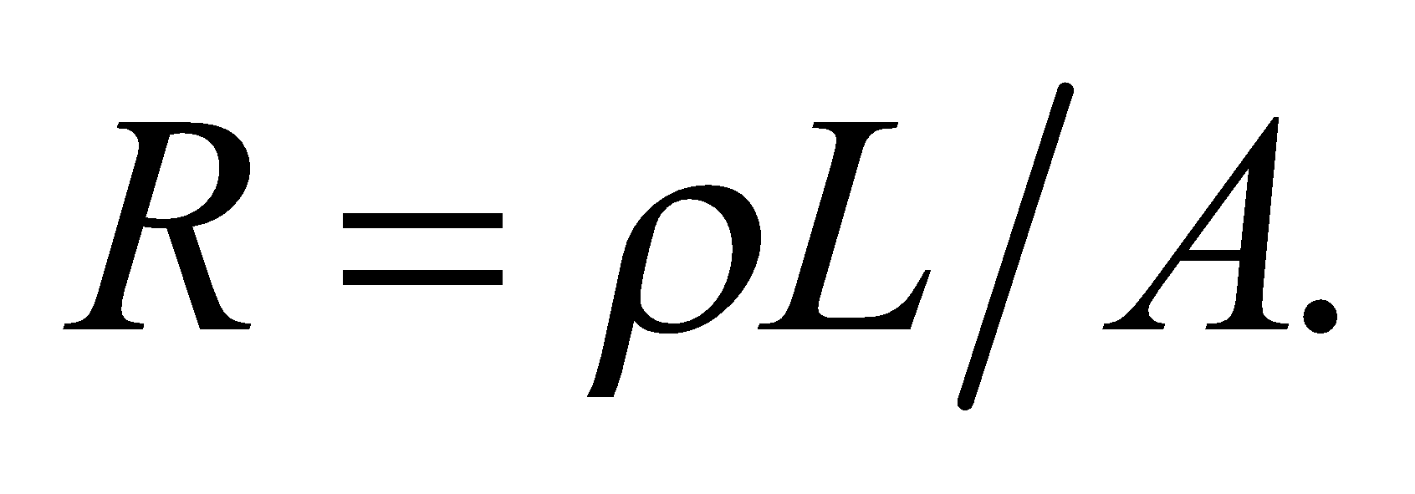

**43.** **Interpret** Given the current and the cross-sectional area of a copper wire, we are to find the current density and the electric field.

**Develop** The current density is *J* = *I*/*A*. From Table 24.1, the resistivity is *ρ* = 1.68 × 10−8 Ω·m, which we can use in Equation 24.4b to find the electric field.

**Evaluate** **(a)** For a wire carrying uniform current density,

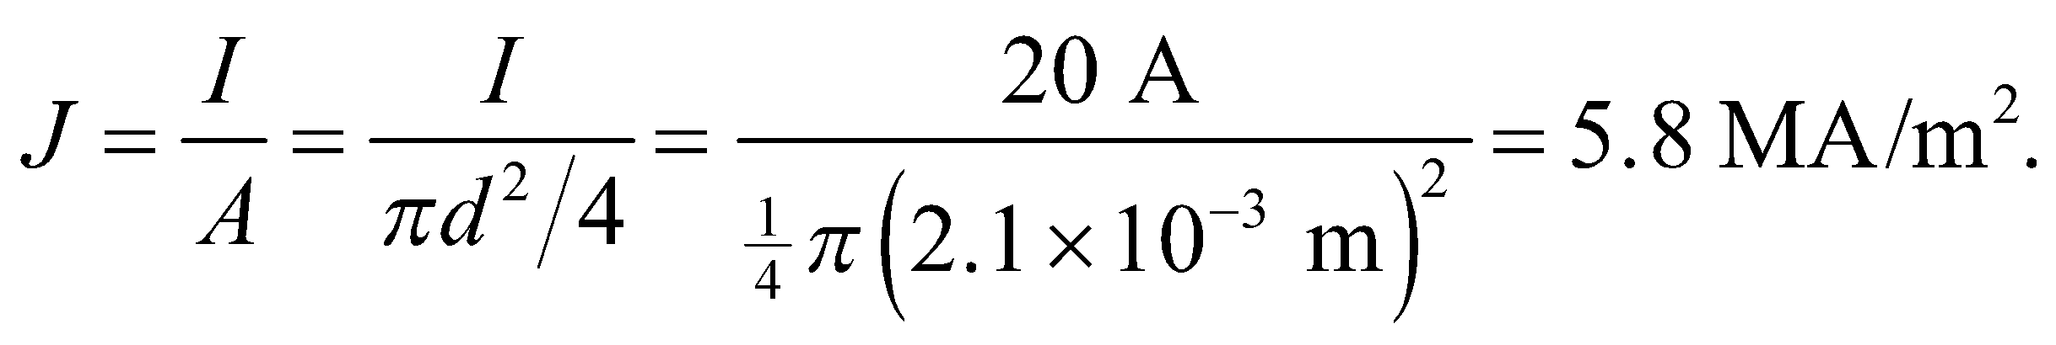

**(b)** The electric field is .

**Assess** This is a rather small electric field, which is not surprising because copper is a good conductor so the charges react quickly in an attempt to cancel out any electric field in the material.

**44. Interpret** In this problem, we are asked to compare the voltages across two wires of equal dimensions with one made of silver and the other of iron, given that they both carry the same current.

**Develop** The resistance of a uniform wire of Ohmic material is given by Equation 24.6: 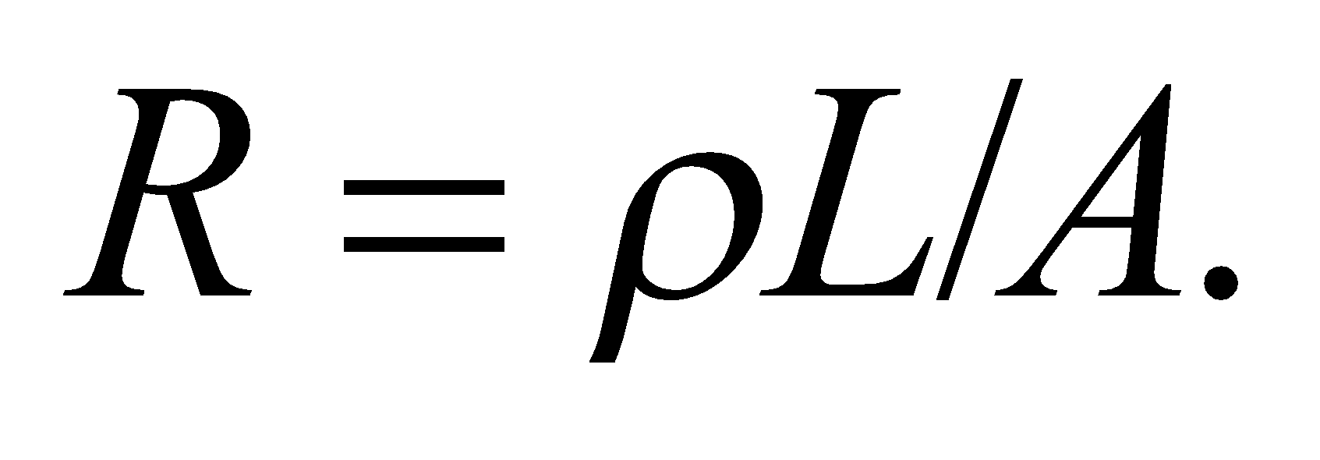 Therefore, for equal *L*, *A*, and *I*, the ratio of the voltages is

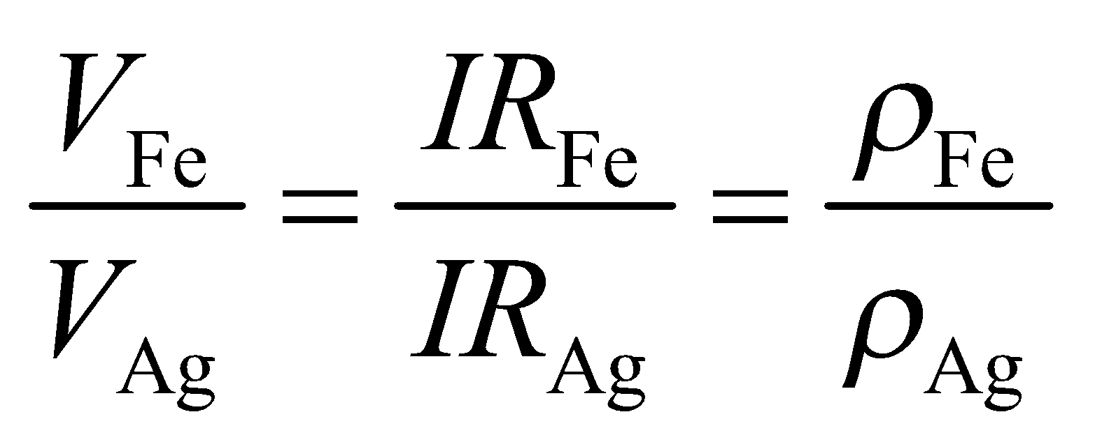

**Evaluate** Using Table 24.1 for resistivities, we obtain

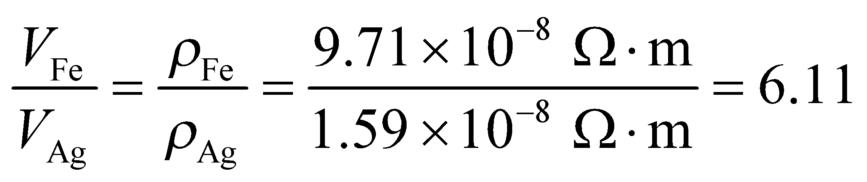

**Assess** Since iron has higher resistivity than silver, for the same length, area, and current, the voltage across the iron wire is higher.

**45.** **Interpret** We are given the dimensions and electrical characteristics of a material (i.e., voltage and current) and are asked to identify the material by matching its resitivity to one from Table 24.1.

**Develop** For a uniform piece of material, Equations 24.5 and 24.6 imply 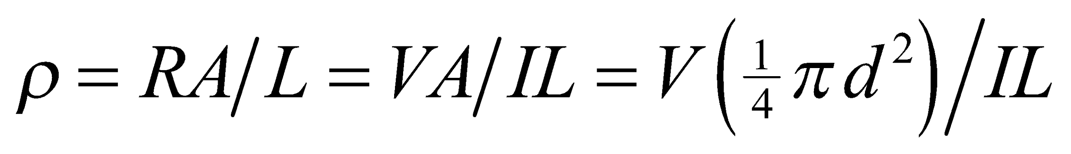.

**Evaluate** Inserting the given quantities gives

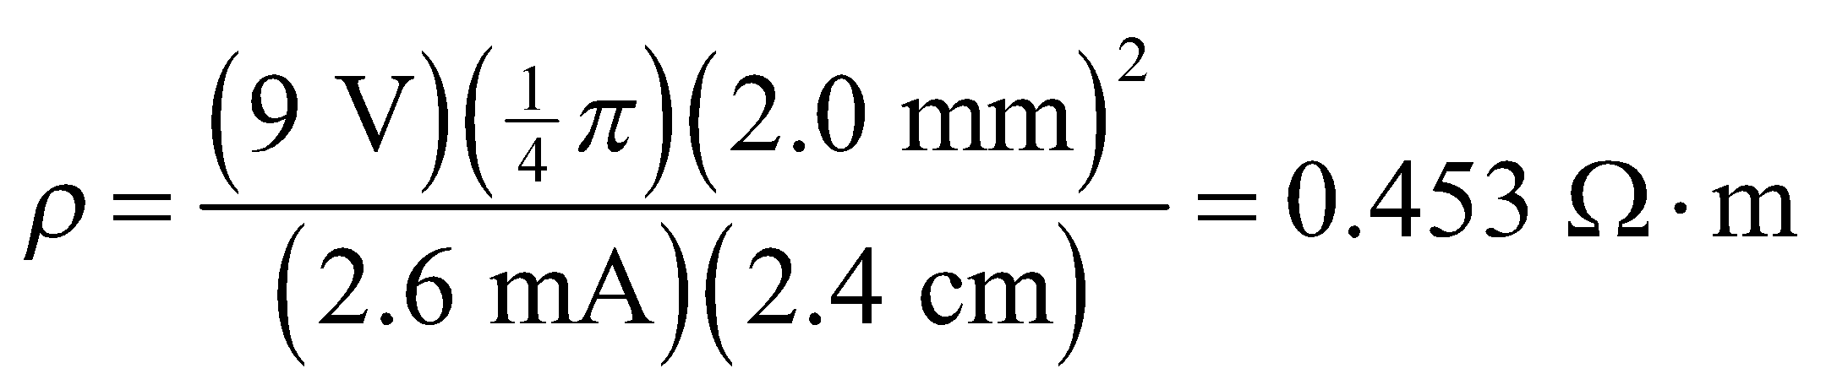

which is closest to the resistivity of germanium (= 0.47 Ω·m) in Table 24.1.

**Assess** This is a useful concept for identifying materials.

**46. Interpret** This problem compares resistances of wires made up of different materials. The microscopic and macroscopic versions of Ohm’s law are involved.

**Develop** The resistance of a uniform wire of Ohmic material is given by Equation 24.6:. Therefore, the resistance per unit length is

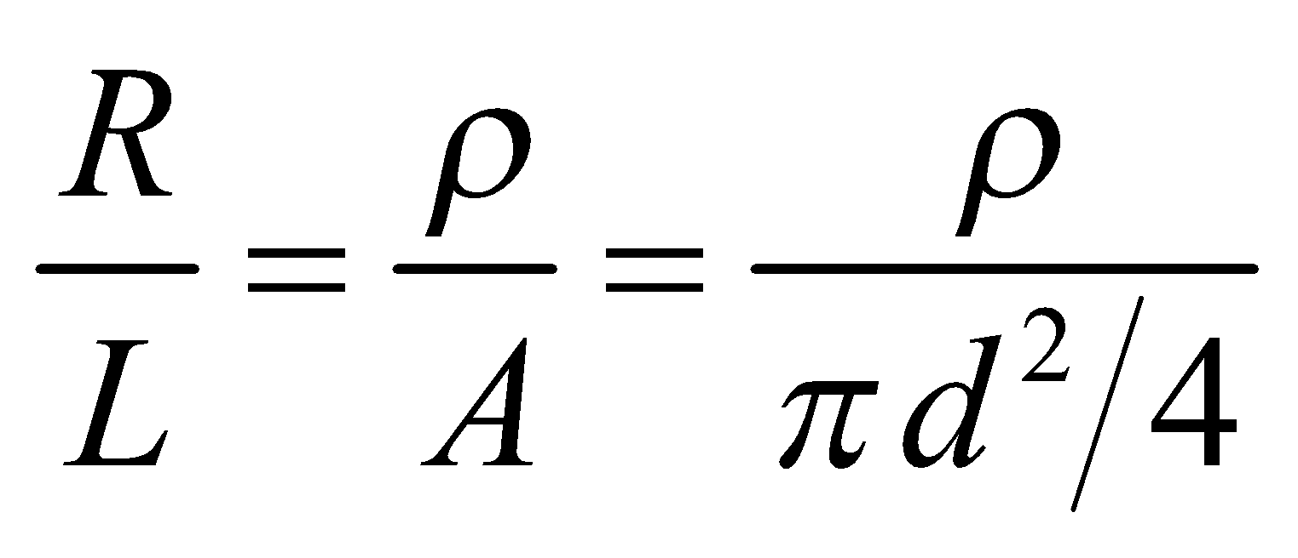

**Evaluate** Equal resistance per unit length for copper and aluminum wires imply that

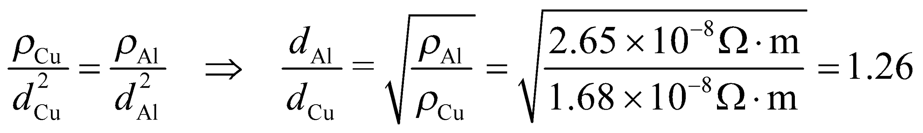

where we have used Table 24.1 for resistivities.

**Assess** Since 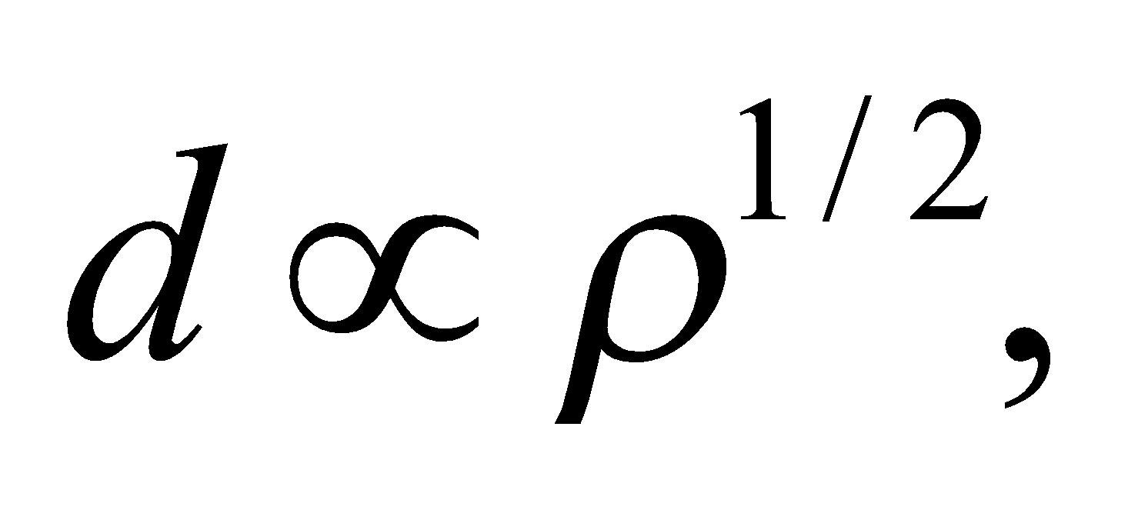 a higher resistivity means a larger diameter wire.

**47.** **Interpret** You need to specify the maximum length of an extension cord for a power saw. The cord has resistance that will reduce the voltage difference across the power saw's motor.

**Develop** Let's define 4 points along the current's path, see figure below. You're told that the voltage across the outlet, 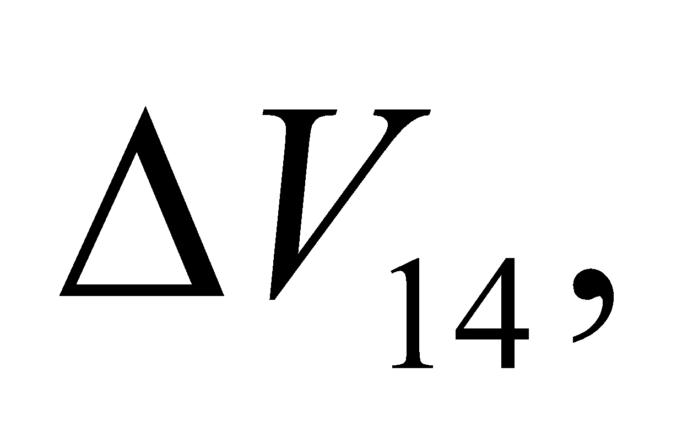 is 120 V, and the voltage across the motor, 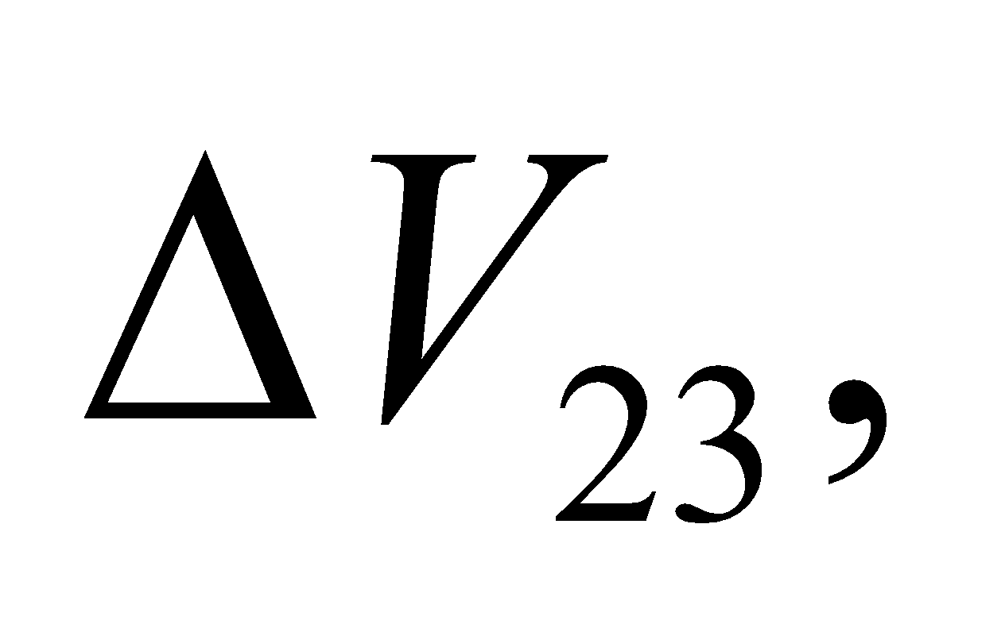 is 115 V.



The copper wires in the extension cord will produce a voltage drop due to their resistance: 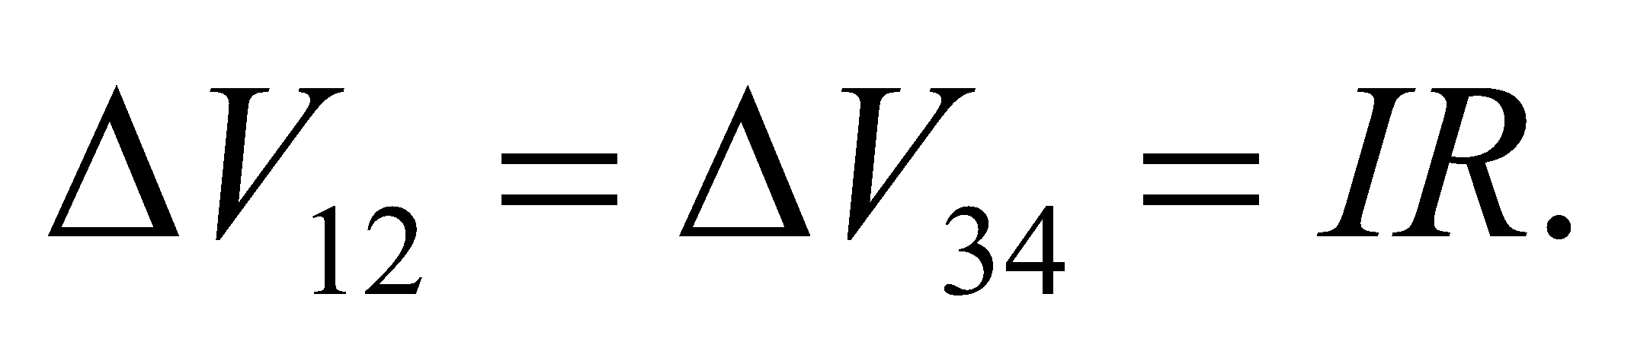 The resistance is given by Equation 24.6: 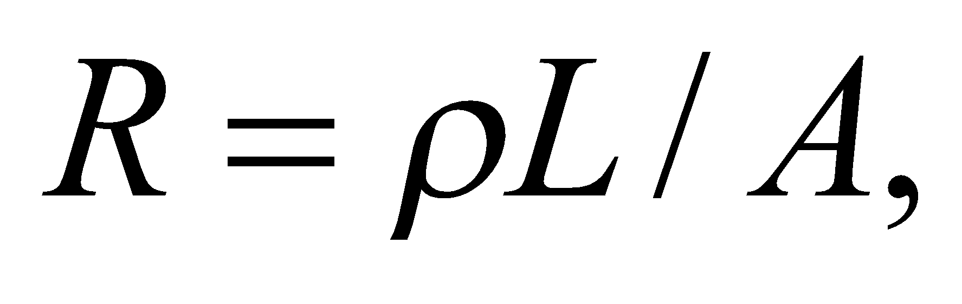where 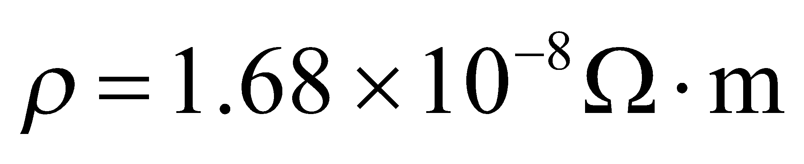 for copper, *A* is the area of the 1-mm-wide wire, and *L* is the length of the cord. For the voltage differences to be consistent with each other:



Since the saw draws 7 A, the resistance in one direction of the extension cord is 0.357 Ω.

**Evaluate** Solving for the length of the cord, we get:

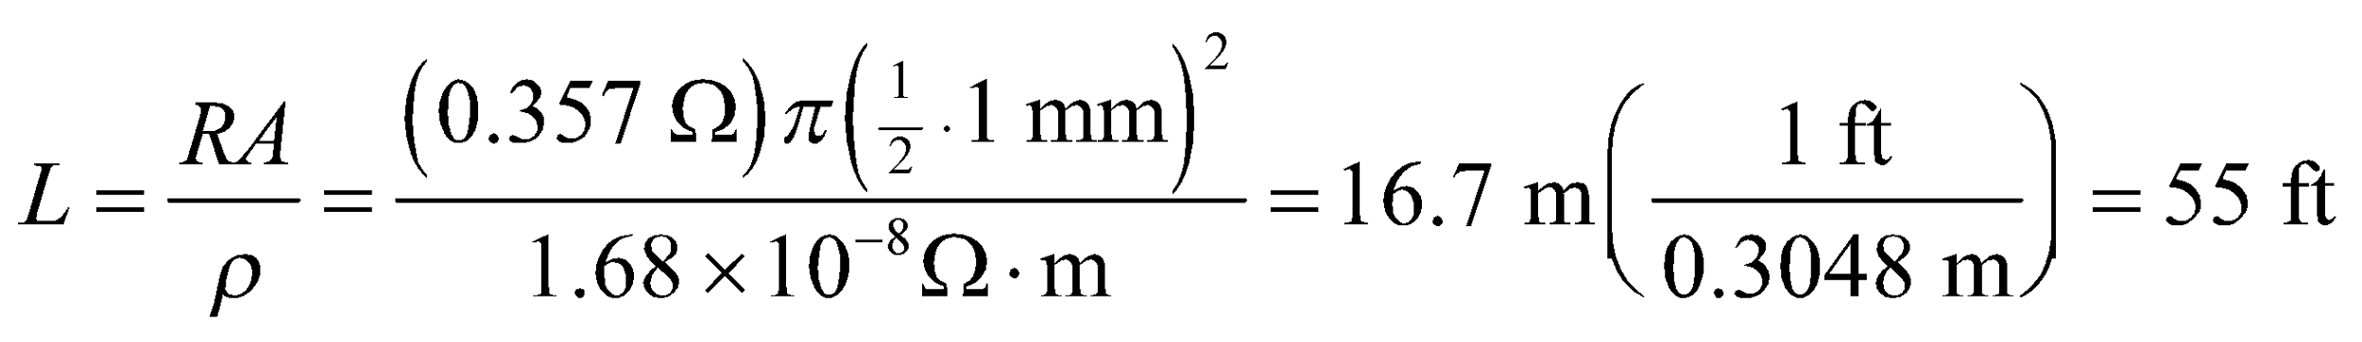

Because the cords come in increments of 25 ft, the maximum extension cord one can use with the saw is 50 ft.

**Assess** We generally tend to ignore the resistance in the wires that carry current to an electric device. But for an extension cord, the long length of the wires means their resistance will have to be accounted for.

**48.** **Interpret** We're asked to determine how much electricity flows out of a heart pacemaker.

**Develop** The pacemaker provides a voltage across the heart for a short pulse. The current flowing during a pulse can be found with Ohm's law: 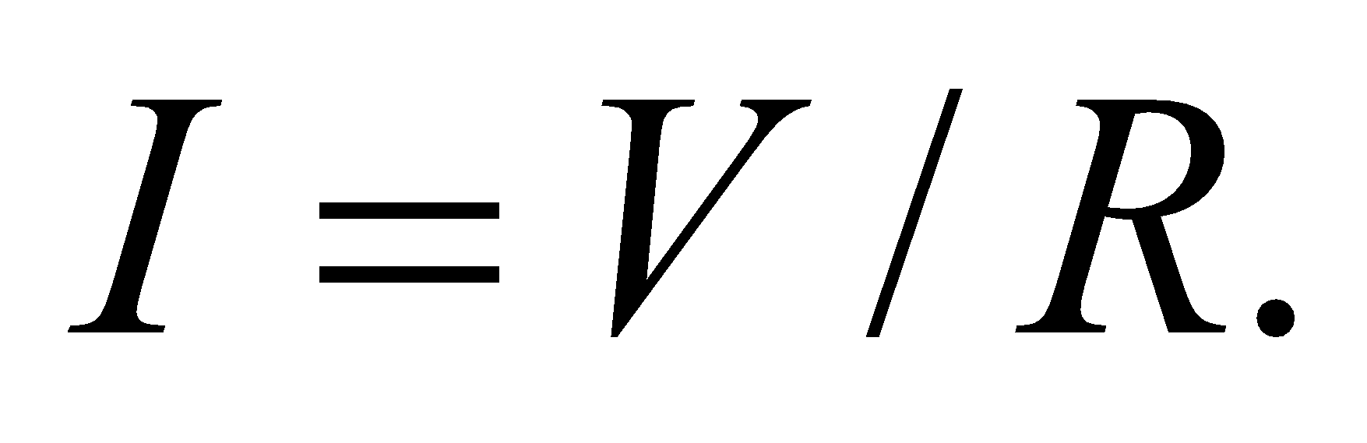The power delivered by a pulse is 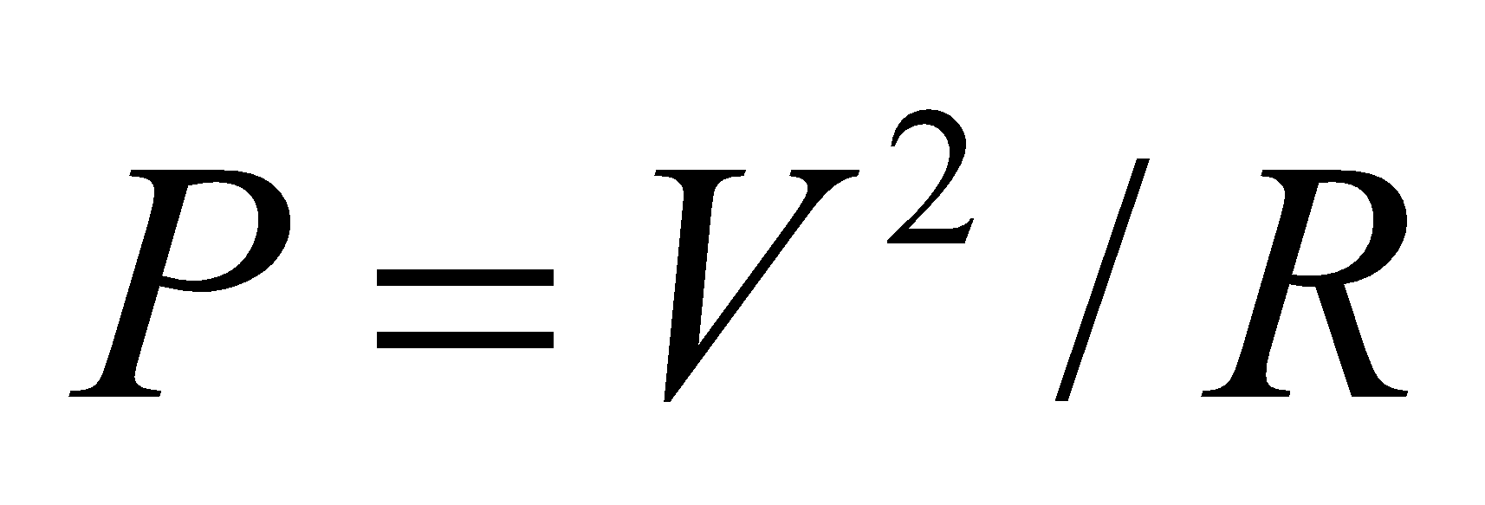 (Equation 24.8b), which means the energy delivered is just 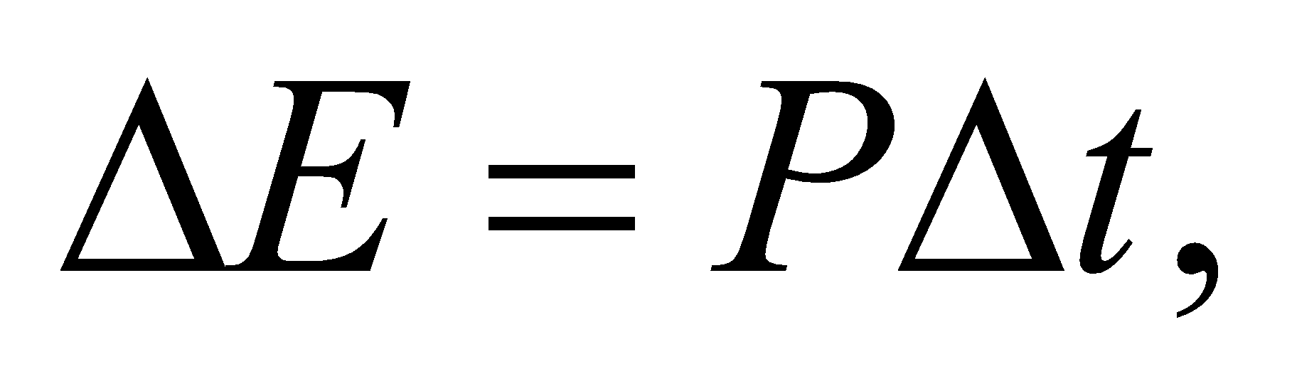where 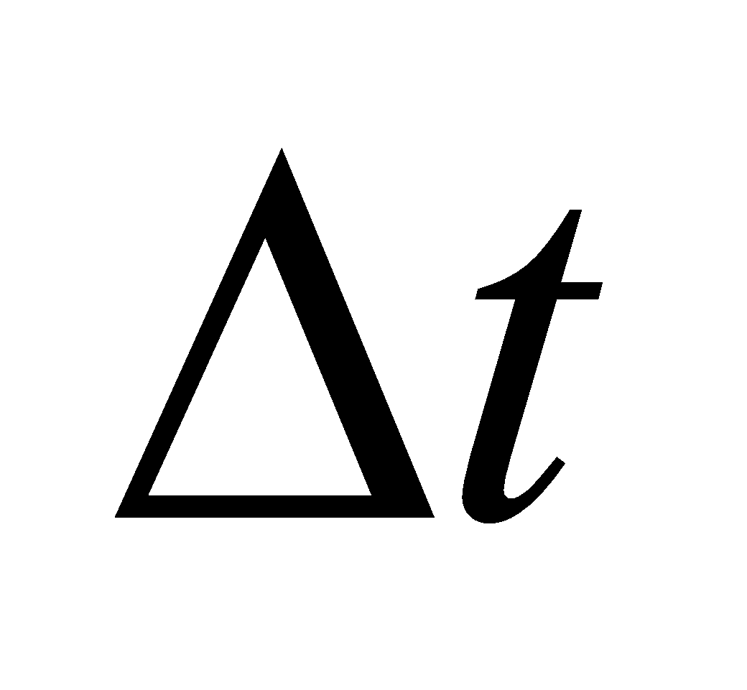 is the length of a pulse.

**Evaluate**  (a) The current flowing from the pacemaker is

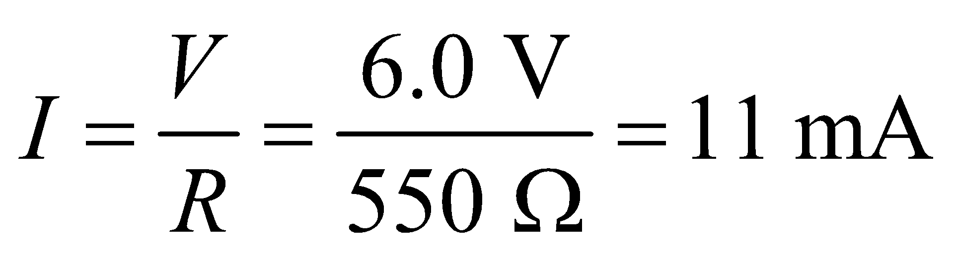

(b) The energy delivered over a single pulse is

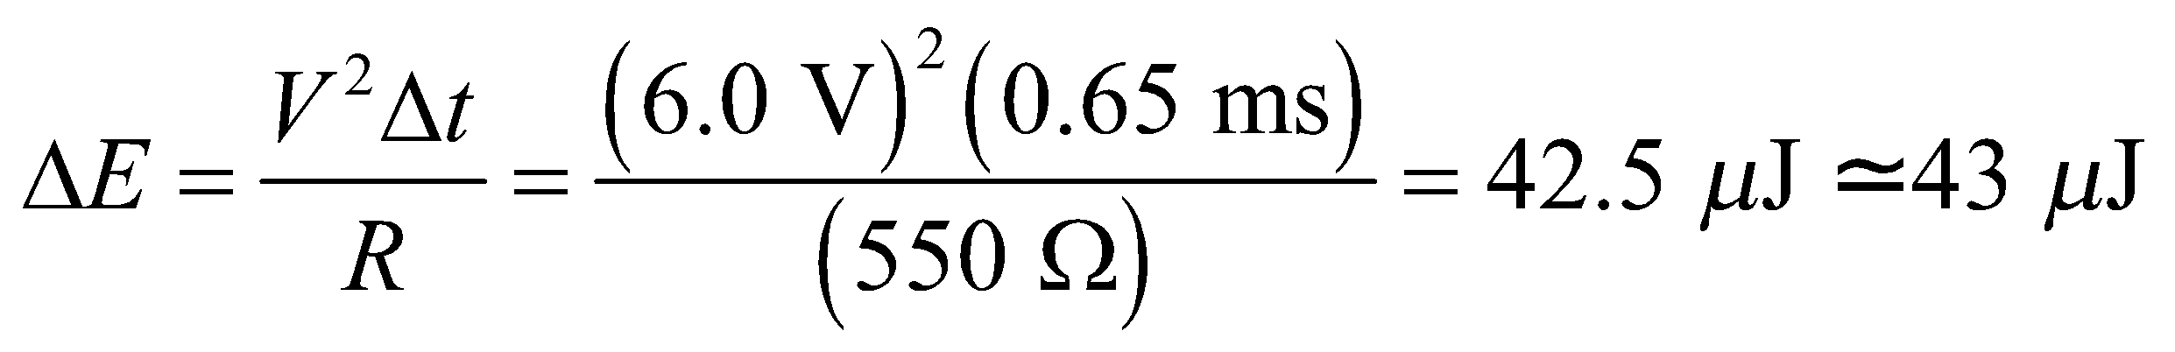

(c) For the average power, we take the energy per pulse and multiply it by the frequency of pulses, i.e. 72 per minute:

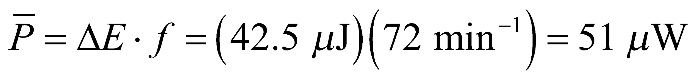

**Assess** The average power delivered to the heart is very small; it is more than 1000 times smaller than the power during a single pulse 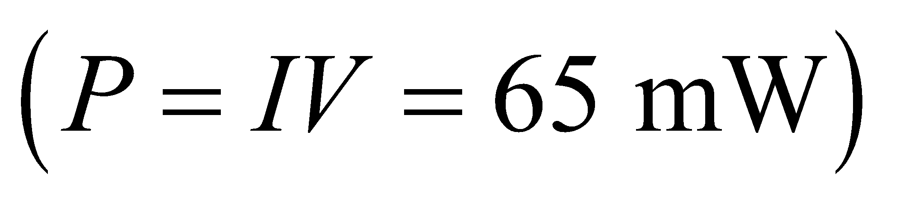.

**49.** **Interpret** We are to find the resistance between opposing faces of a rectangular block of iron, given that the opposing faces are all equipotentials (i.e., the electric potential is the same across any given pair of faces).

**Develop** If opposite faces are equipotentials, the current density is uniform over any parallel cross-section. In this case, Equation 24.6 gives 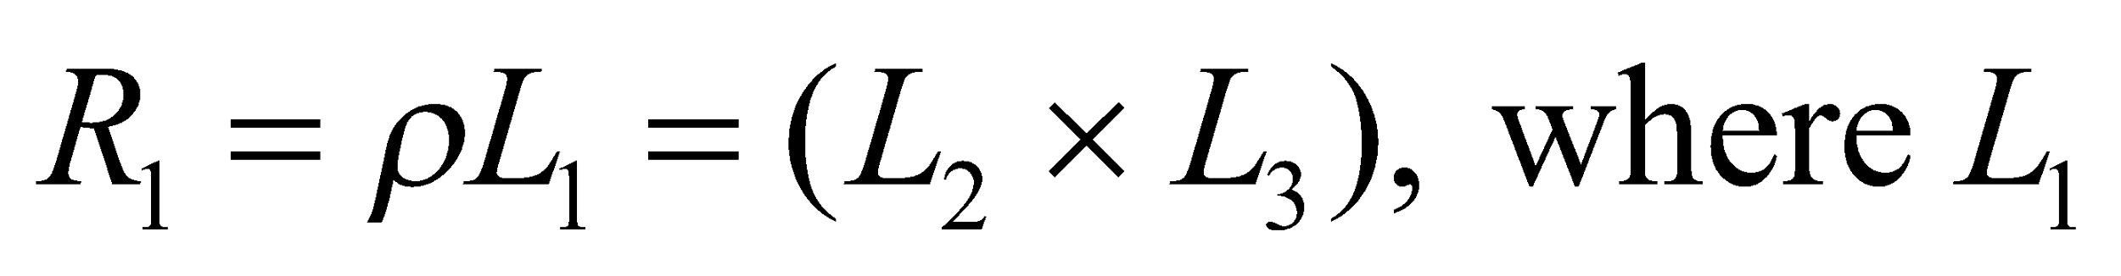 is the length in the direction of the potential drop and 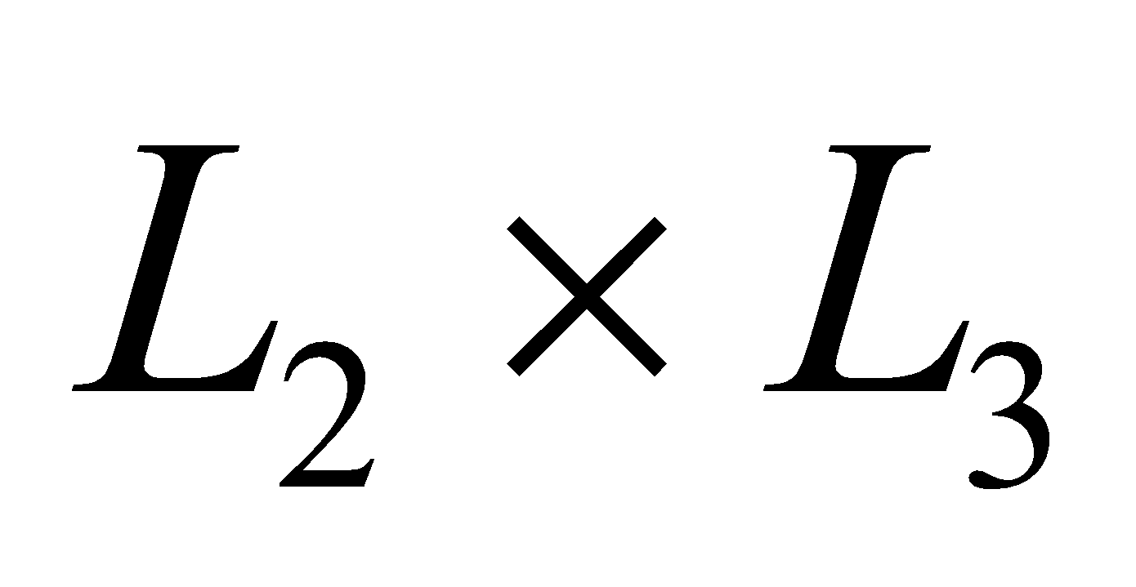 is the cross-sectional area of an equipotential face.

**Evaluate** For  and permutations thereof, we find  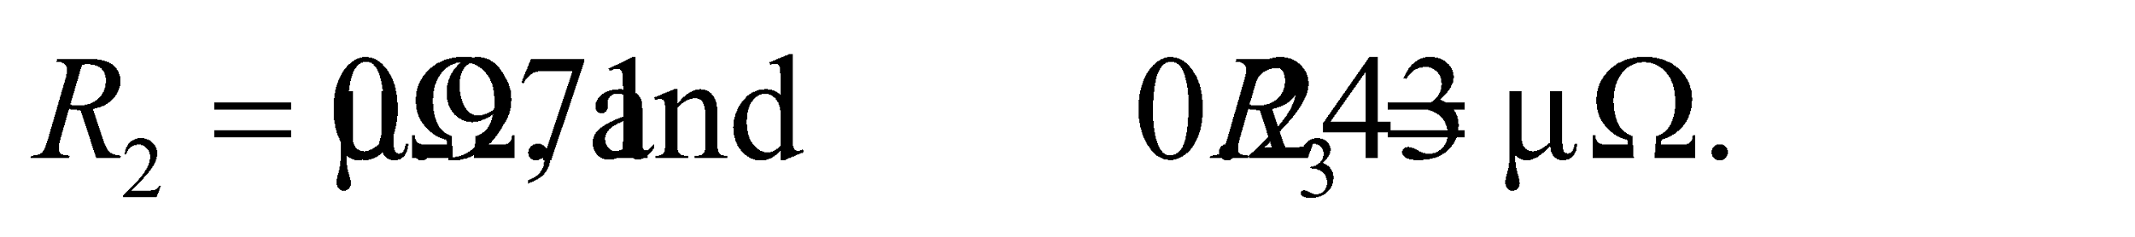

**Assess** The greatest resistance is greatest for current traversing the greatest length per unit area.

**50.** **Interpret** You want to check if your car battery is working properly by measuring the resistance between the battery and the starter.

**Develop** By Ohm's law, the resistance is the voltage divided by the current.

**Evaluate** From your measurements,

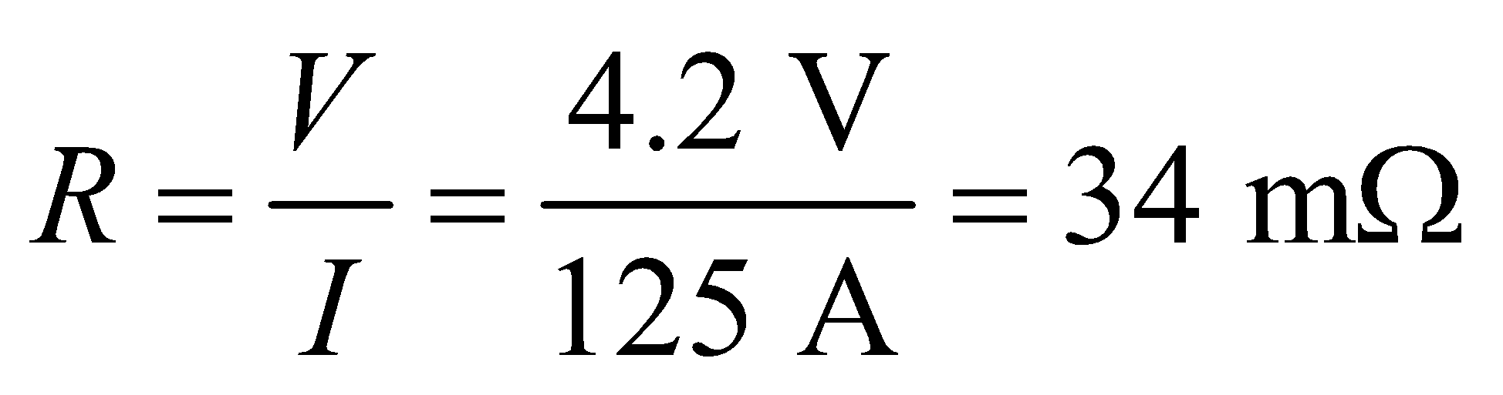

The resistance is far above normal.

**Assess** Corrosion is due to chemical reactions that change the metals at the contacts on the battery. Metal compounds (such as metal sulfates and metal oxides) are typically poor conductors, so the resistance in the battery connections increases.

**51. Interpret** This problem involves the dependence of resistance and power dissipation on the geometry of the material. We are to find the diameters of resistors given their length is the same and the same voltage is applied across both.

**Develop** Equation 24.6, 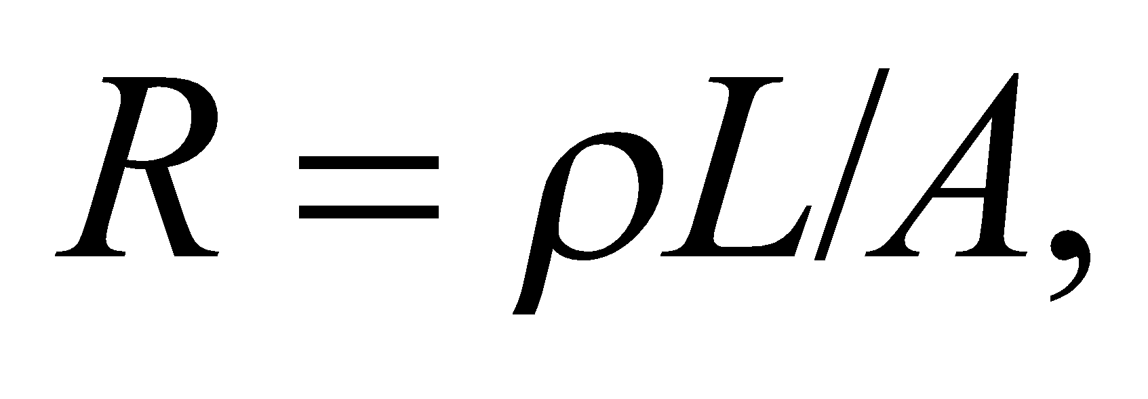 relates the resistance of a material to its geometry (length and cross-sectional area). With a fixed voltage, the power dissipated is given by Equation 24.8b, 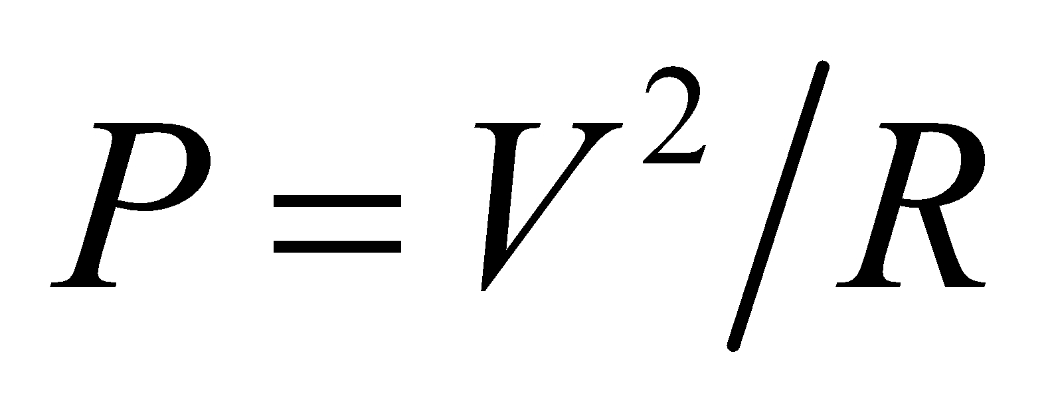. Thus, we see that at the same voltage, the ratio of the power dissipated is the inverse of the ratio of the resistances, which in turn, goes as the inverse of the square of the ratio of the diameters:

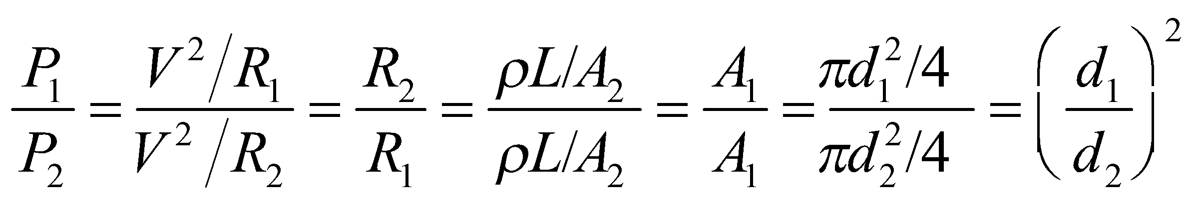

**Evaluate** From the equation above, we see that if 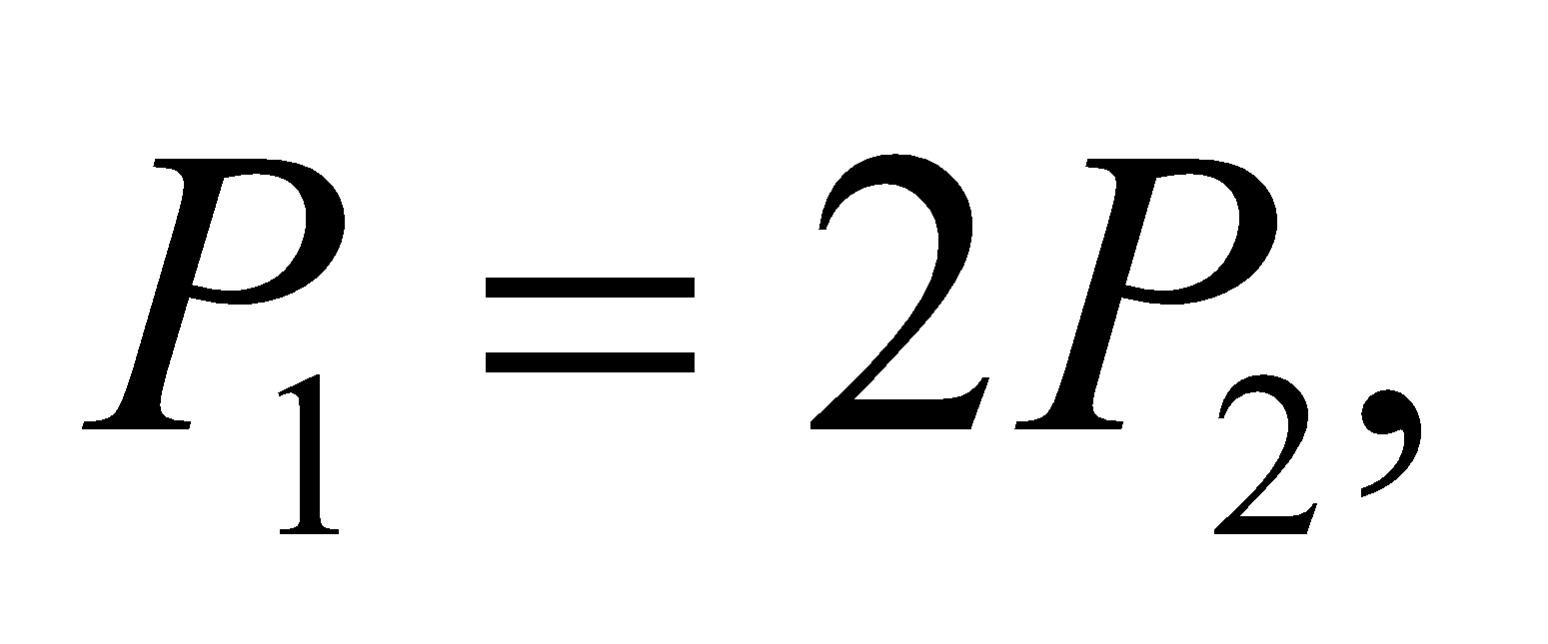 then 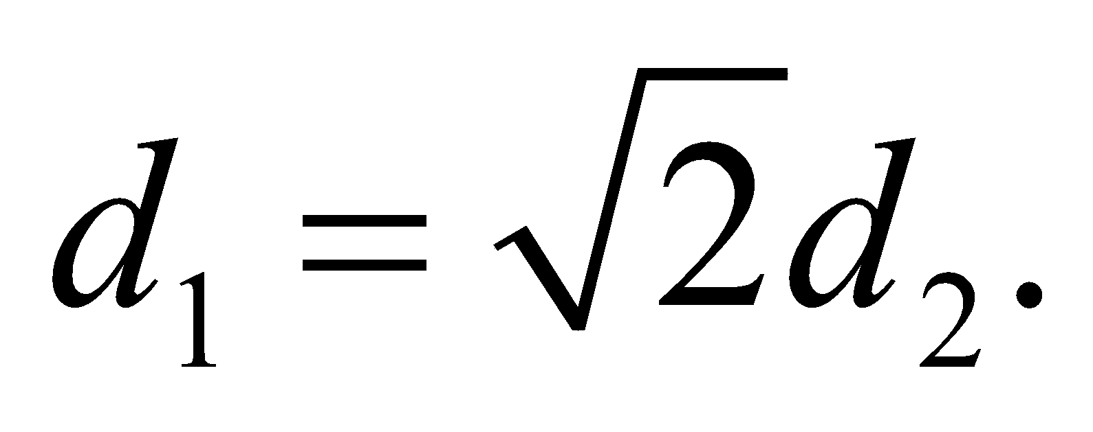

**Assess** Our result shows that power dissipated increases with the area, or the square of the diameter,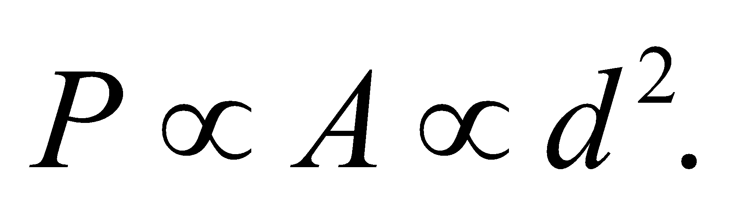

**52.** **Interpret** This problem concerns the power loss along a wire that supplies electric power to a high-speed train.

**Develop** The amount of current needed to meet the train's power needs is given by Equation 24.7, 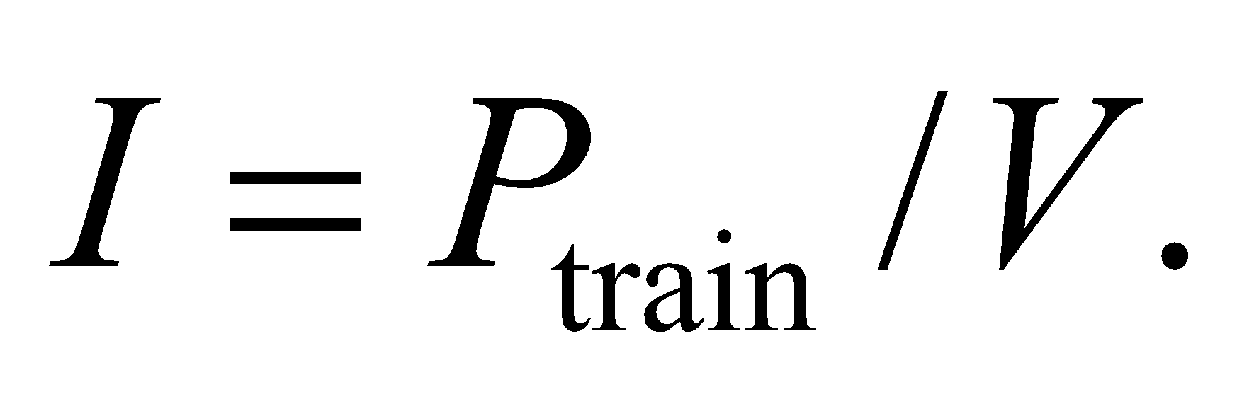 We'll assume that no matter how far the train has gone, the voltage is always 25 kV between the wire and the track. But the farther the train goes, the farther the current travels down the wire. This will lead to power loss given by Equation 24.8a, 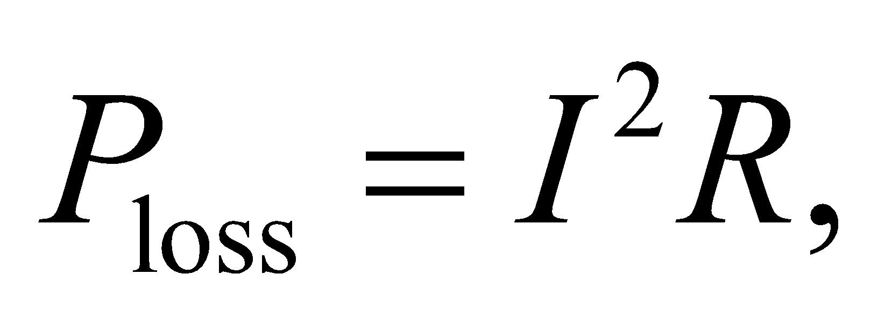where the resistance increases linearly with distance: 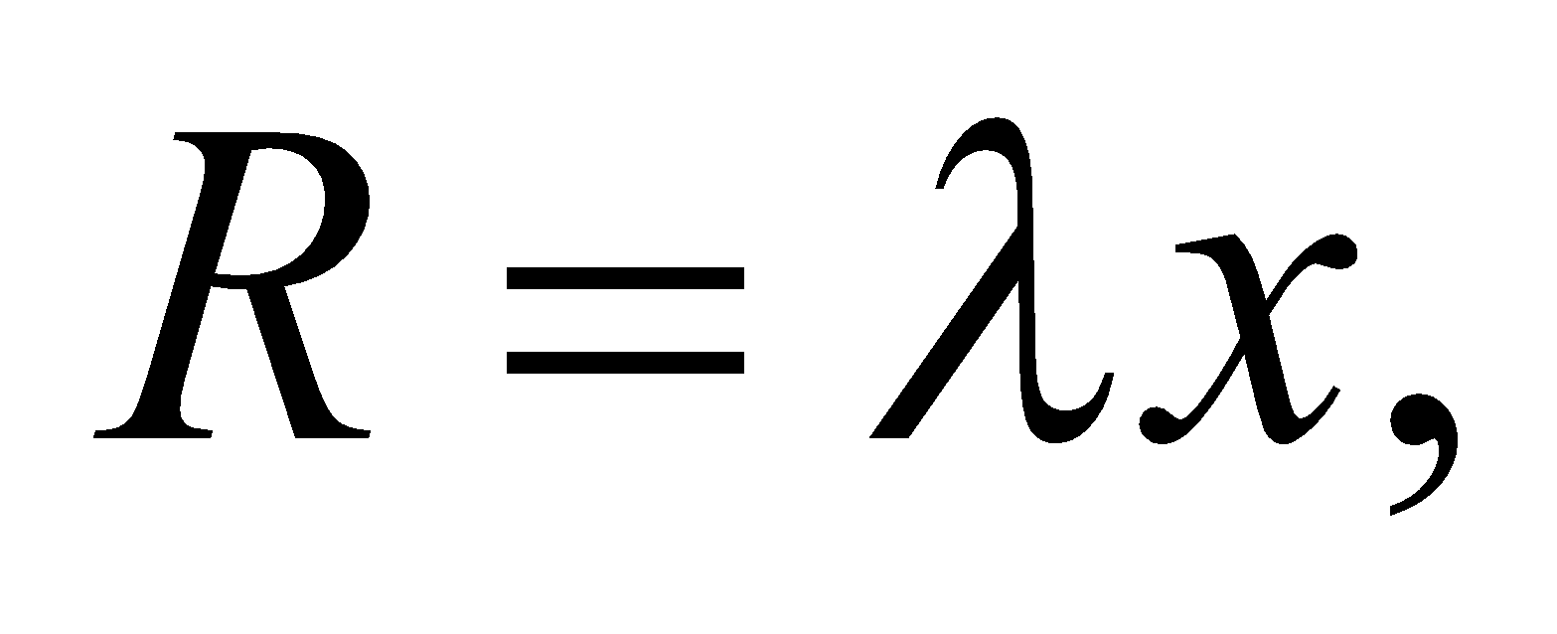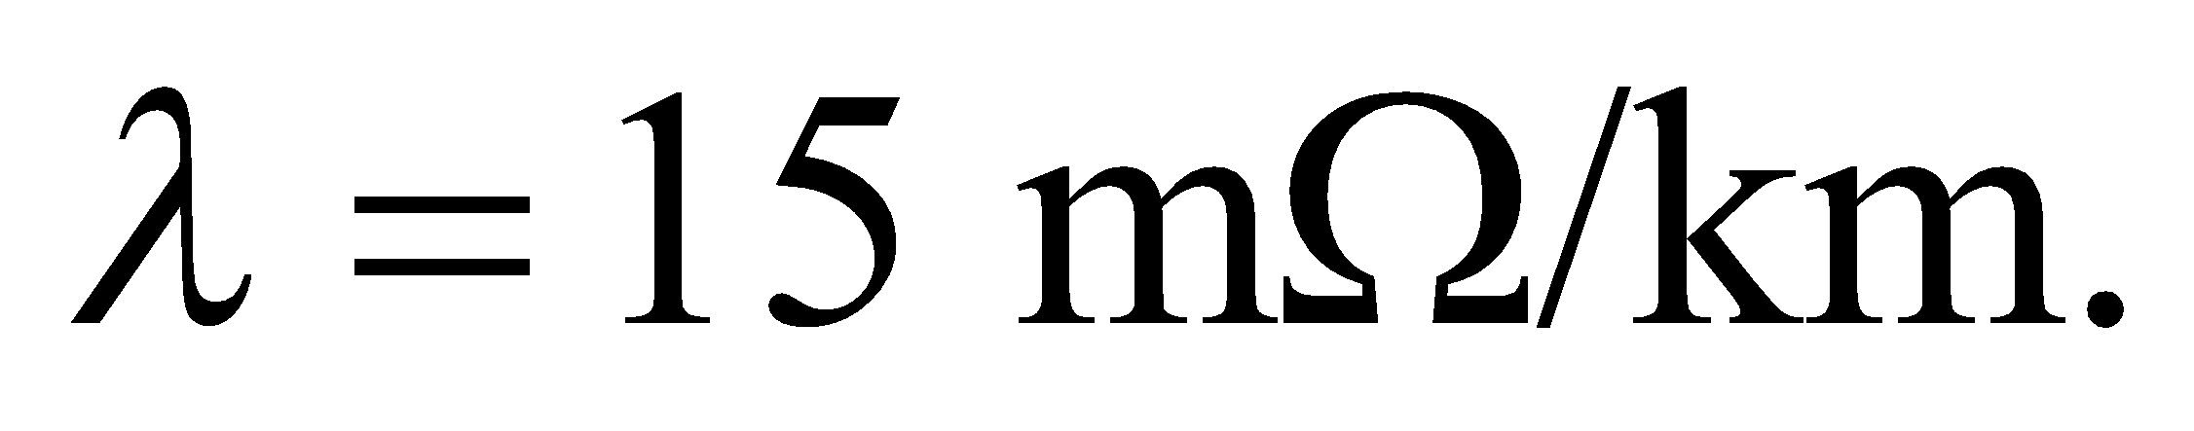

**Evaluate** To ensure that 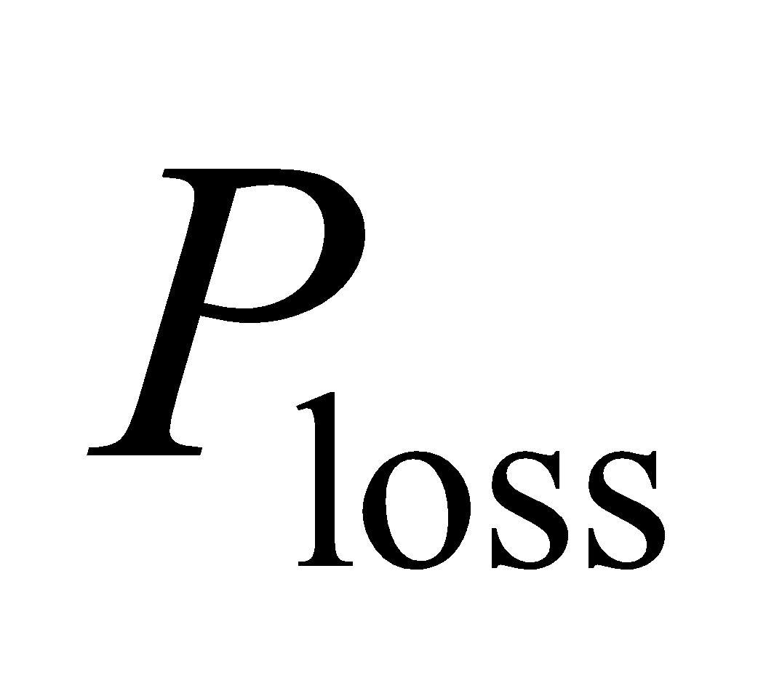 is less than 3% of the train's power use, the distance traveled must be less than

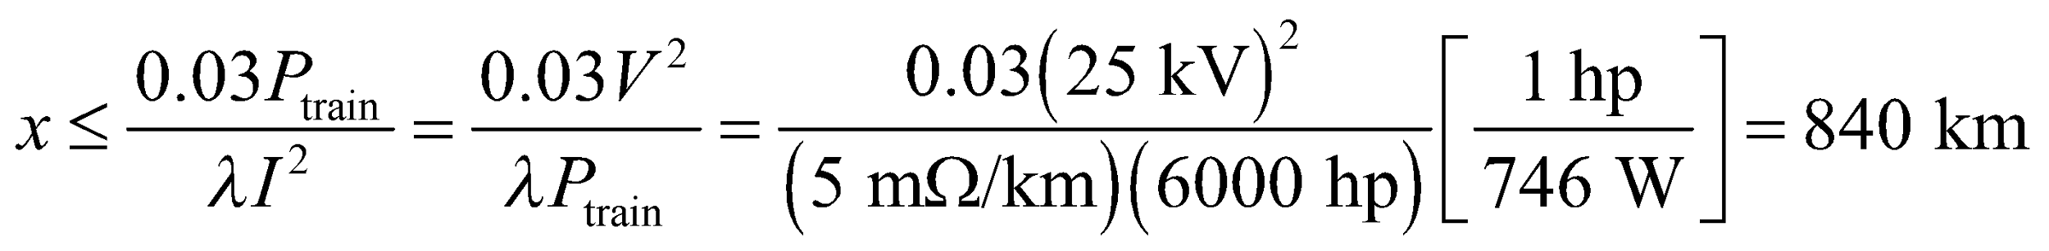

**Assess** This seems like a reasonable distance for a train to travel. Beyond this distance, the train can presumably obtain its electricity from a different power plant that might be closer. Note that the maximum distance is proportional to the voltage squared. This implies that power loss can be reduced by increasing the potential difference between the wire and the track.

**53. Interpret** This problem is about using electric power to do mechanical work.

**Develop** If there are no losses, the electrical power supplied to the motor, 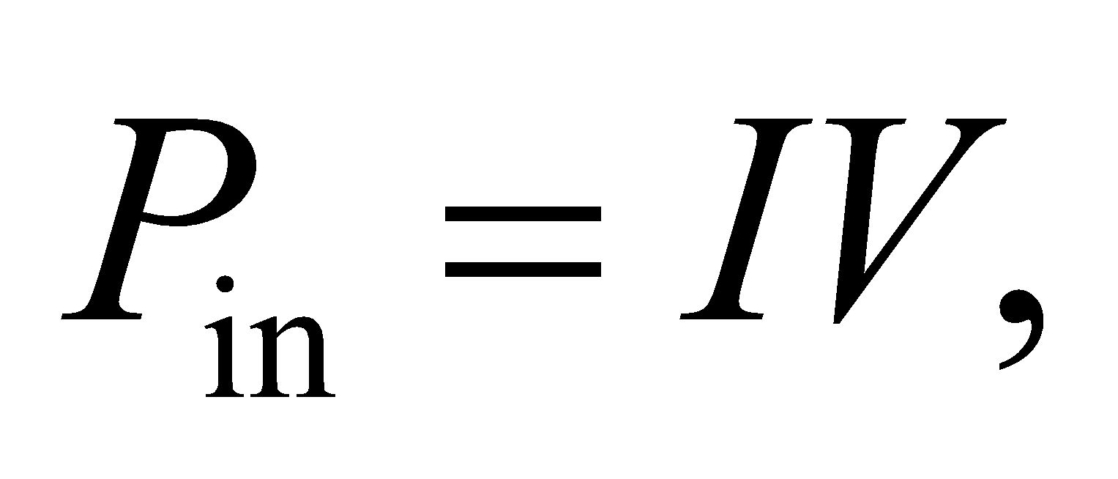 must equal the mechanical power expended lifting the weight, 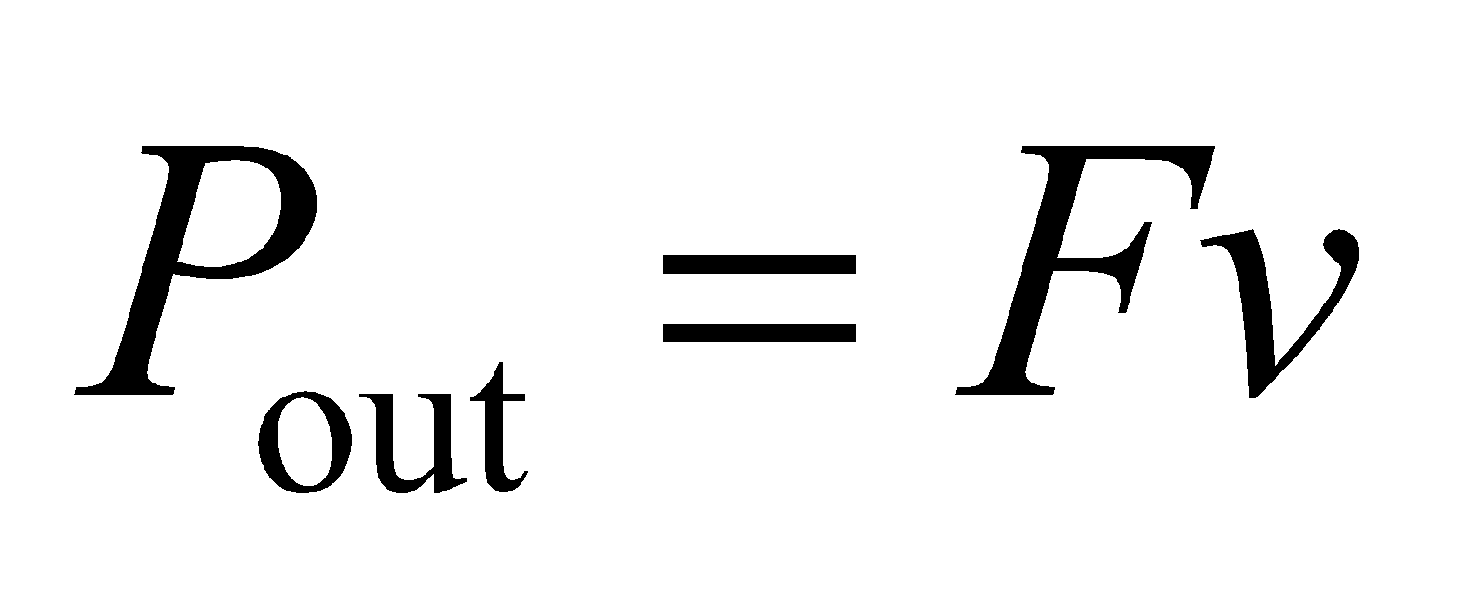 (see Equation 6.19).

**Evaluate** With 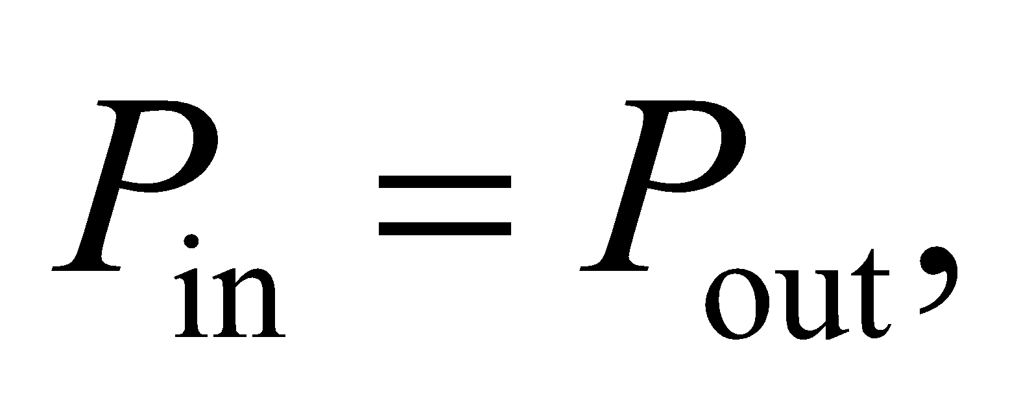 the current is

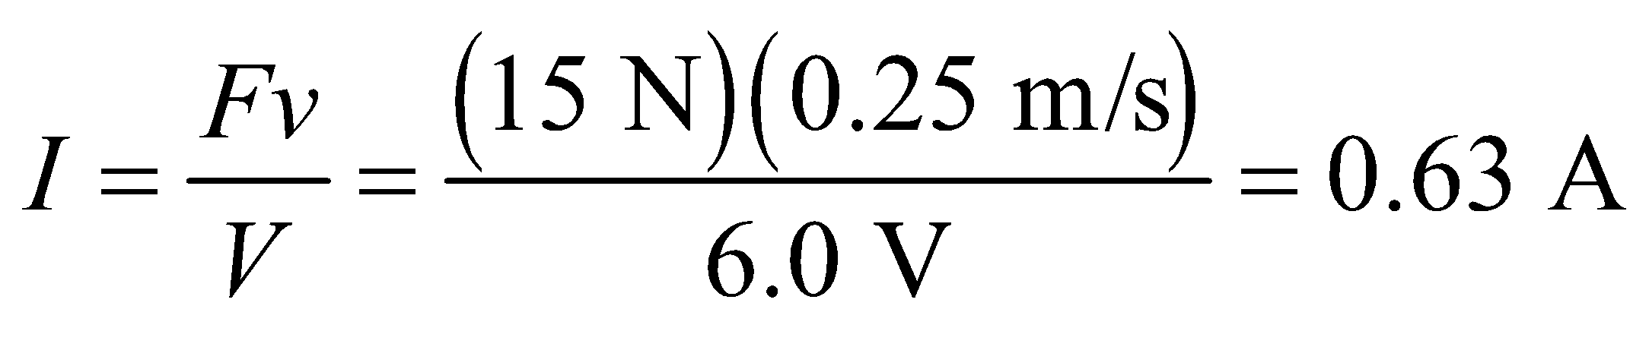

**Assess** In reality, the motor will not be 100% efficient. So the current drawn will be somewhat higher than 0.63 A.

**54.** **Interpret** This problem involves a circuit with a given resistance and voltage and for which we are to find the current and the fraction of power lost over the circuit.

**Develop** To find the current, apply Equation 24.7, Pout = *IV*. The fraction of power lost is that due to the resistance, *P*loss = *I*2*R* (Equation 24.8a) divided by the power supplied Pout.

**Evaluate** (**a**) Inserting the given quantities gives 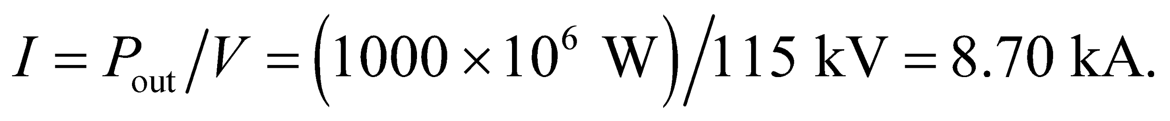

(**b**) The power loss in the transmission line is  which is 151/1000 × 100% = 15.1% of the power supplied.

**Assess** The power lost in transmission is quite significant.

**55.** **Interpret** You are looking to save money on utility costs by comparing copper to aluminum wires.

**Develop** You're given the specifications for the resistance per unit length along the power line. From Equation 24.6: 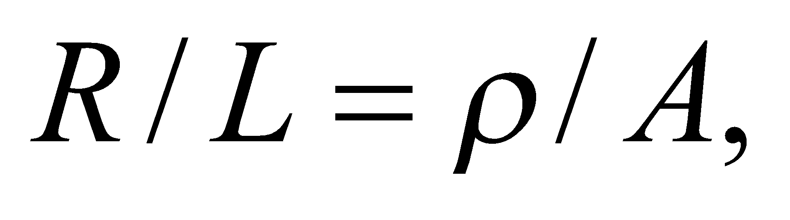where the resistivity of copper and aluminum are 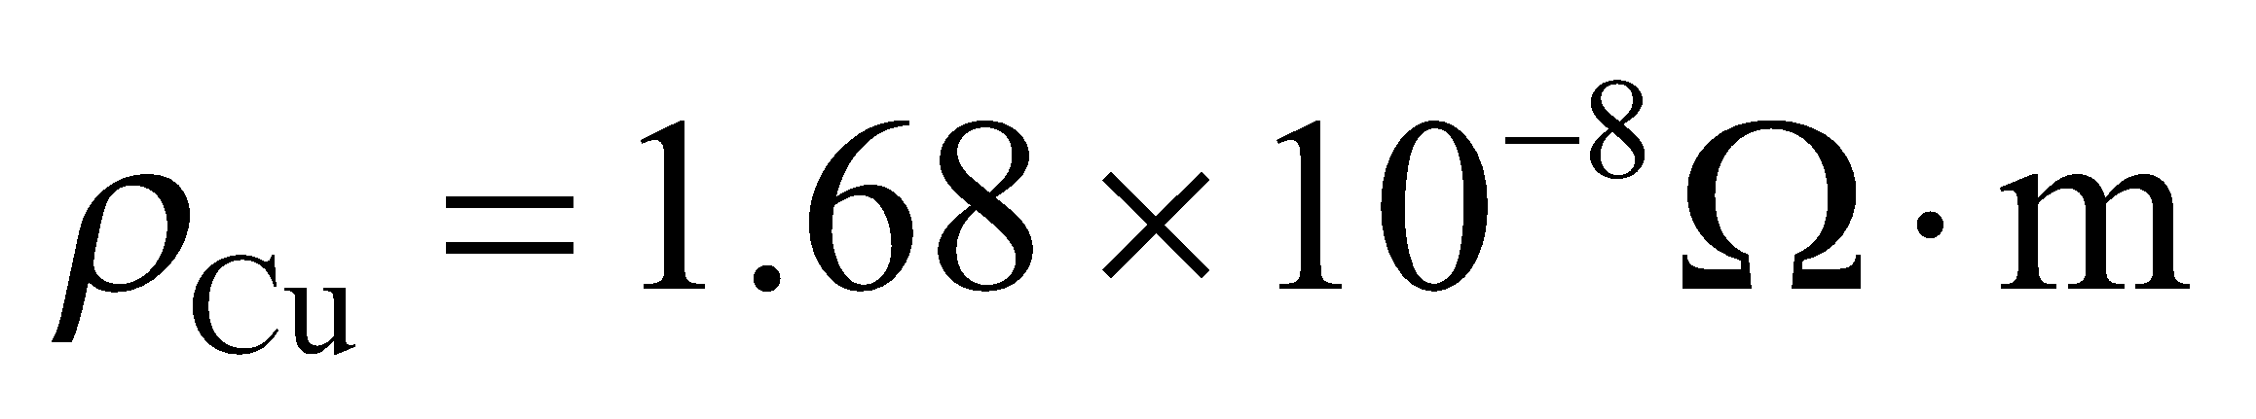and 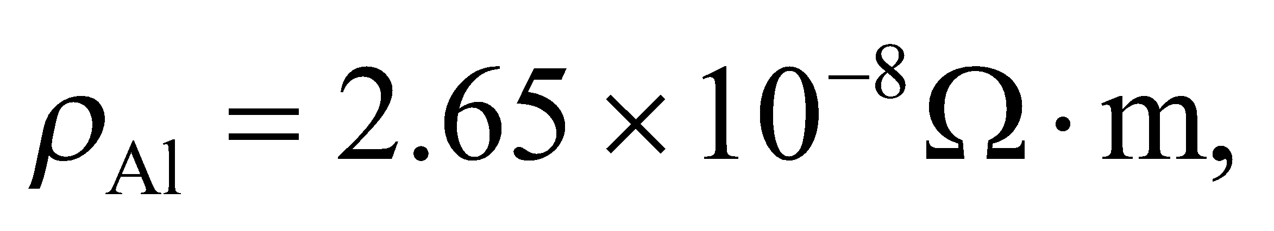respectively. This allows you to specify the cross-sectional area, *A*, of the wire. Since the mass per length is 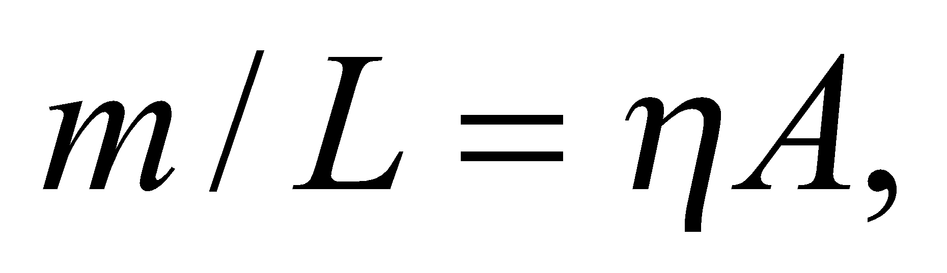where *η* is the mass density for either copper or aluminum, the cost per unit length will be

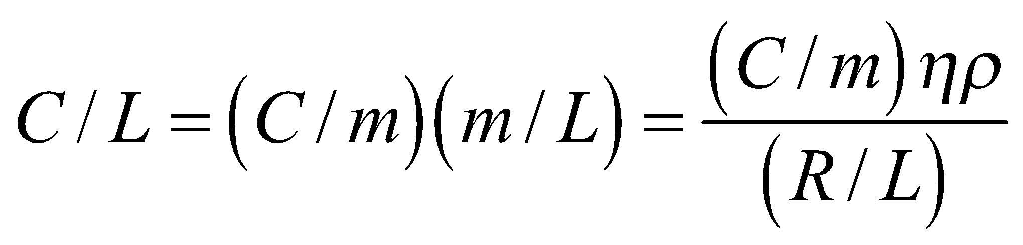

where 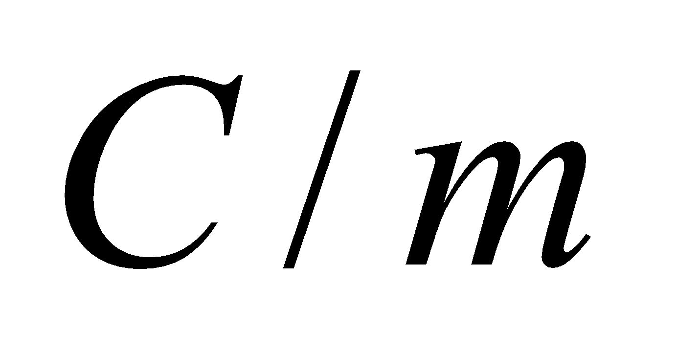is cost per kg of the material.

**Evaluate** The cost per length of copper wire is

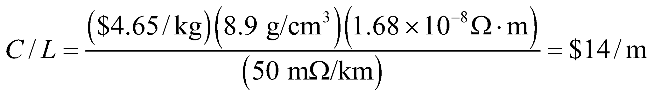

The cost per length of aluminum wire is

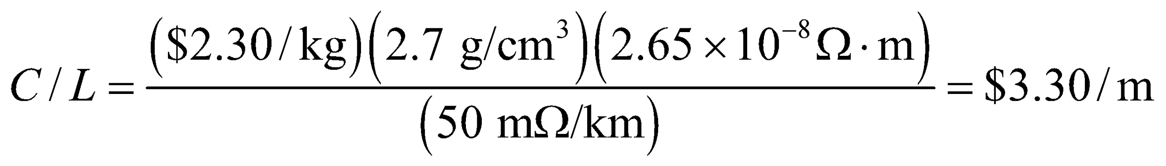

Clearly, the aluminum is more economical.

**Assess** Copper is a better conductor, so the required diameter of the wire 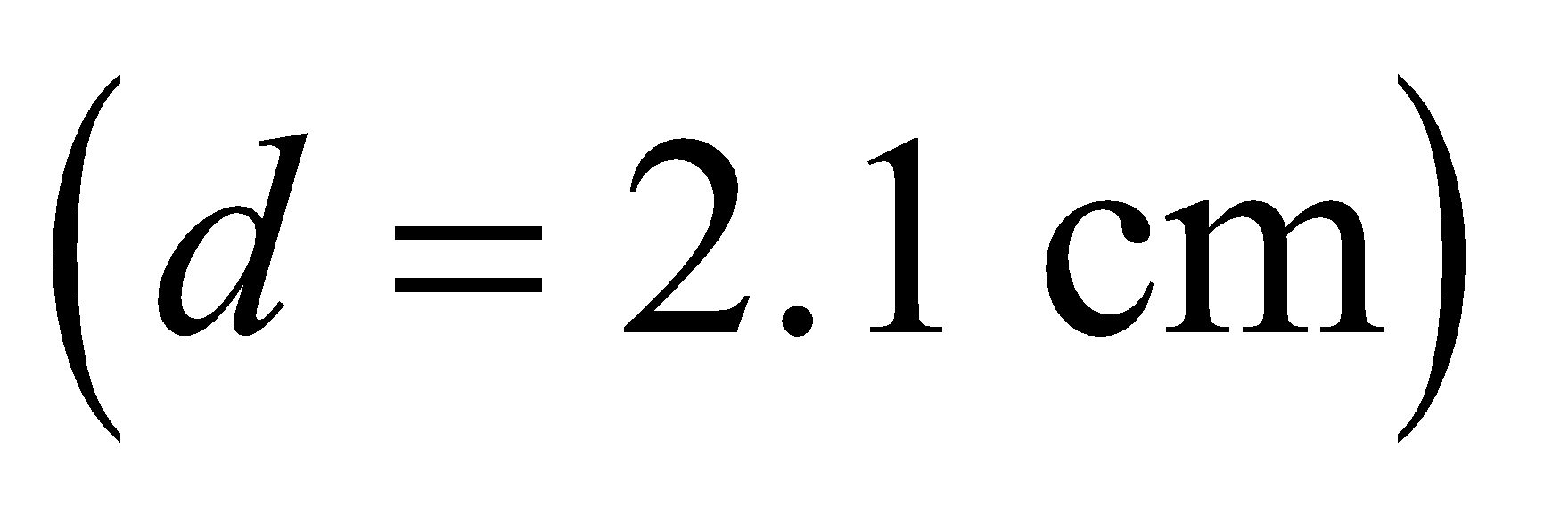 is smaller than that for aluminum 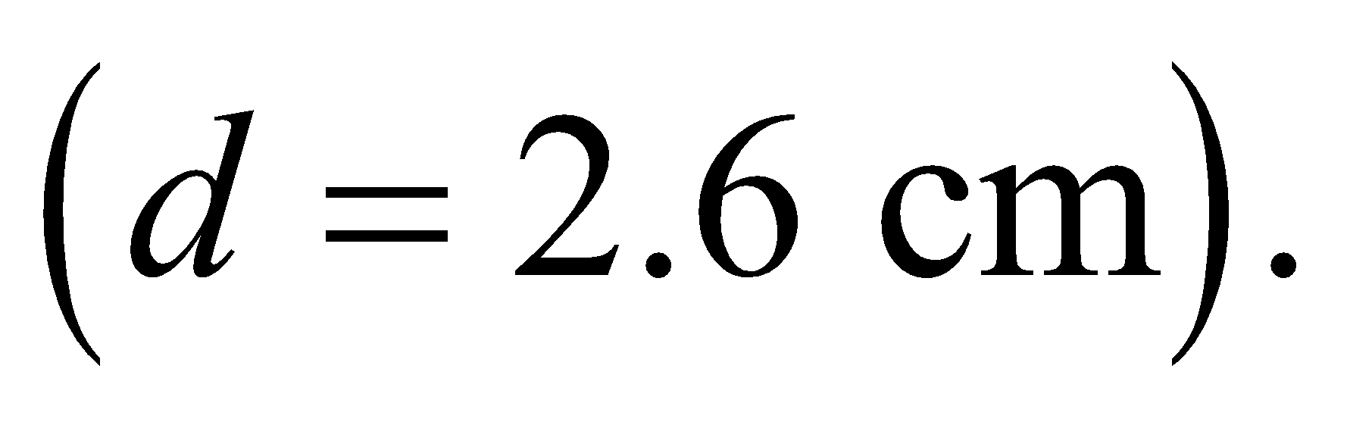But aluminum is lighter and costs less per kilo, so it would save money to use aluminum wires.

**56. Interpret** For this problem, we are to find the current required by an eclectic motor with the given efficiency and voltage to deliver the power necessary to lift a mass at the given rate.

**Develop** From Equation 24.7, the electrical power supplied to the motor is 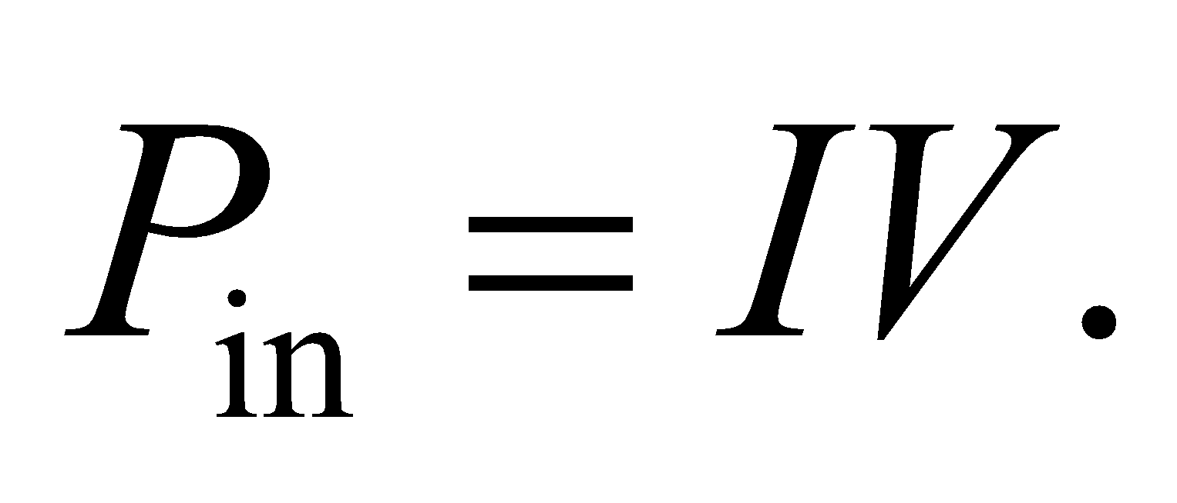 The power required by the mechanical lifting is given by Equation 6.19, *P*mech = *Fv*. With 90% efficiency, the mechanical power expended lifting the weight is 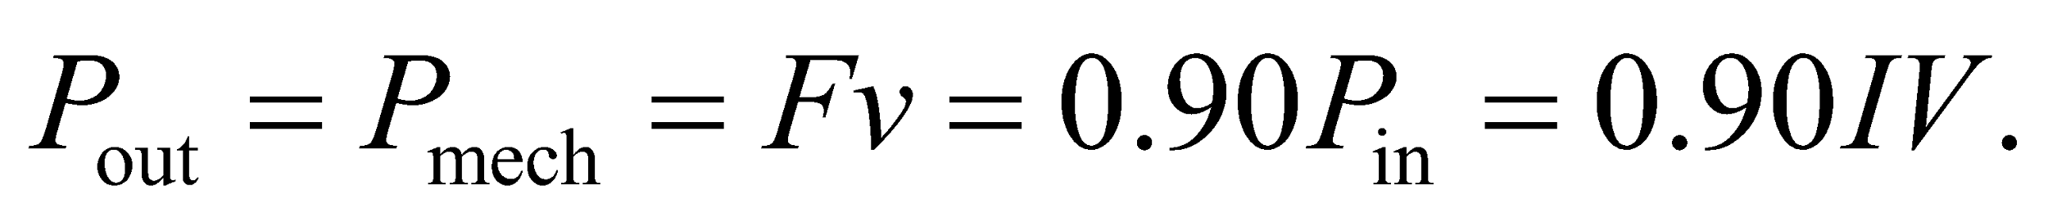

**Evaluate** Thus, the current drawn is

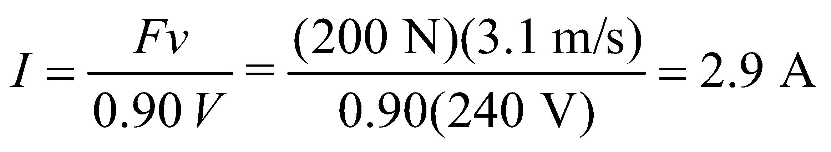

**Assess** The less efficient the motor operates, the more the current that must be drawn to supply the required power.

**57.** **Interpret** This problem involves a nonuniform current density in a metal bar. We are given the dimensions of the bar and are to find the total current in the bar.

**Develop** Use the coordinate system given below in the figure. The current density in the bar is 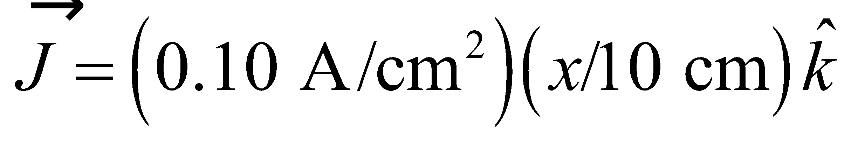. The cross section can be divided into strips of area 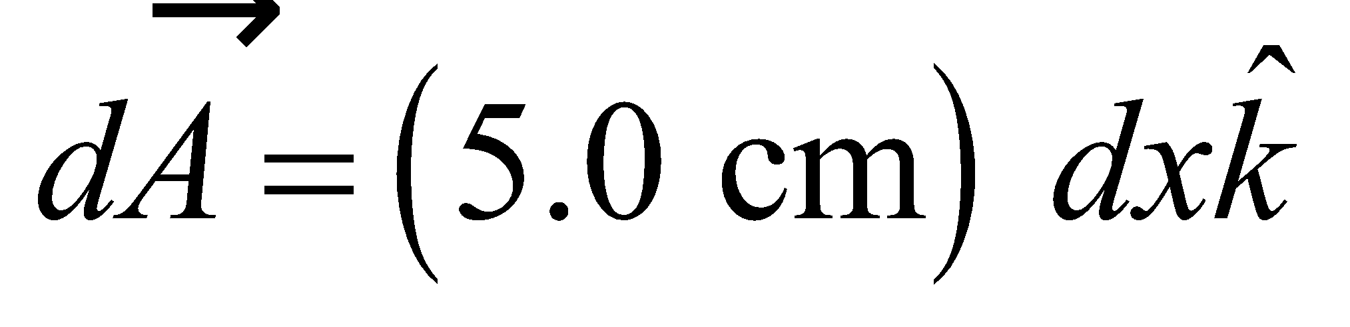 (over which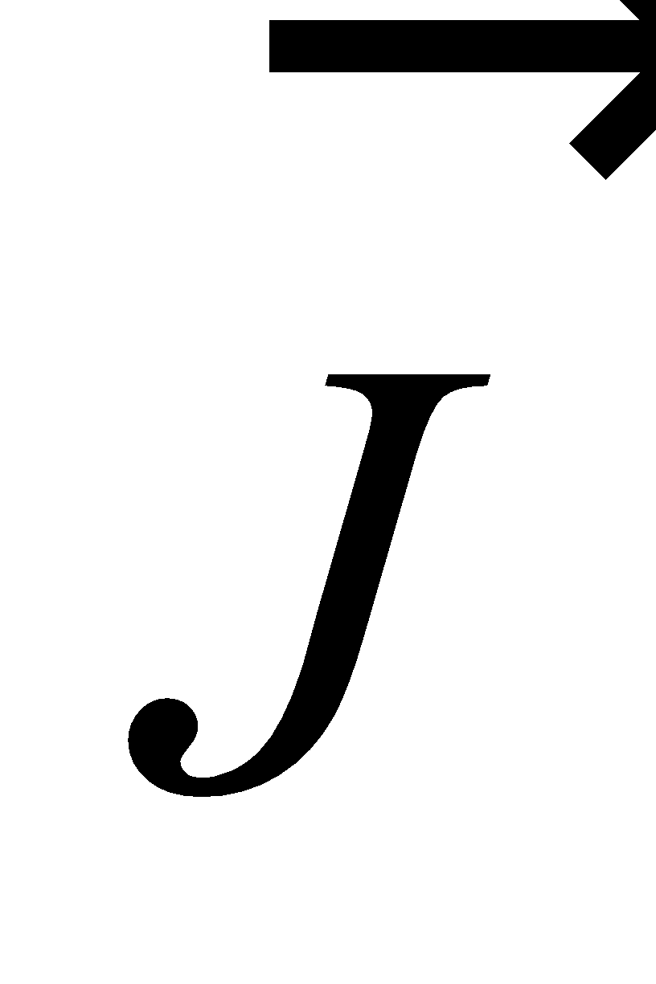is constant), so we can integrate over *x* to find the total current:

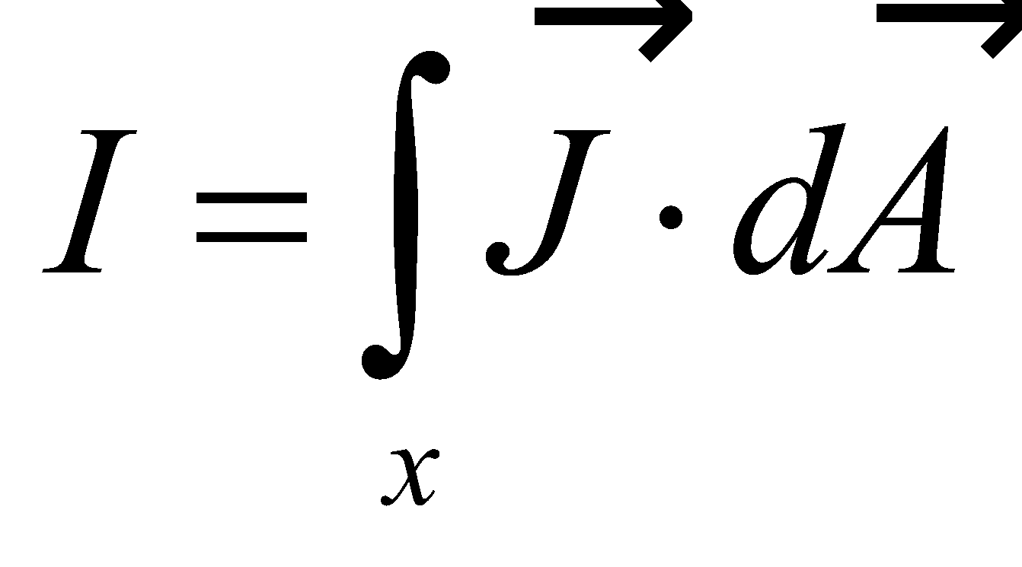



**Evaluate** Performing the integration gives

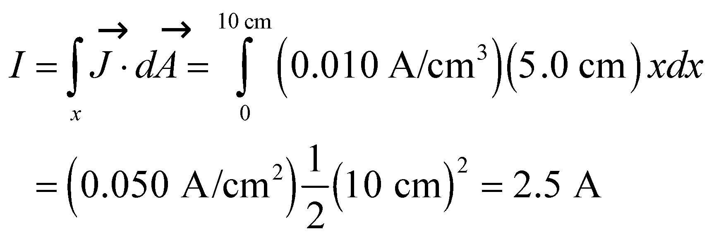

**Assess** This is quite a significant current!

**58. Interpret** This problem involves using electric power to boil water. Electric energy is converted to thermal energy, and we are to find the power required to heat the water in the given time and, from the power, find the heater’s resistance.

**Develop** Combining Equations 6.15 for the average power and 16.3 that relates thermal energy to temperature change, the power required to bring the water to its boiling point is

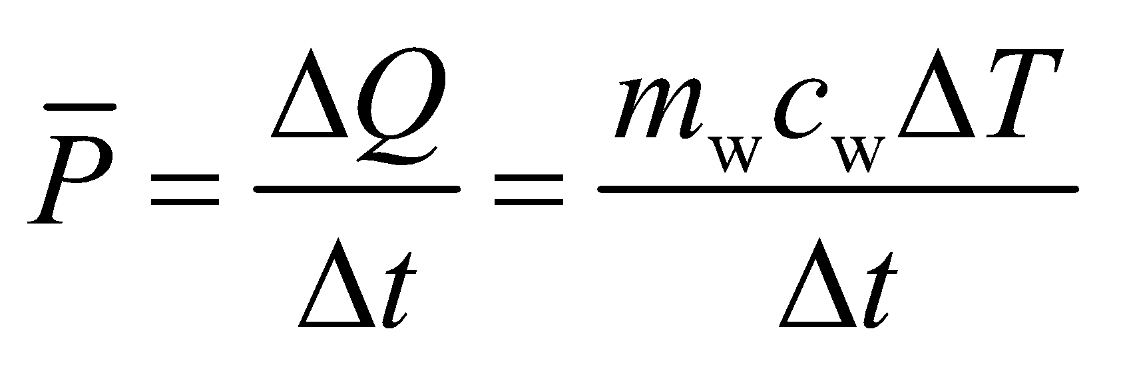

We can then apply Equation 24.8b, *P* = *V*2/*R*, which is applicable for Ohmic devices, to find the resistance of the heater.

**Evaluate** **(a)** Substituting the values given in the problem, we find the power is

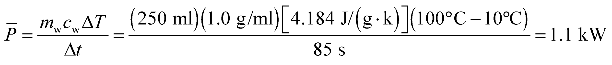

**(b)** With 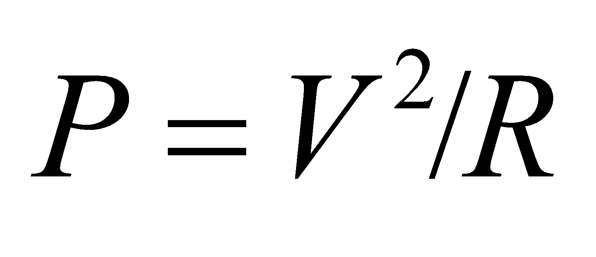, the heater’s resistance is

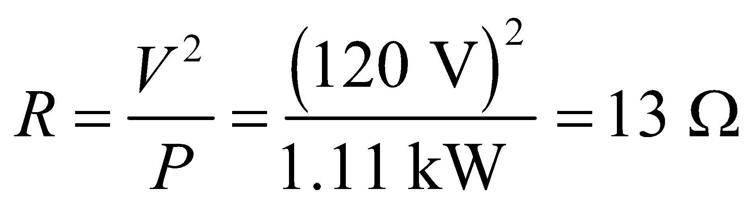

**Assess** Besides the power supplied to heat up water, additional power is also needed to compensate for any power lost to the surroundings or cup, plus that used by the heater itself. All these factors have been neglected in this problem.

**59.** **Interpret** This problem gives the resistivity of copper as a function of temperature, from which we are to find the temperature at which the resistivity is twice its room-temperature value.

**Develop** We are to find the resistivity *ρ*(*T*) = 2*ρ*(*T*0) (where we let *T*0 = 20 °C be room temperature). Take the ratio of this equation for these two temperatures and solve for *T*.

**Evaluate** The temperature at which the resistivity doubles is

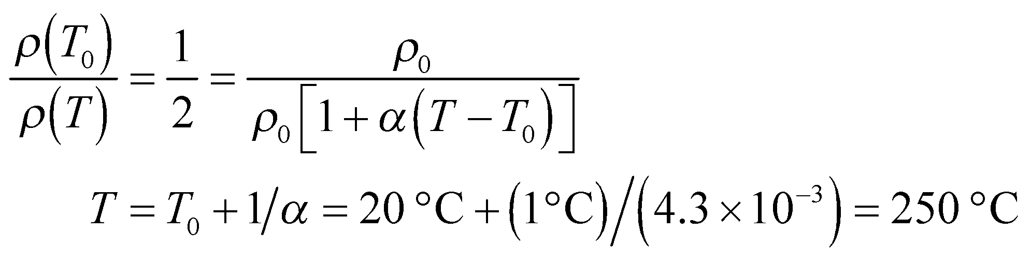

to two significant figures.

**Assess** This ambient temperature is much higher than is encountered in normal circumstances. At a very hot ambient 50 °C, the resistivity is 13% higher than at room temperature.

**60. Interpret** In this problem we are asked to calculate the drift speed of electrons in Al. We are given enough information to find the number density of conduction electrons in the Al wire.

**Develop** Using Equation 24.2, the drift speed of electrons in the wire is

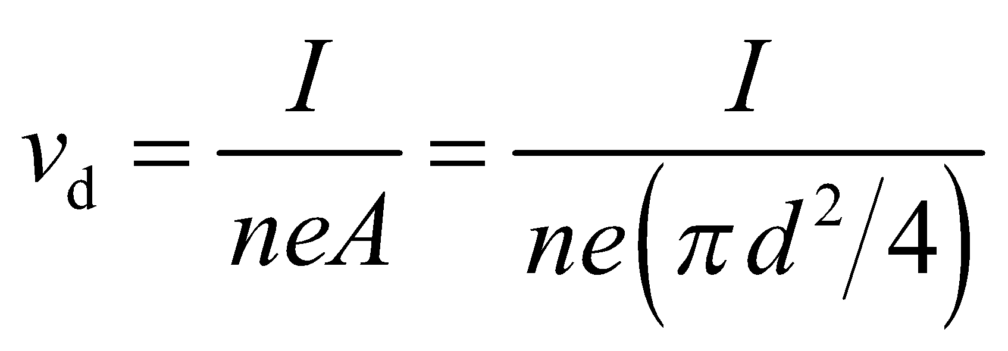

where *n* is the number density of conduction electrons. The density of Al is 2702 kg/m3, and each atom has a mass of 26.98 u (from Appendix D). Let the units guide you to find the number density *n* of electrons:

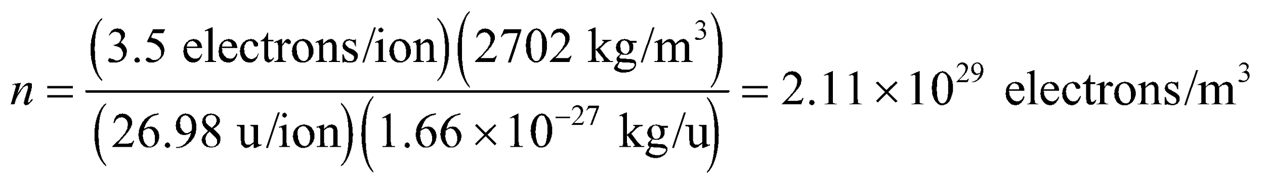

**Evaluate**  Inserting the given quantities, the drift speed is

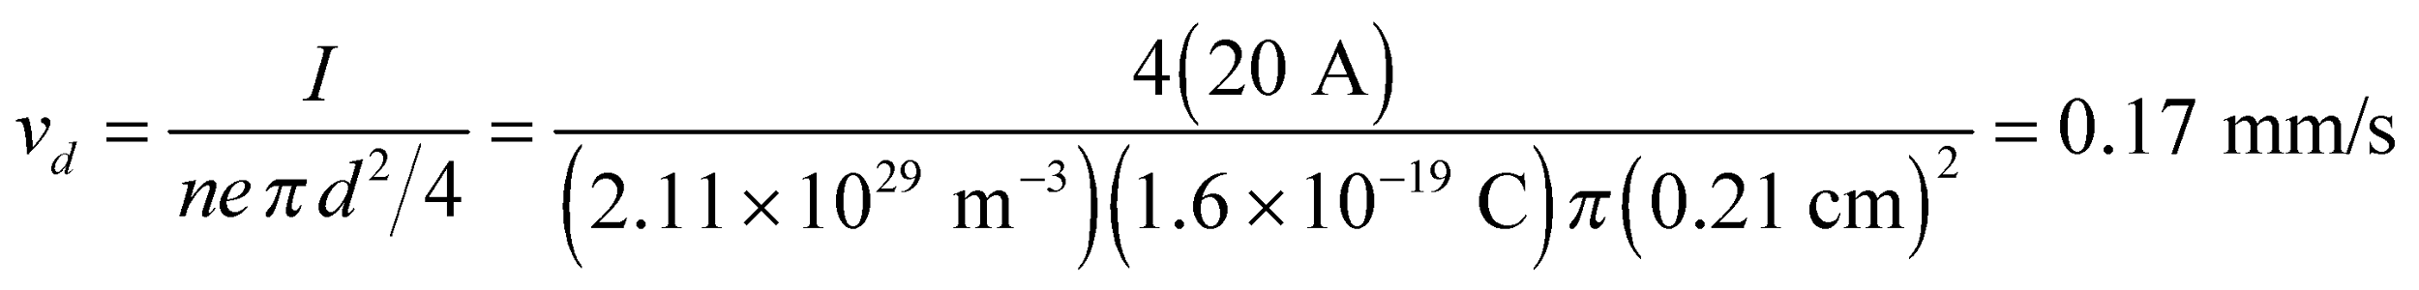

**Assess** The drift speed is very small. With this speed, it would take about 100 minutes for an electron to travel 1 m. However, as explained in Example 24.1, electrons inside the conducting wire all get their “marching orders” from the electric field, which is established almost instantaneously. Consequently, when you flip the switch, electrons throughout the wire start to move almost instantaneously and light comes on immediately.

**61.** **Interpret** For this problem, we are to find an expression for the resistivity through the solution with resistivity *ρ* from the cylinder side to the center disk.

**Develop** Consider a concentric cylindrical surface *S*, of radius *r* and height *h*, between the two metal electrodes. *S* completely surrounds the inner disk, so the current flowing (assumed from the center to the sides) is

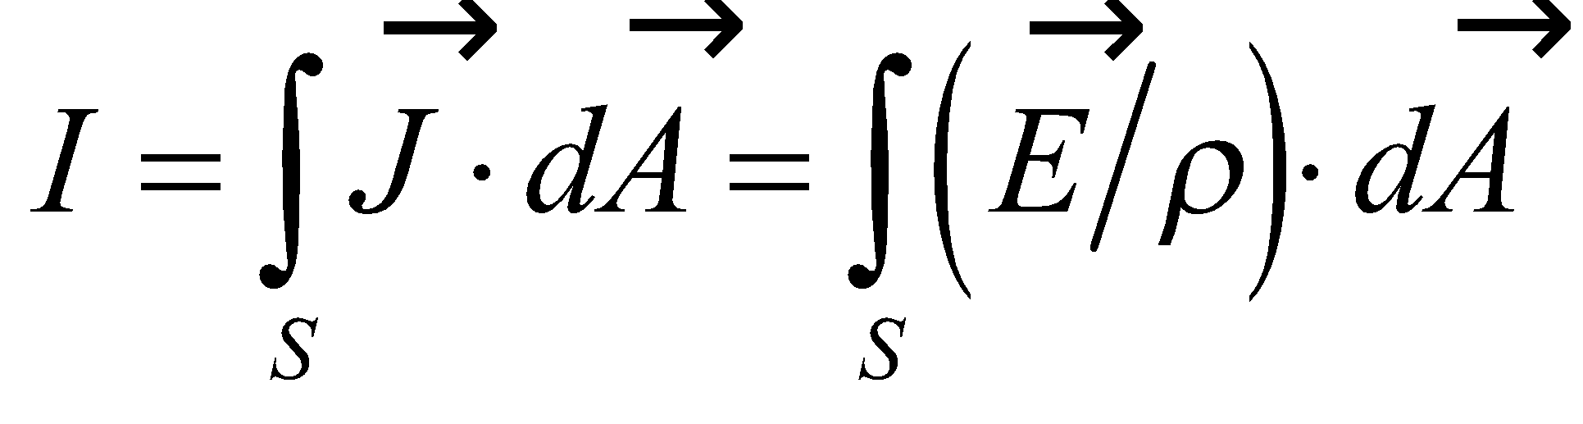

for an ohmic solution. If the electrodes behave like perfect conductors 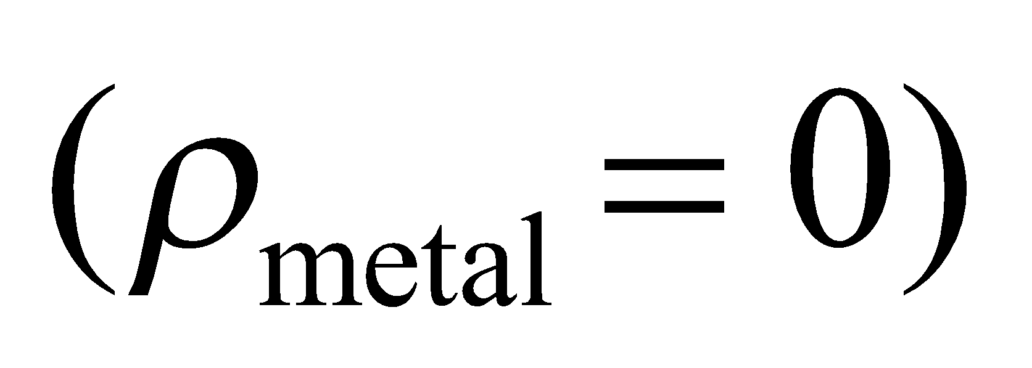 they are essentially equipotentials, and the electric field in the solution has cylindrical (line) symmetry. (There are no fringing fields because outside the solution, the current density is zero.) Thus, without changing the integral, flat circular surfaces above and below may be added to close the surface *S*, so that

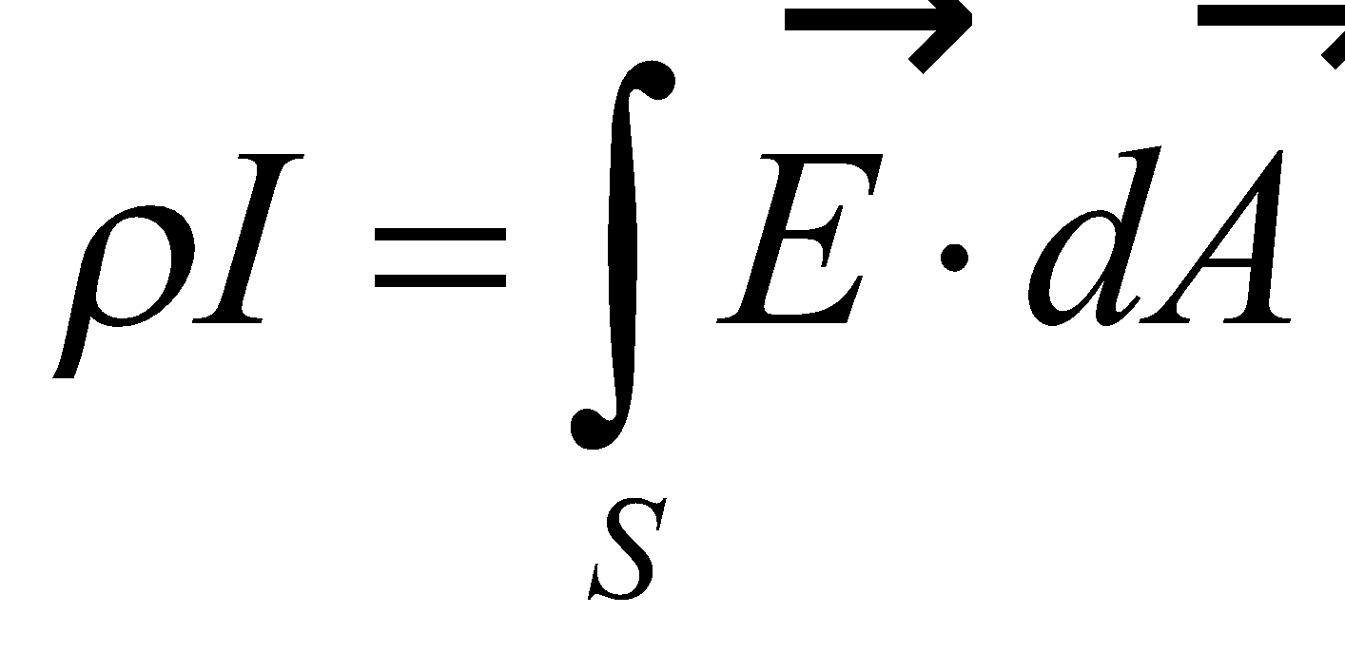

This integral is the same as the one appearing in Gauss’s law for two conductors in an identical configuration, as in Example 21.5. Thus,

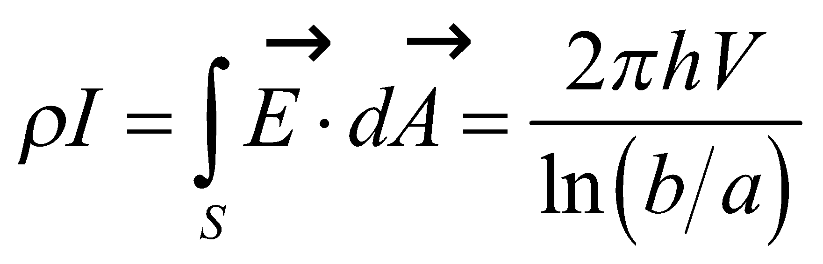

where 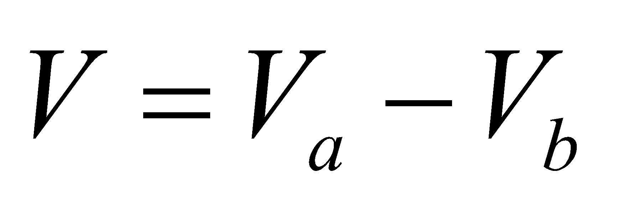 is the potential difference and we used *h* instead of *L* for the length. Comparing this with the macroscopic version of Ohm’s law (Equation 24.5) *V* = *IR*, we can solve for the resistivity *ρ*.

**Evaluate** A comparison of this with Ohm’s law, *V* = *IR*, shows that the resistance between the electrodes is

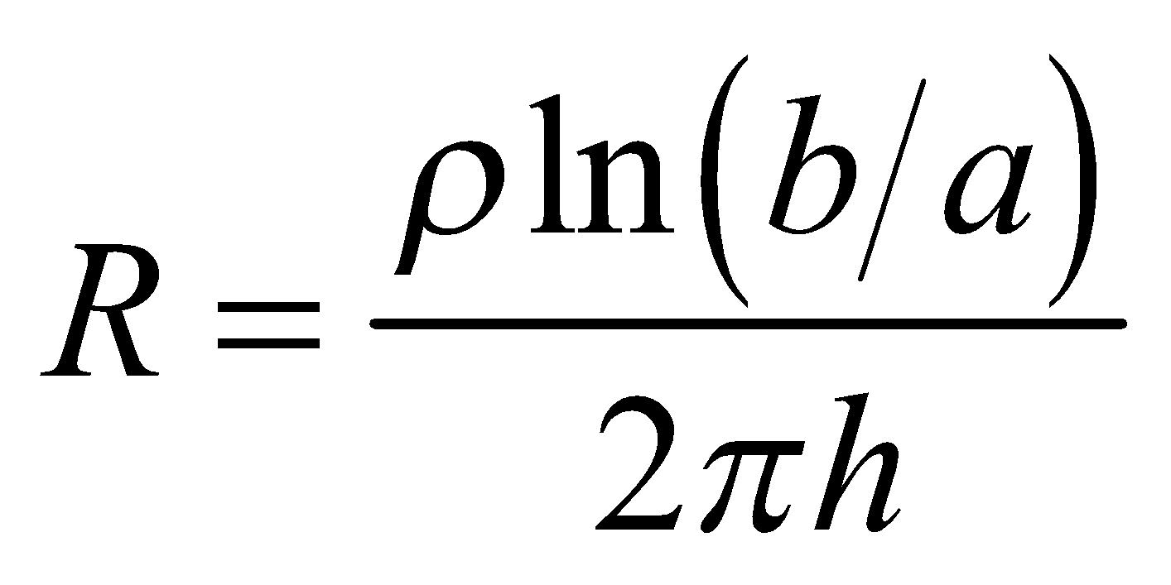

**Assess** In terms of the capacitance of the same configuration of electrodes with air between the electrodes,

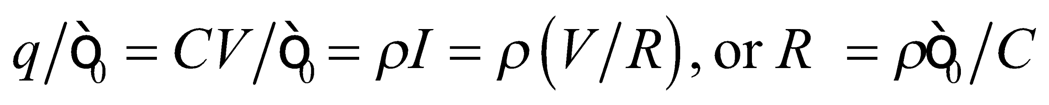

This relation holds for electrodes of arbitrary shape.

**62.** **Interpret** The problem involves the resistance of an object whose cross-sectional area varies.

**Develop** The fact that the equipotentials are parallel to the two faces implies that the electric field is aligned with the axis of the cone. The electric field will vary in strength along the cone, but in a slice of thickness *dx* the electric field should be uniform. Therefore, the differential resistance in such a slice will be from Equation 24.6: 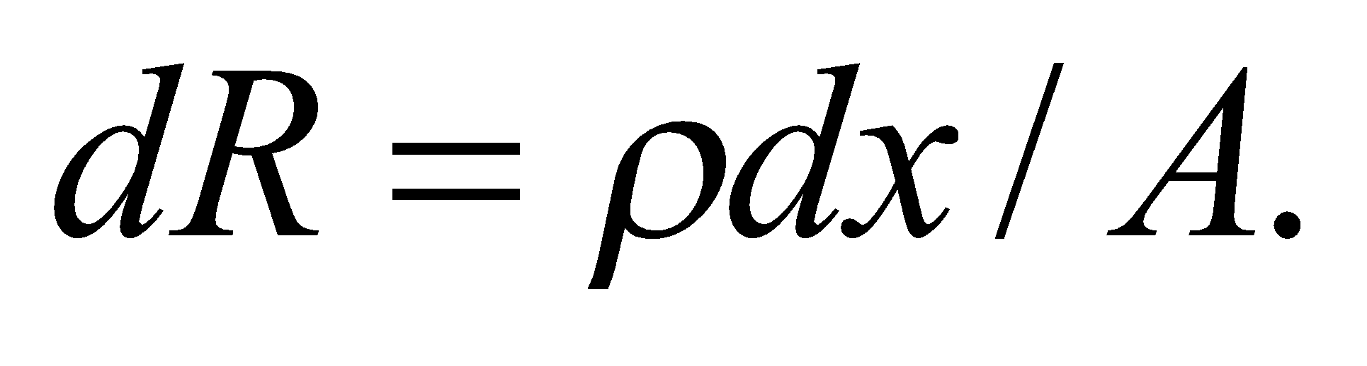 The area of each slice is 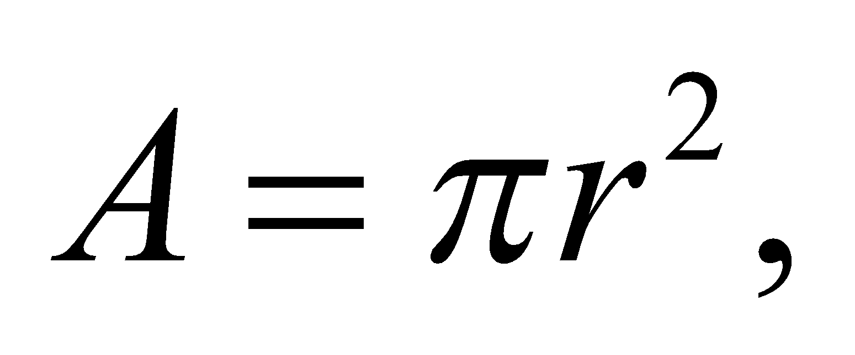 where the radius of the slice can be related to the position of the slice between 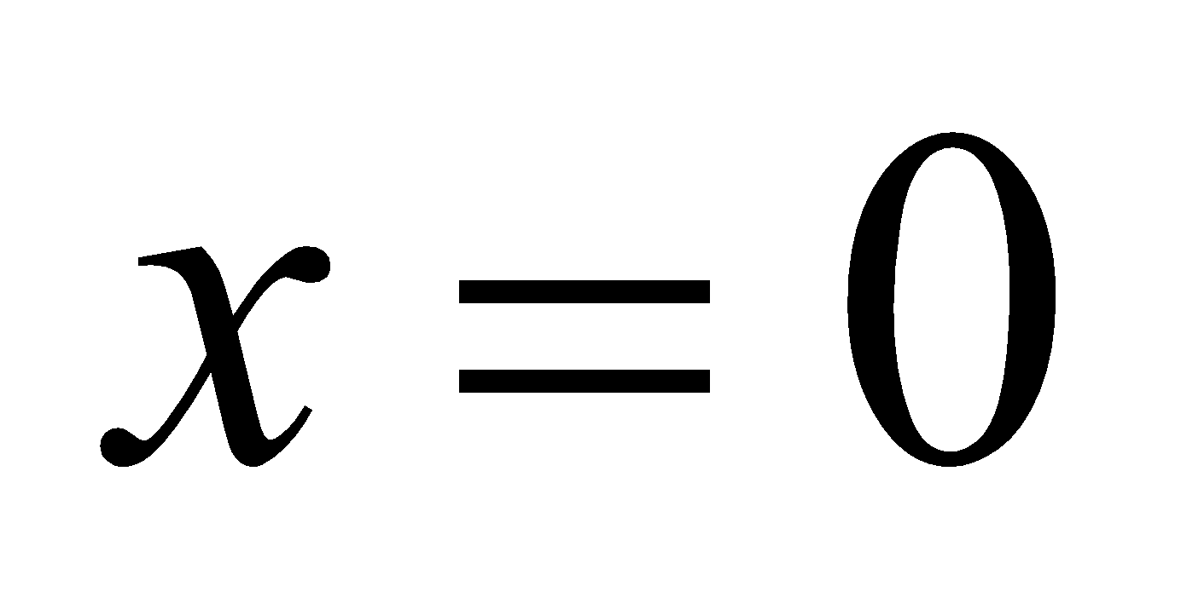 and 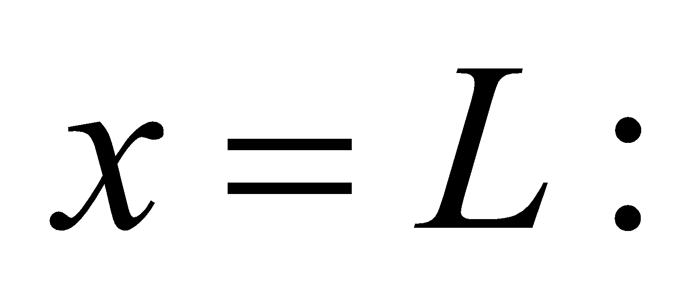

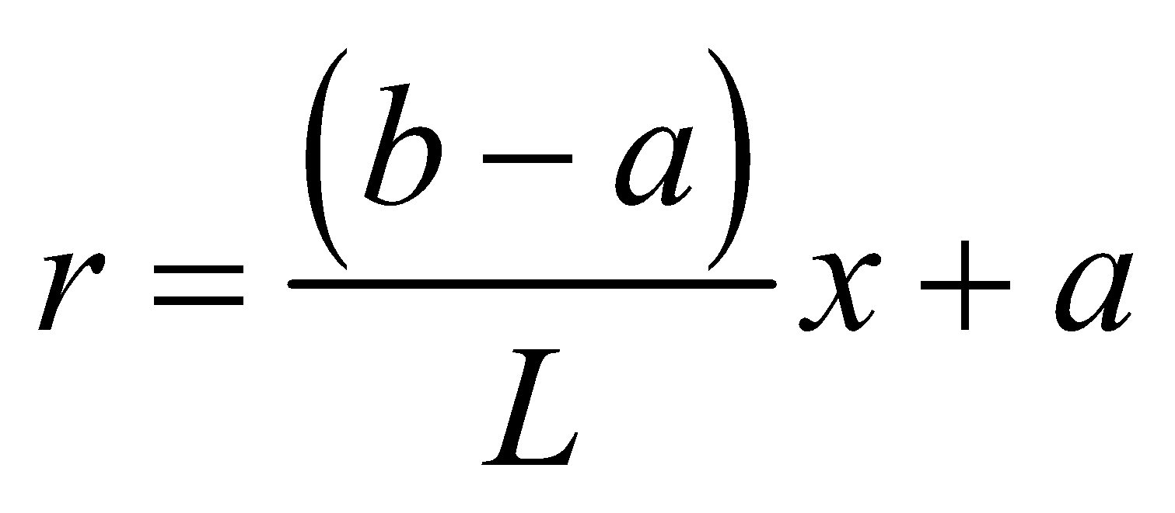

From this, we can relate the differentials: 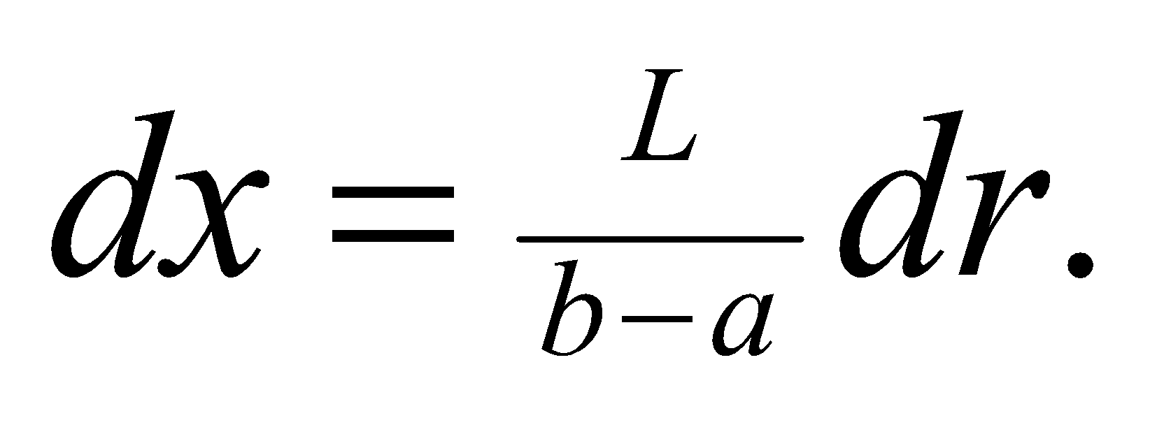

**Evaluate** We can integrate over the slices to obtain the full resistance through the cone:

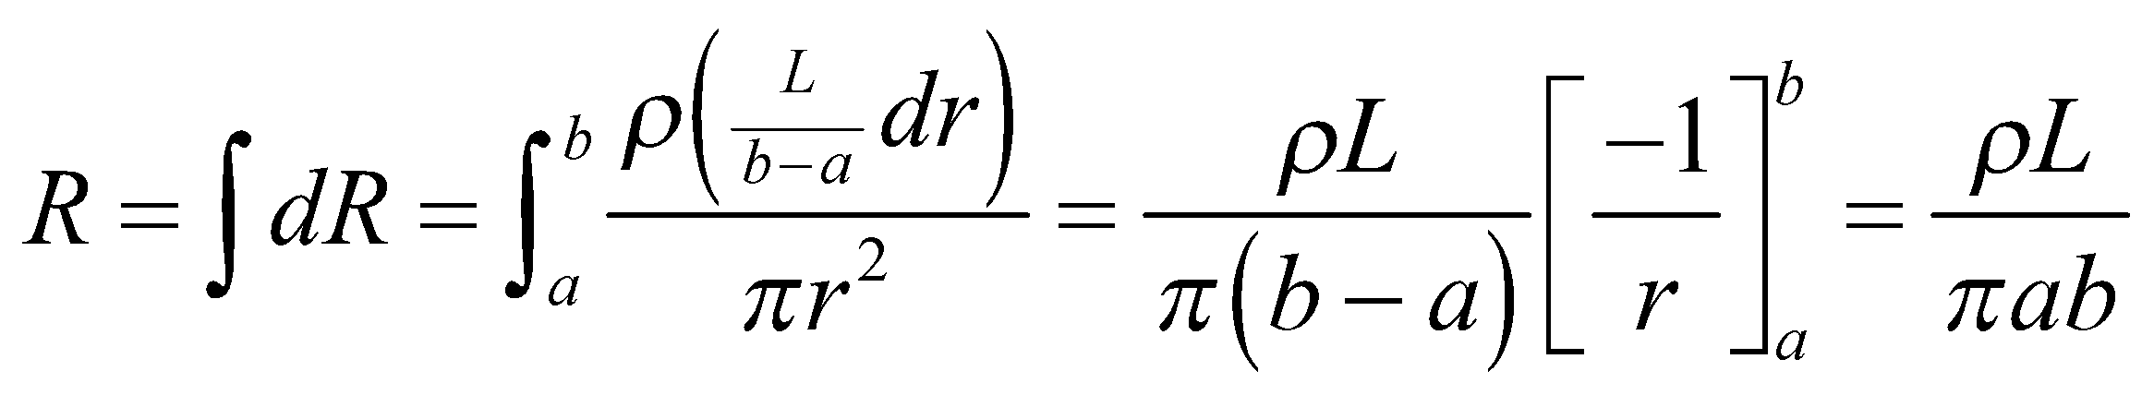

**Assess** Obviously, if 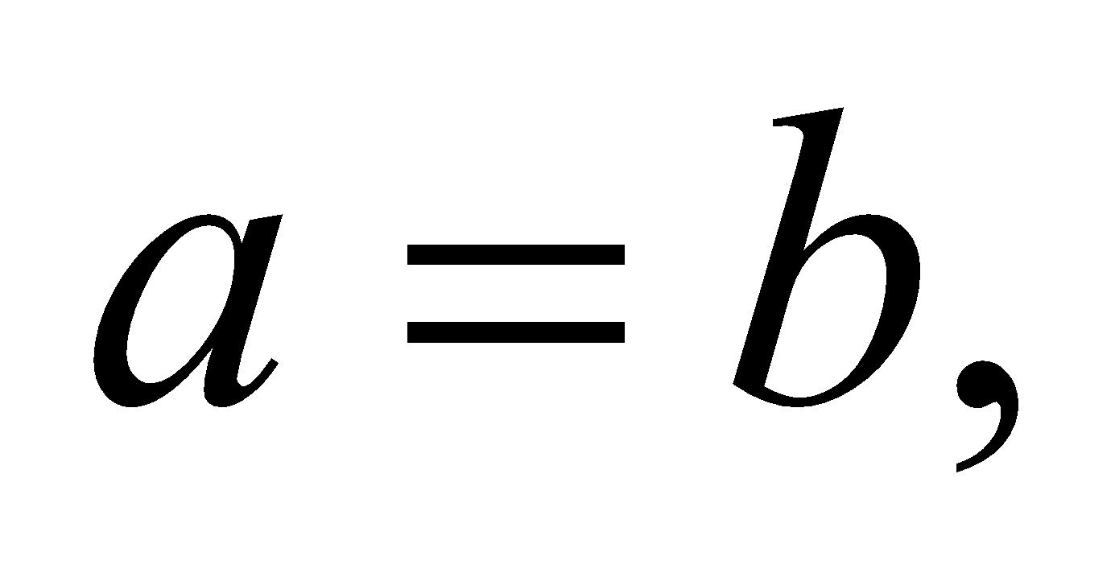the cone becomes a uniform cylinder, and we recover the resistance from Equation 24.6.

**63. Interpret** We are to find the current in a particle beam, given its current density as a function of the beam radius. The beam is circular, has a current density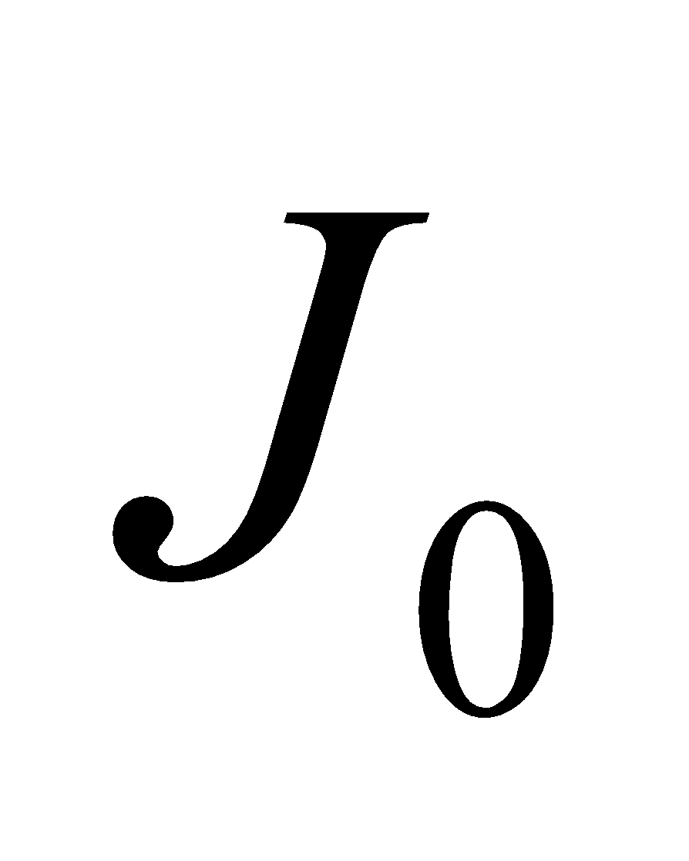at the center, and the current density falls to half that value at the edge.

**Develop**  Integrate the current density over the beam to find the total current. From the problem statement, we can express the current density as a function of radius as

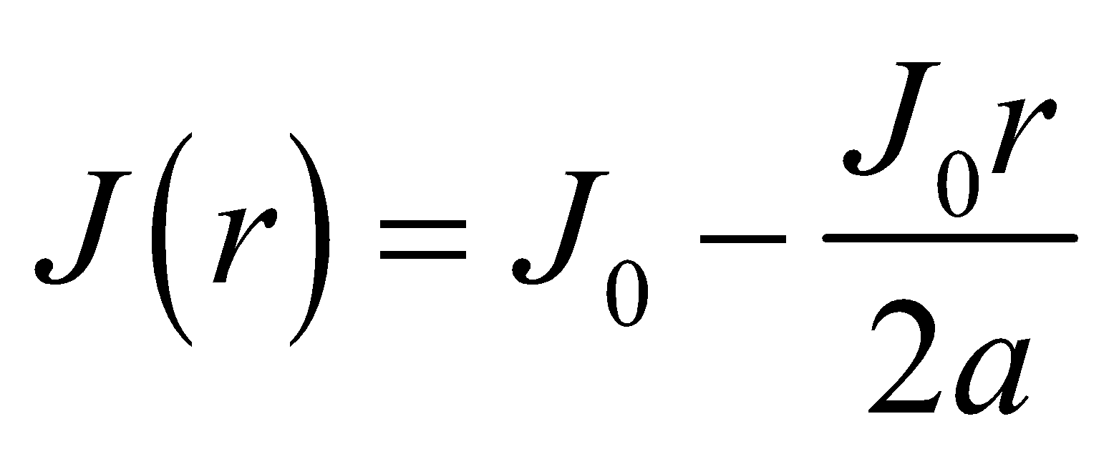

To find the total current, integrate over circular rings of radius *r*, each of which has area 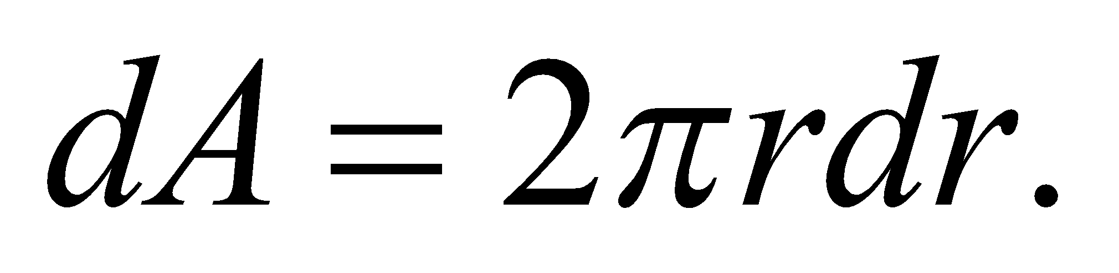

**Evaluate** Performing the integration gives

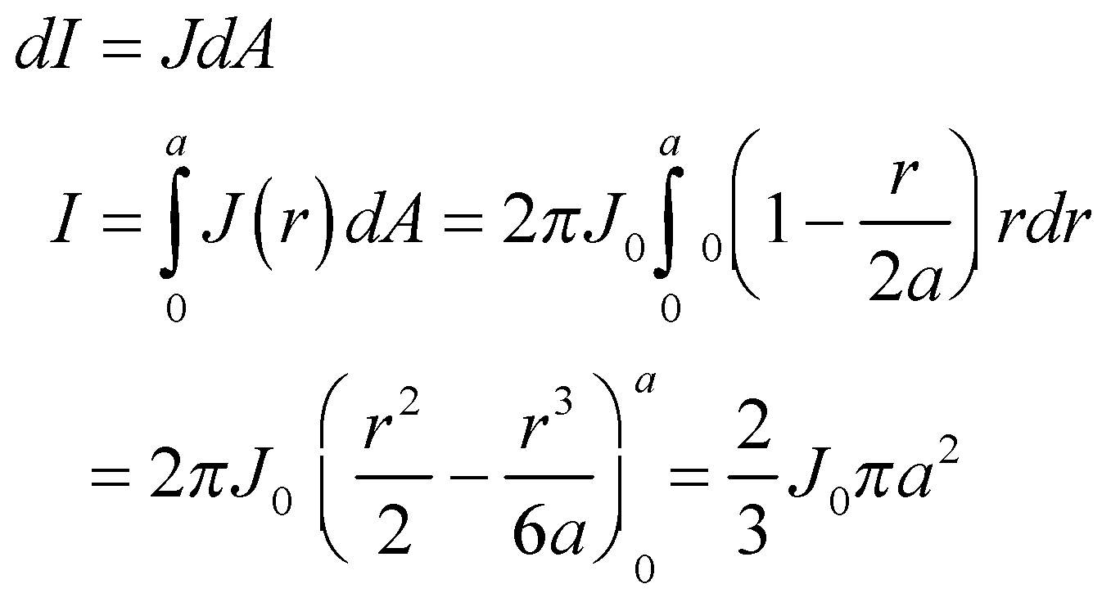

**Assess** The beam current is 2/3 as much as it would be if the current density was constant.

**64. Interpret** We are to find the resistance of a cylinder that has varying resistivity. We integrate over the length of the cylinder, using the given equation for resistance.

**Develop** We are given an equation for the resistivity:

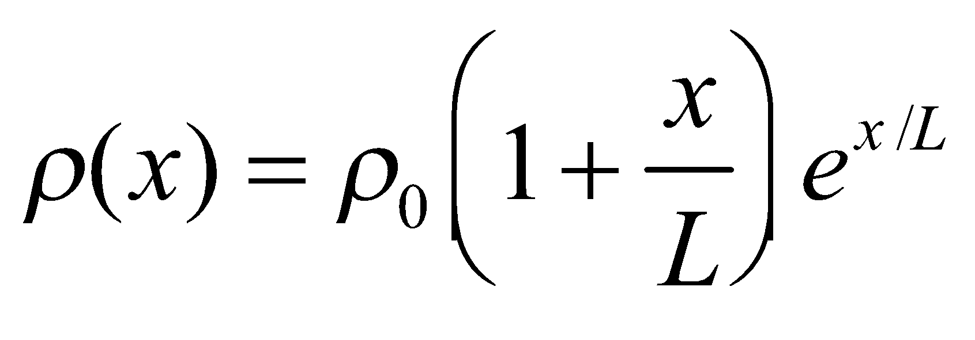

where 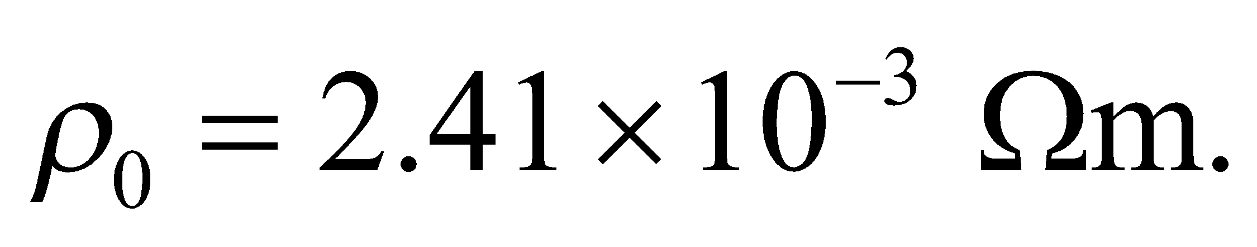 The radius of the cylinder is *r* = 0.0025 m, and the length is *L* = 0.015 m. Integrate

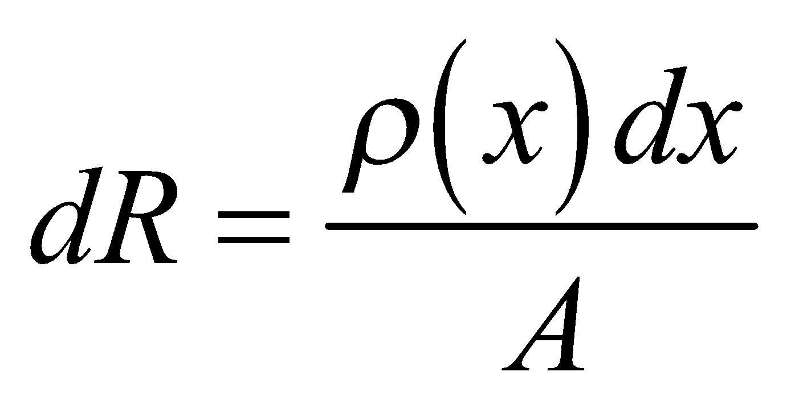

from *x* = 0 to *x* = L.

**Evaluate** Performing the integration gives

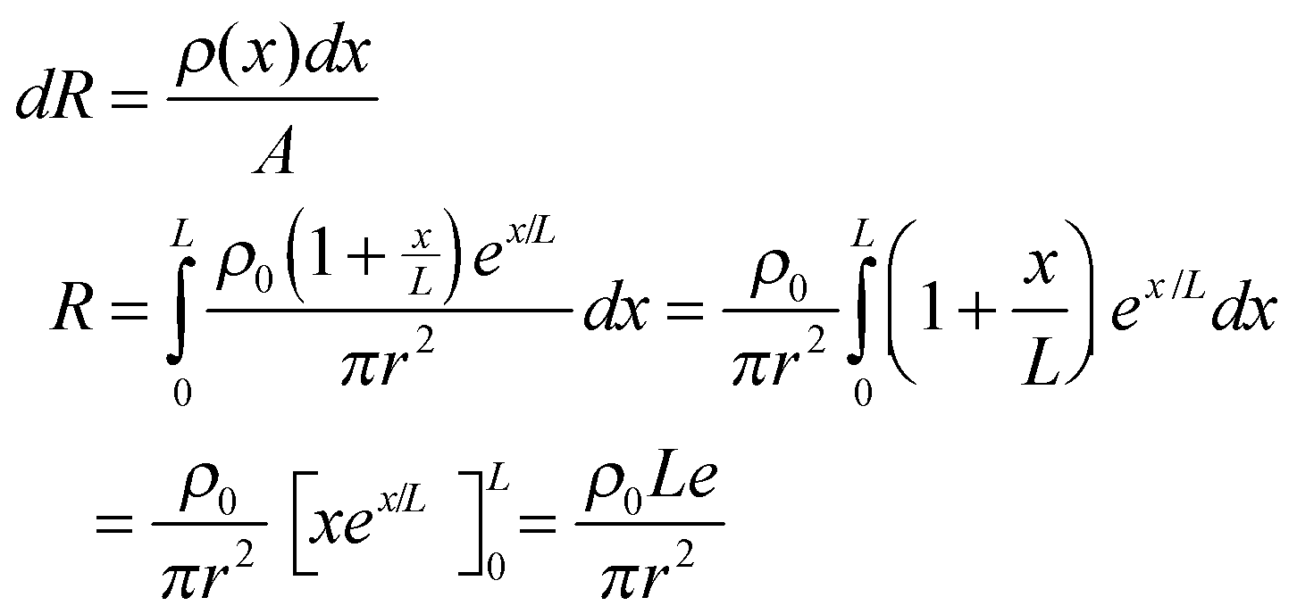

Inserting the given values *r* = 5.0 mm and *L* = 1.5 cm gives

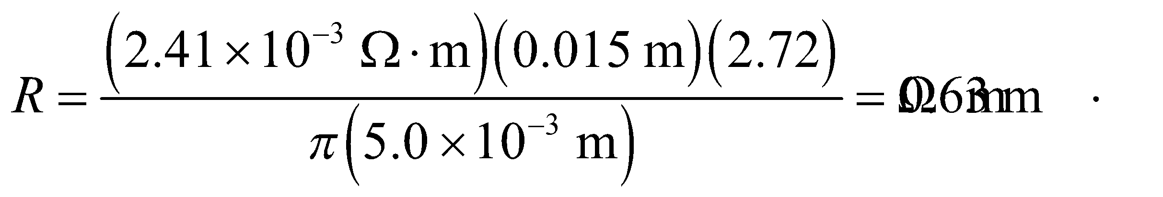

**Assess** The resistivity increases linearly with length.

**65.** **Interpret** You want to find the steepest hill that a hybrid car can climb using only its battery.

**Develop** The maximum power that the battery can supply is given by 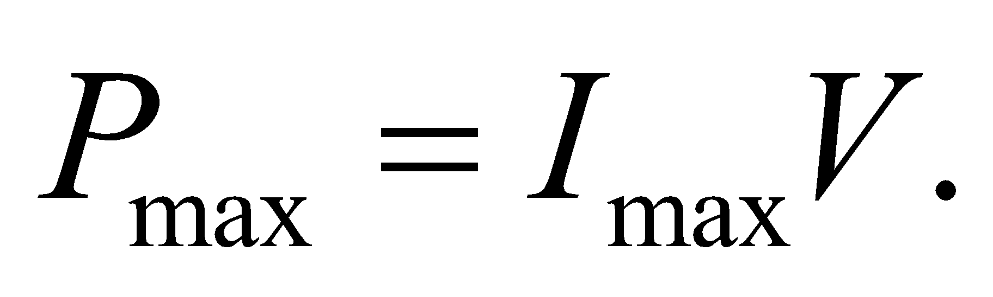 If all this power is used to propel the car forward, then the force will be equal to the power divided by the velocity: 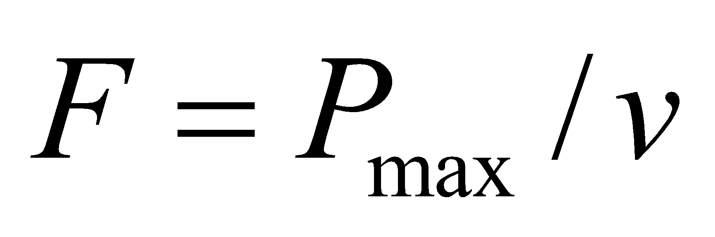 (recall Equation 6.19). If we neglect wind resistance, this force must be equal and opposite to the component of the gravitational force that is parallel to the slope of the incline, 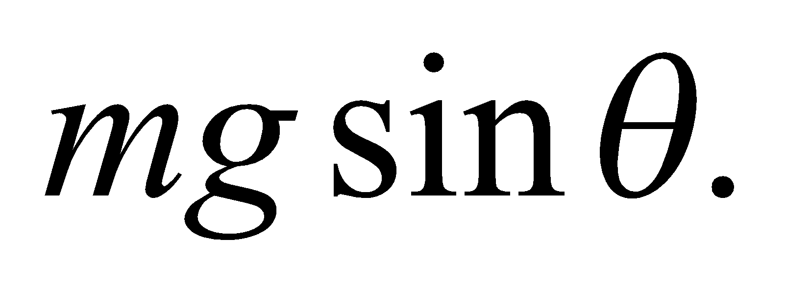

**Evaluate** Solving for the angle of the incline gives:

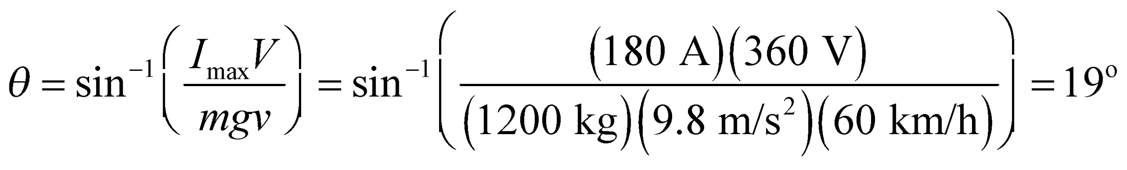

**Assess** It's rare that one encounters a slope this steep. But in a real situation, you would have to account for not all of the battery's power being used to turn the wheels. Moreover, the drag from wind resistance will reduce the car's speed for a given battery output.

**66.** **Interpret** We explore the effects of a brownout on a electrical network.

**Develop** We first consider conductors whose resistance is independent of temperature.

**Evaluate** A 10% reduction in voltage will result in a corresponding 10% drop in the current through a conductor whose resistance is essentially constant.

The answer is (a).

**Assess** This will be true for any conductor that obeys Ohm's law.

**67.** **Interpret** We explore the effects of a brownout on a electrical network.

**Develop** We will use the fact that the current density 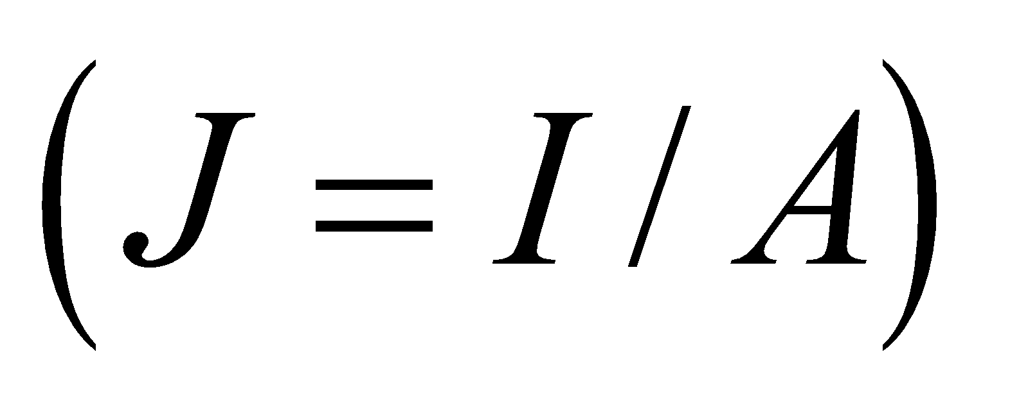decreases during a brownout.

**Evaluate** The current density is related to the electric field by Equation 24.4b: 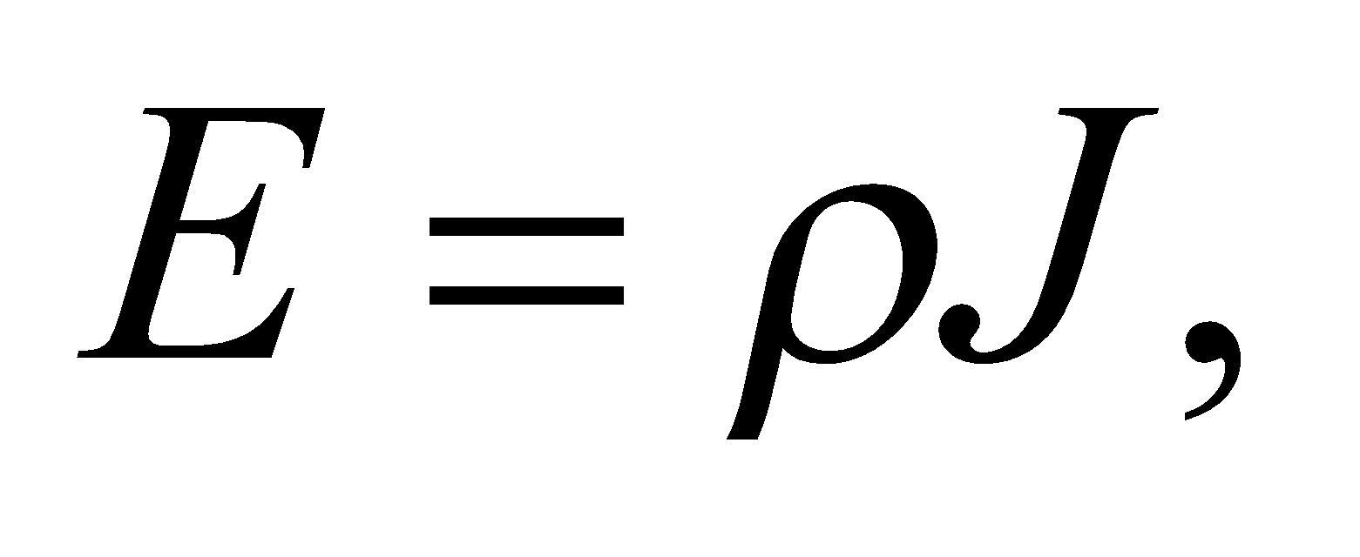so the electric field strength should decrease with the current density. The current density is also related to the number of charge carriers and the drift speed through Equation 24.3: 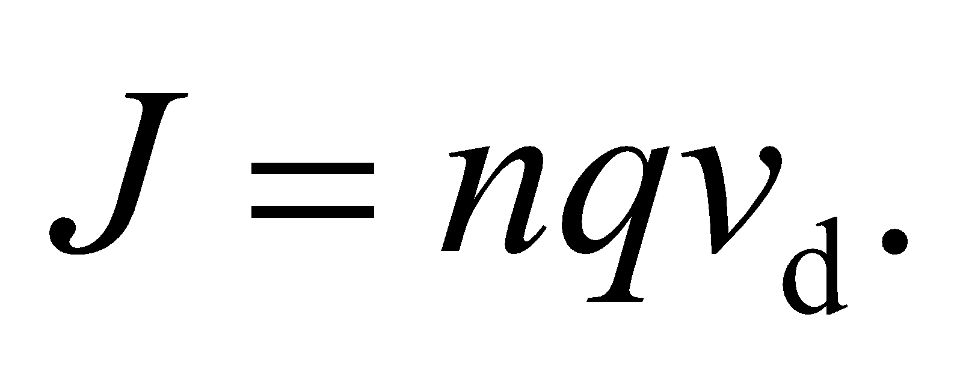 The number of free electrons does not vary in conductors under normal conditions. Therefore, the drift speed must fall when the current density decreases. Finally, the number of electron collisions depends primarily on the temperature.

The answer is (a).

**Assess** Another way to think of this is that the electric field is directly related to the voltage: 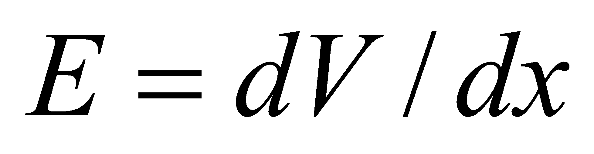 in the one-dimensional case. So a drop in voltage corresponds to a drop in the electric field. Moreover, the electric field provides a force on the charges that results in the drift velocity.

**68.** **Interpret** We explore the effects of a brownout on a electrical network.

**Develop** The power dissipated in conductors with constant resistance can be written as 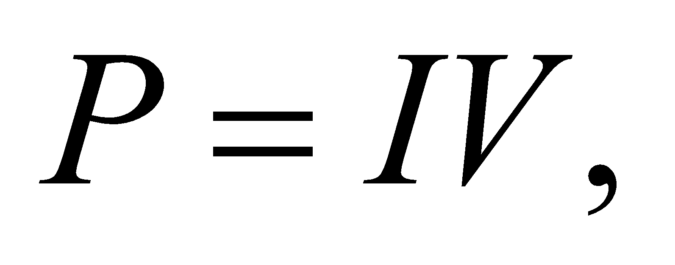 or 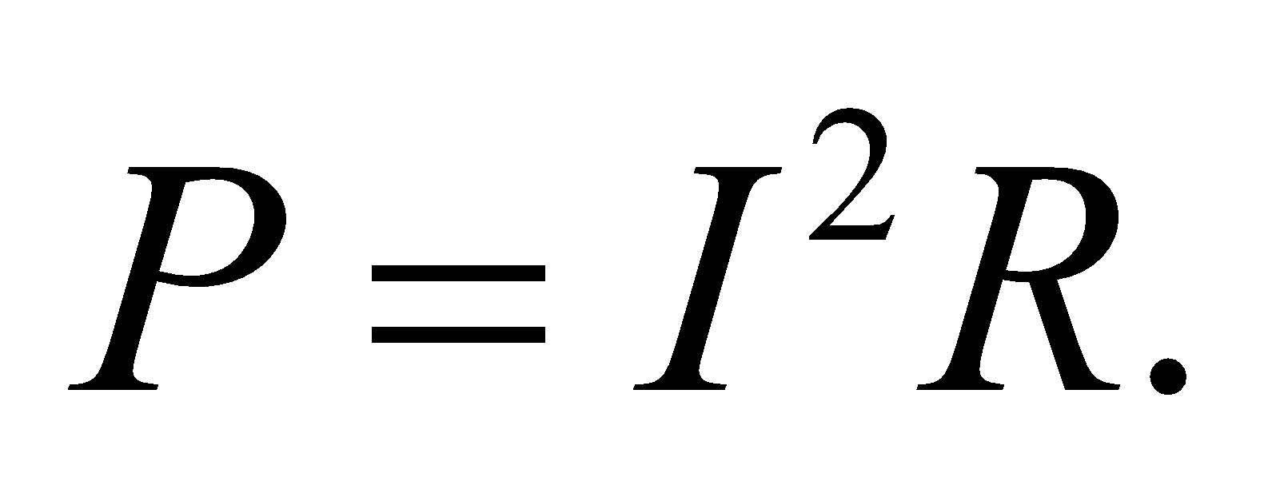

**Evaluate** No matter which expression we use for the power, there will be a factor of 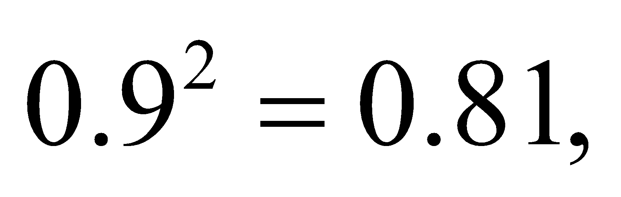 which means the power will decrease by about 20%.

The answer is (b).

**Assess** This power reduction is what customers will notice, as their light bulbs will be about 20% dimmer than usual (but see the next problem).

**69.** **Interpret** We explore the effects of a brownout on a electrical network.

**Develop** The temperature of the resistor in a light bulb or a stove top should be proportional to the power being dissipated. Since we've just argued in the previous problem that the power decreases during a brownout, the temperature in these resistors should be lower than normal periods of electricity supply.

**Evaluate** As the problem states, the resistance scales with the temperature, so these devices should have slightly higher current going through them than if their resistance were constant. In other words, their current decreases by less than 10%.

The answer is (c).

**Assess** This temperature dependence reflects the fact that at higher temperatures there will be more electron collisions. This reduces the net flow of charge in the direction of the applied electric potential.